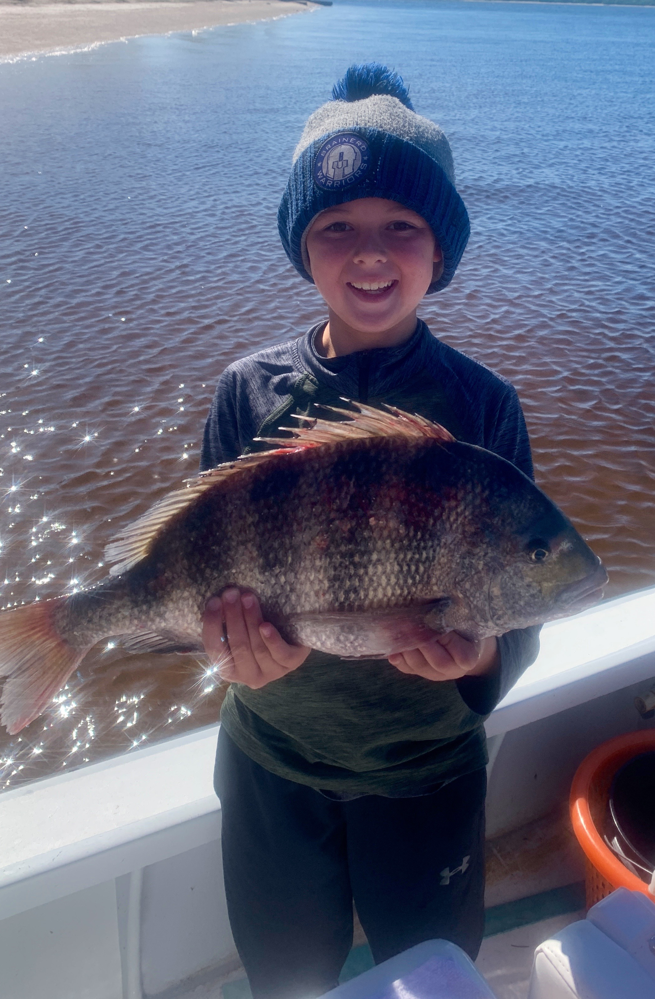

Cold front tactics
Pic: Charlie from MN caught this big sheepshead while fishing with Capt Matt Mitchell.

Weather ups and downs are all part of our winter fishing pattern. One morning can be in the 40’s and then just a few days later we are back in the 80’s. Knowing how to taking advantage of what the days conditions are is the key to success. During the coldest periods sheepshead fishing was on fire then as conditions gradually warmed it was back to catching snook.

Immediately following a cold front I quickly headed to the passes and targeted sheepshead around the structure and docks. Each new cold fronts give us a fresh push of sheepshead moving in from the Gulf. The largest concentration of fish will be close to the passes as they move into the bay. Chunks of fresh shrimp on a 1/4oz jig head caught sheepshead up to 20 inches. Unfortunately this bite only lasted a couple of days after this last cold front as water temperatures gradually rebounded.

Deeper mangrove creeks and even canals stay warmer during these cold snaps. These area’s produced a great redfish and trout bite during the first few cold days after the front. Live shrimp slowly bounced across the bottom caught lots of rat redfish, trout and even a few black drum. Fish the deeper holes and bends in these creeks during the colder periods. These protected creek systems can be amazing fishing all winter long.

While back in these same creek systems I saw lots of snook, in fact more snook than I have seen in these places in years. As temperatures slowly crept back up I caught shiners and headed back to these laid up fish. During the last few days of warm weather as another strong cold front approached this bite totally went off. Along with snook we also caught redfish, trout, jacks and ladyfish all getting in on the shiner buffet.

