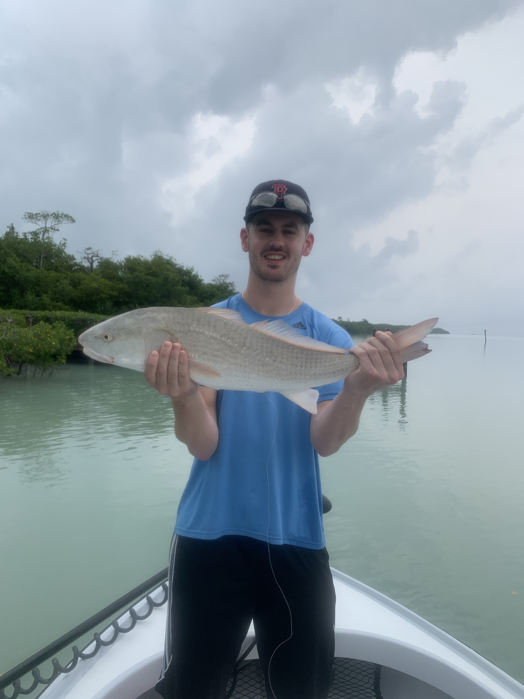

Pic: Nick didn't mind the rain catching lots of redfish and snook with Capt Matt Mitchell this week

Changing it up for success

Even though Tarpon fishing is in full swing getting a decent calm weather day that will give you a chance to locate these fish by sight seems to be extremely tough. Strong winds from the south had us quickly changing plans and targeting snook and redfish instead. No matter how bad you want to tarpon fish there are just some days when mother nature makes it next to impossible.

Big flood high tides driven by southerly winds made for the perfect set up to stay close to home and mangrove fish. Pitching live shiners up close to the mangroves we caught lots of snook and redfish. Such massive high tides gave us lots of options to fish the many wind blown shorelines right around St James City. Many of these islands are not usually accessible during anything but a giant tide. Bouncing from shoreline to shoreline this bite just kept going with never more than a handful of fish coming from any one island. Picking out the indentations and points gave us the most success and kept us busy and my clients smiling.

Another great option during what was a windy week was to fish in and around the passes. Some days this bite was amazing while other days we never had a bite. With approaching storms over the weekend I opted to start a morning trip in the pass. Light rain and storms pushing in from offshore made for one of the most wide open bites on snook and redfish I can remember in the past few weeks. For over three hours during the incoming tide we caught fish after fish both on pinfish and shiners.

With what looks like another week of disturbed weather ahead all we can do is hope we get a few windows of flat water to target tarpon. Luckily anglers will have plenty of other options if the tarpon do not pan out. My daily plan is to bring gear for a multitude of species. We will start out chasing tarpon and if they do not cooperate we will quickly go to plan B.

