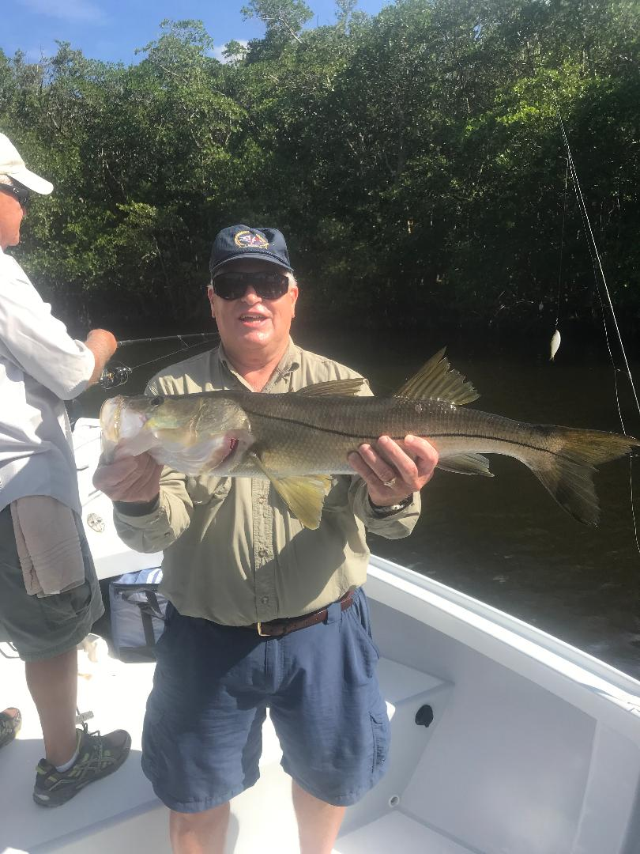

Pic: Chuck Johns from MO with a 30inch Snook caught and released with Capt Matt Mitchell this week

Beach fishing frenzy.

The first cold front of Fall blew threw over the weekend bringing Northwest winds and dropping temperatures. This much awaited end to our summer heat and humidity will kick the southbound annual bait migration into even higher gear. The amount of life both out on the beaches and through the sound will only continue to improve with the passing of these next cold fronts. This change of season is the transition time for both our migratory species along with our resident species to pack on weight for winter. The next few months or until water temperature drops below the low 70’s brings some of the most wide open fishing of the year.

Out along the beaches this week the action was nuts. Tarpon, sharks, mackerel and many other species worked tight packed bait schools often feeding right on the surface. Seeing rolling tarpon all around the boat that ate almost whatever you pitched at them was amazing. Feeding frenzies of sharks splashed around right on the surface, this is what our fall fishing is all about. During calm or east winds locating these fish frenzies out on the Gulf side is just a matter of running until you found feeding birds. After you find these fish you can often stay with them for hours and then return for the next several days to the same general area. Most of this action was within a few hundred yards of the beach. The best bite for me came while free lining large shiners threw the activity to jump tarpon and catch sharks. Ladyfish, mullet and even plugs and jigs also caught these fish.

Once you locate the action move into the area slowly,. you don’t want to motor right into the activity as not only will you spook the fish you mess it up for anyone else. There are plenty of fish out here so keep a good distance from the other boats and everyone will get a shot at them. There is nothing worse than having another boat just out for a ride run right through the pack and the fish and put them down.

Back in the bay the Snook bite continues to go off. In the past few weeks I don’t remember catching so many slot sized Snook. The tide pattern this week has been low water so I have been setting up in deeper mangrove holes and shorelines. Chumming a few live shiners quickly lets you know if you are in the right place. The bigger mangrove snapper we enjoyed all summer long seem to be about done and are getting tougher by the day. On windy days I’ve been taking a few shrimp which have caught redfish, Sheepshead and even a few black drum.

As the winds lay back down after this cold front I cannot wait to get back out on the beaches and enjoy some of the best tarpon fishing of the year. Some years these fish stay as late as Christmas it just depends on when it gets cold and they migrate out. Get out and enjoy the frenzy while they are still here

