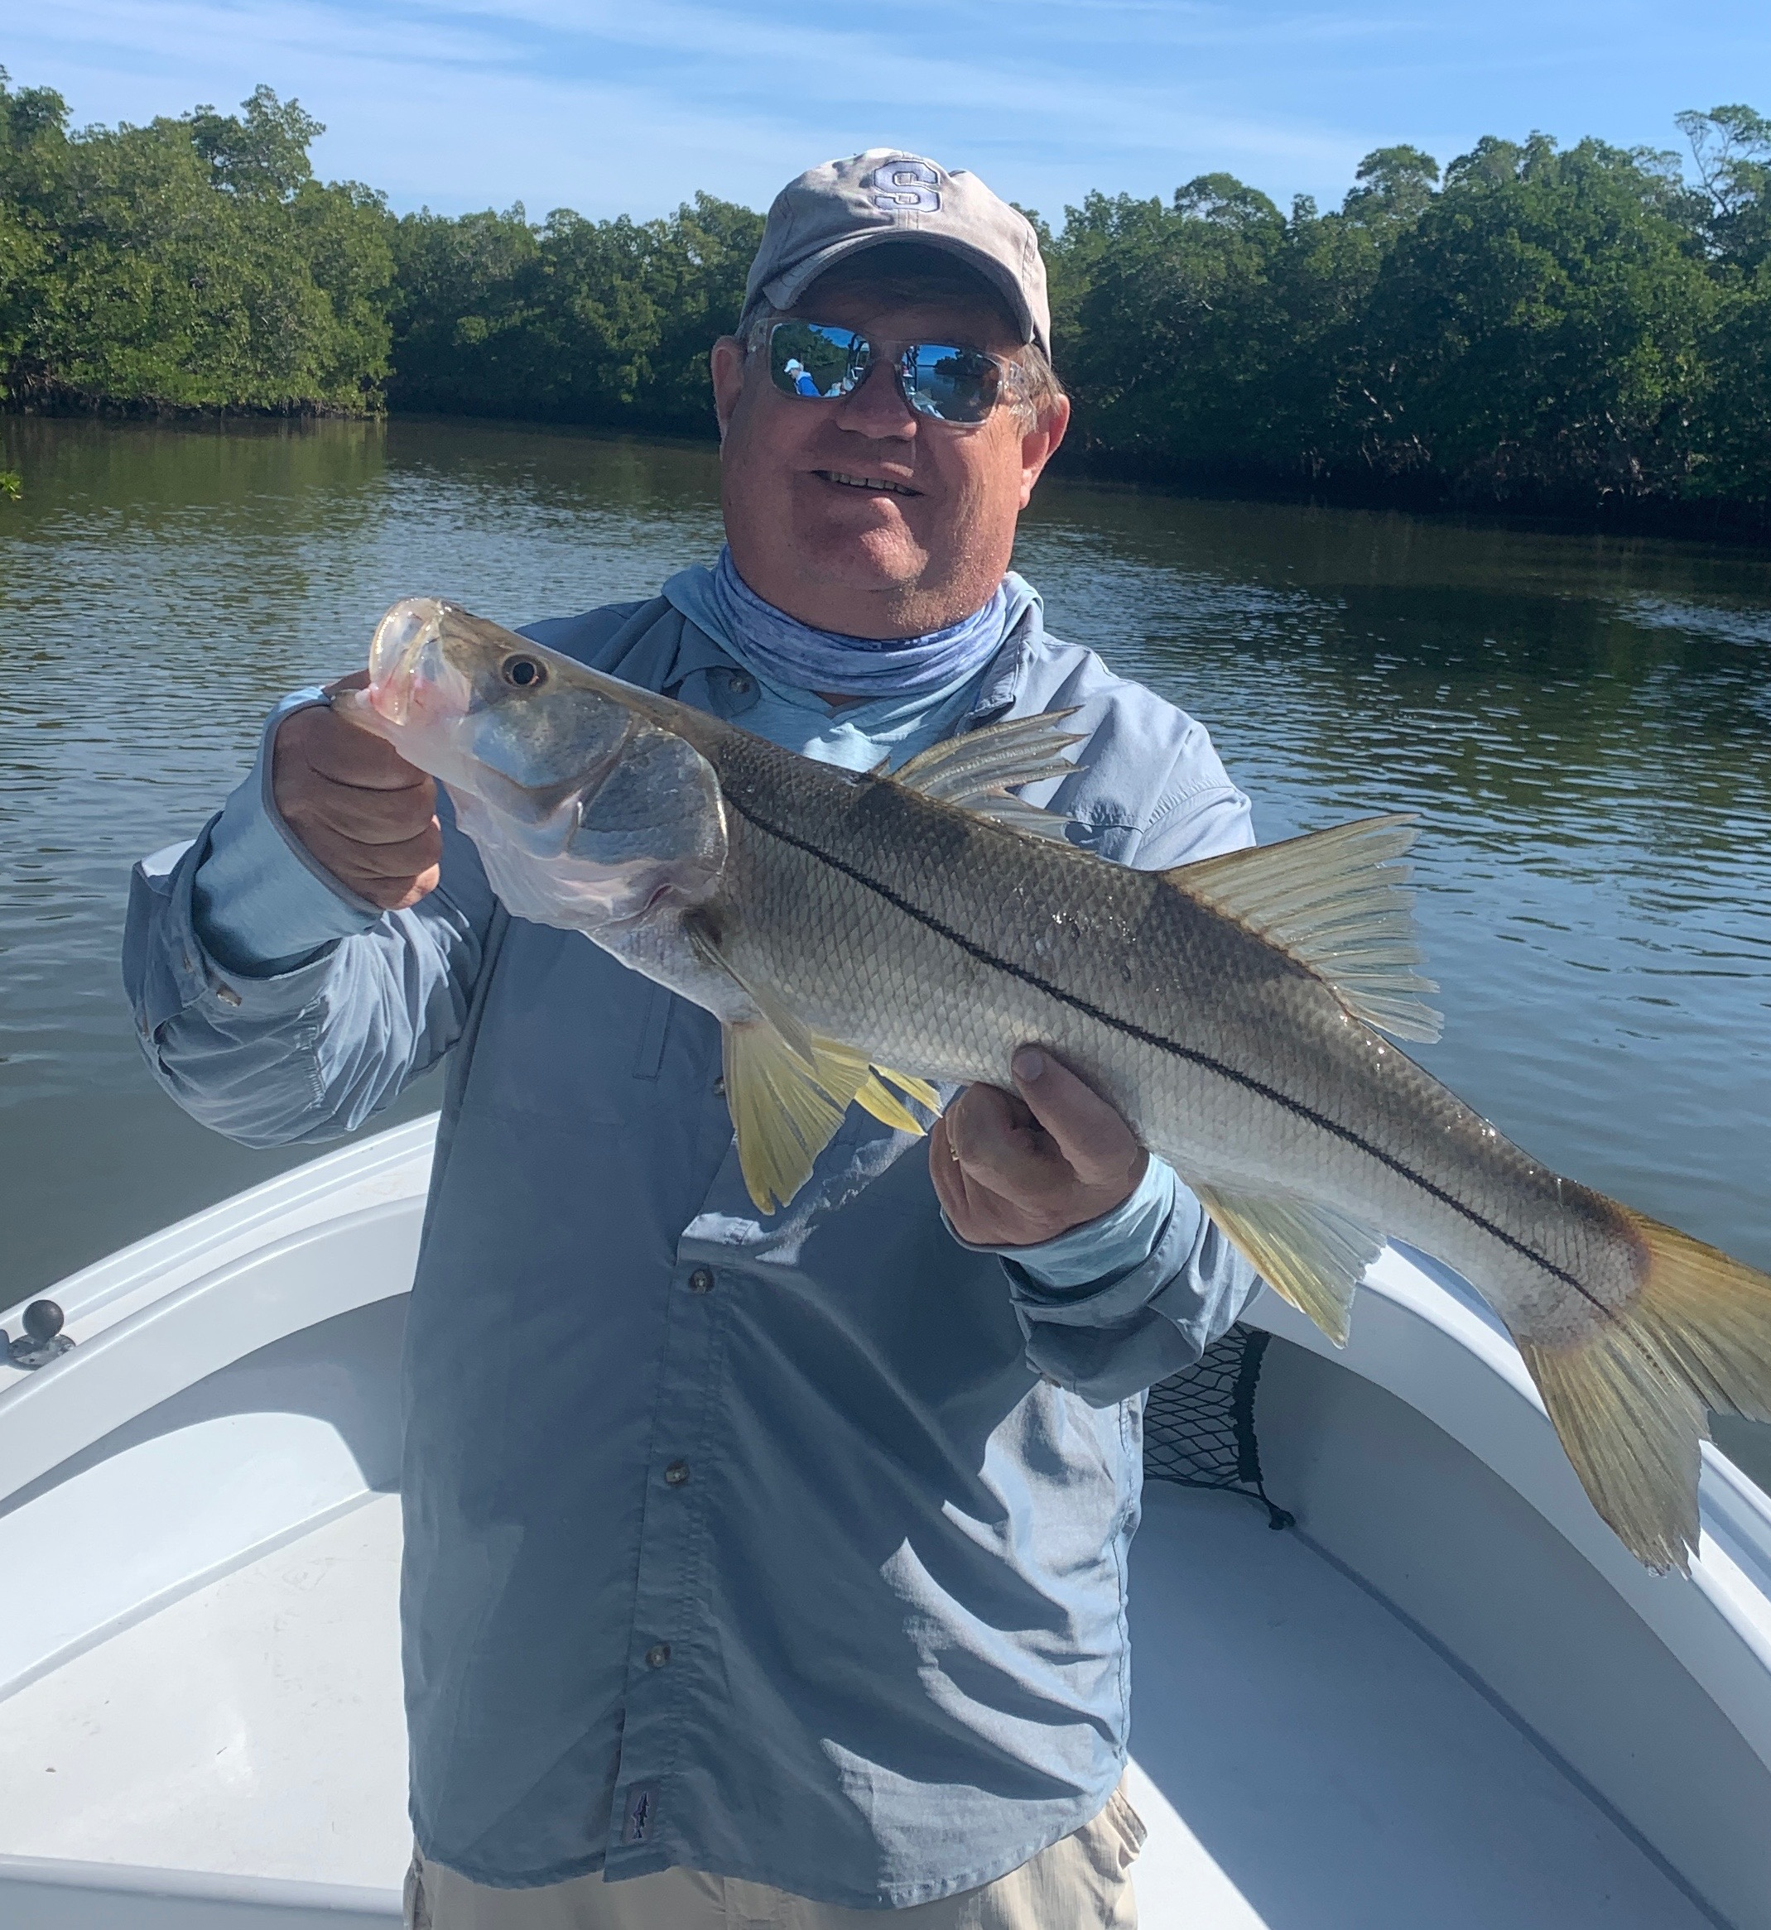

Bad weather-Great fishing

Pic: Long time client Kevin Murray got in on the wide open snook bite while fishing with Capt Matt Mitchell this week.

Our winter weather has been unpredictable to say the least. Last week over a 5 day period we had dense fog like pea soup, gale force wind gusts and even a few extremely cold mornings in the upper 40’s. Despite this weather roller coaster our fishing has remained very consistent. Snook and redfish fishing has been amazing and earlier in the week I even located some of the best big sheepshead action so far this winter.

Mangrove creeks in the southern sound gave my clients some wide open snook fishing. I found these fish early in the week and returned to them during the low incoming tide for days. Several favorite creeks had hundreds of laid up snook of all sizes. All it took was a live well full of shiners and we kept the rods bent. Most of these snook are between 18-24 inches though most trips we have had a few right around 30 inches. Whats making these snook feed non stop in cold water I do not know.

Along with the snook we are also catching redfish. The better redfish bite has been on the mangroves around the passes. Days of catching a dozen or more ranging from 20-30 inches have been pretty common. Live shrimp fished on the bottom has been the bait of choice for these fish. Several times this week while targeting sheepshead on docks throughout the sound we have also come across good redfish.

For clients looking for eats I finally found some larger sheepshead. While riding docks on my tower I found a series of docks that for no apparent reason had large schools of sheepshead ranging from 14-20 inches. Watching these fish rise up and down in the water column they were still not easy to catch. We would catch a few on each dock before the bite shut down and we had to move to the next dock. Most trips we harvested 6 or more quality sheepshead.

Operating a boat in the fog is always less than ideal and a white knuckle experience. Not being able to see more than 50 yards really heightens your senses. I choose to stay as far away from the intercostal water way as I possibly can to avoid any other boats. Using and trusting your navigational electronic’s is a must, no matter how much it can feel like you are going in circles. Having a few saved tracks you can trust makes things much easier. Sea fog can blow in at almost any time of day and is no fun to navigate through.

