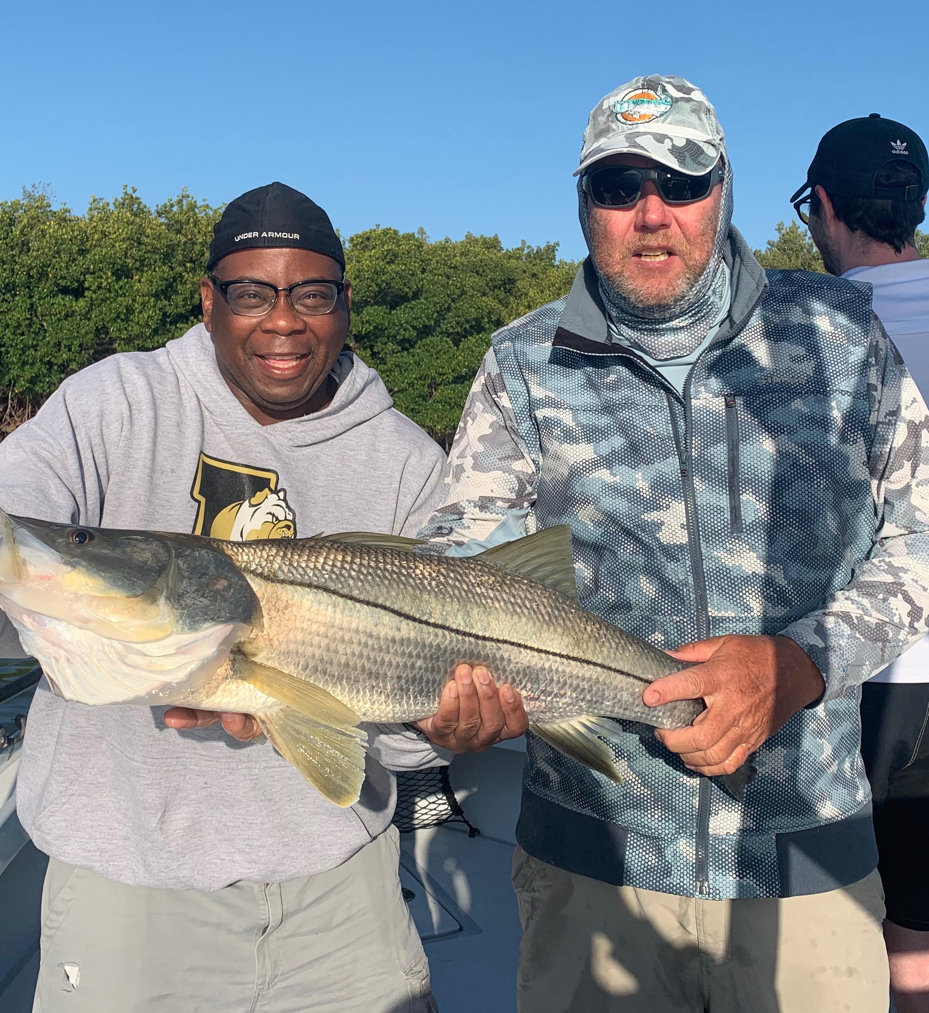

Pic: Ben from Indianapolis with his first salt water fish a 40 inch snook.

A week of firsts

No matter how long I guide I continue to see things happen that simply cannot be scripted. Spending over 300 days a year on the water it just never gets old. Nature is full of surprises and things that happen when you’re out on the water never fail to disappoint.

While fishing crystal clear water over the past few weeks we have been on the most non stop spawning sheepshead bite I may have ever seen. Sight fishing these schools of hundreds of fish is as good as this fishery gets. As the week wore on the average size of this fish slowly began to decrease though the action continued to be as fast as you can put a bait on a hook.

Fishing with clients from Indiana early in the week one of my regulars Larry had brought both his future son in-law Lloyd along with his employee Ben who had never salt water fished. Returning to a shoreline I had done really well on the day before I was a little chaffed one of my other boats had beat me there. First bait, first cast Ben hooked a giant snook that screamed 50 yards off the reel and went up under the other boat which was anchored up near me. My other boat was quick to react and backed out before the big snook could break off. After a few minutes a monster came to the landing net. Ben’s first saltwater fish was a 40 inch snook. You just cant make this stuff up.

Mid week we had approaching weather and strong south winds which always fire off the bite. Hiding from the wind the first stop that day only resulted in a trout on the first cast. Though the second cast we hooked and somehow landed a 40 pound tarpon. What made this a really amazing catch was the fact it was caught on a medium light rod with 15# test line and a 1/0 hook intended for snook. After a few laps around the boat and lots of crazy jumps I managed to get a leader touch before the tarpon broke off and swam away. Like I said some days just cannot be scripted!

