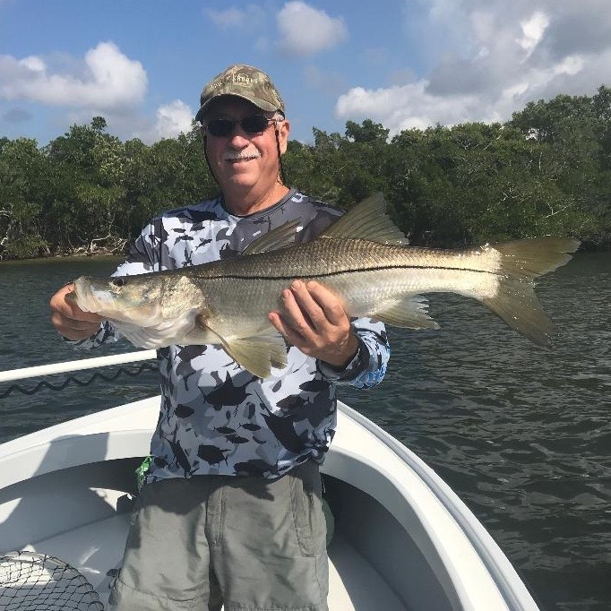

Picture: Gary Biltgen with a big snook caught while fishing with Capt matt Mitchell pre cold front.

A few hours can make all the difference.

Things can and do change by the day or even hour when it comes to winter fishing in SWFL. This up and down pattern is typical this time of year making timing everything when it comes to catching certain species of fish. This week we experienced some of the best catch and release snook action in the days just prior to another strong cold front moving through. During the periods of south wind as a front approaches our snook fishing can be as good as it gets. This proved very true with back to back days of catching several snook over 30 inches along with lots of other snook.

Then the first day after a cold front we are blasted with strong northerly winds and cold morning temperatures. With our low temperatures in the high 40’s behind this last cold front along with gusty winds most anglers stayed off the water for at least one full day before temperatures gradually improved. Plummeting water temperatures brought our wide open snook bite to a complete halt in just a few hours and making our fishing all about sheepshead and drum for the next couple of days.

Fishing with one of my oldest clients Nick Basilio and his son visiting for a few days from PA this week we where faced with a morning trip during the passing of a cold front. With this being the only day they where able to go on the trip my expectations where a little low due to the weather. Hopefully our water temperature would hold in the low 70’s for at least a few hours so we could catch snook close to home hiding from the 20-30 mph winds.

Working in our favor though was a extreme low tide which bunches these snook up in deeper warmer water. Heading out in the dark to get shiners it was rough and you could noticeably feel the air temperature was falling. After chumming for about 15 minutes the bait came easy enough and with a blacked out live well I suddenly felt much better about our chances of having a decent trip.

Hiding in deeper mangrove sheltered channels around St James to stay out of the direct wind we caught over 50 snook on the 4hr morning trip. Along with the snook up to 26 inches we caught Jacks of all sizes, small grouper and 5 keeper mangrove snapper. As the morning continued to get colder by the hour at roughly 11am the water temperature dropped below 70 degrees and the snook just stopped feeding. A few hours either way during these passing cold fronts of winter can make all the difference in the world. The pattern of weather ups and downs will continue all winter long and requires the juggling of trips around the arrival of weather events to keep everyone happy.

