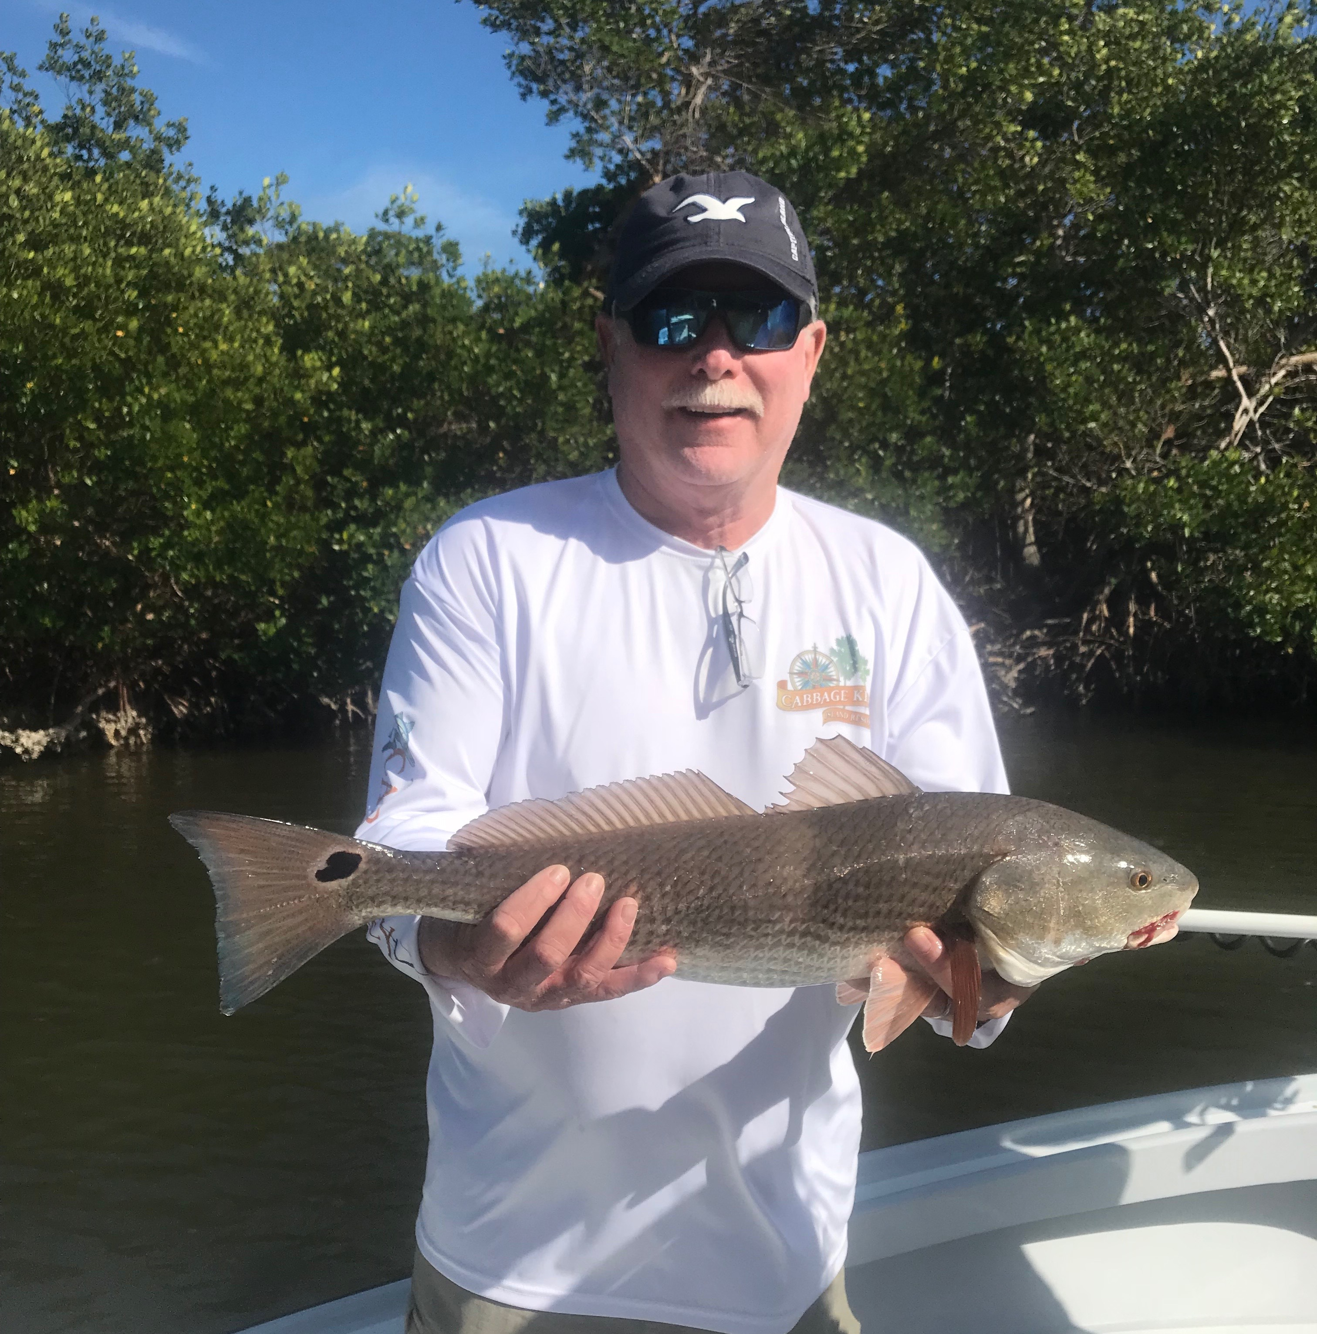
Picture: Mike Bennett with a 25 inch redfish caught while creek fishing with Capt Matt Mitchell this week.

Windy weather duck and hide.

Days of blustery strong winds made it rough going out on the water for what seemed like the whole week. Although I did not cancel any scheduled charters making any long open water runs was just not a option. The southern end of the sound offers anglers plenty of sheltered places to fish and have a successful day no matter how strong the wind blows. Once you make it back into the mangrove creek systems you have no idea that its gusting 30mph plus as the water is clear and the fish are biting.

Sheepshead, black drum and redfish proved to be the best action this week while hiding back in the deep water mangrove creeks. No one place was on fire even though everyday we went home with a cooler of keeper fish it took persistence, patience and moving alot at times. Non stop action on a great mixed bag of smaller fish is not a bad thing you keep getting a keeper now and again. I don’t remember in recent years ever catching so many black drum as we have this winter. I recently had to pull up the FWC regulations on my phone to see that it is a 5 black drum per angler max as we took home 7 on one trip up to 21 inches. Black drum from 15-20 inches are excellent table fare, plentiful and a fun fish to catch.

With a full moon January 31st and another big cold front forecast for mid week we will get another large push of pre spawn Sheepshead moving into the sound. February is the best month to catch big Sheepshead and this will play out again this year. Last week during the super low tides I found some sunken palm tree’s and other submerged post Irma structure in deep mangrove creek systems that have been a Sheepshead honey hole now for days. So far unlike in years past I have been doing better deep in the mangrove creeks than on the docks and jetties around the passes to catch keeper sized Sheepshead. Much of the open water structure in the sound is holding some larger Sheepshead but until the wind lightens up its just been to rough to fish.

With our water temperatures still in the low 60’s our Snook bite is still almost non existent. Even after catching great shiners all week I was never able to catch more than a few Snook on any given day even though I could see them stacked up in the places we fished. Live chumming would not even get a single Snook to pop a bait on the surface when set up on dozens of fish in dead end creeks and canals. Working some of my favorite cold water Snook spots was extremely frustrating when you have a whole livewell full of shiners and no Snook will play. A few trout and ladyfish did eat the shiners but it was just not worthwhile adding a few hours to your day to catch shiners.

In years past I remember catching Snook all winter long and even when it did get really cold water temperatures quickly rebounded and we never went more than a few days without being able to get on a good Snook bite. The prolonged cold this winter has totally shut our catch and release Snook fishing down since January 1st. Each time another cold front is approaching I think the Snook may turn on but this has just not happened yet. Luckily we have lots of other species of fish we can catch during this colder than normal winter that we are dealing with.

