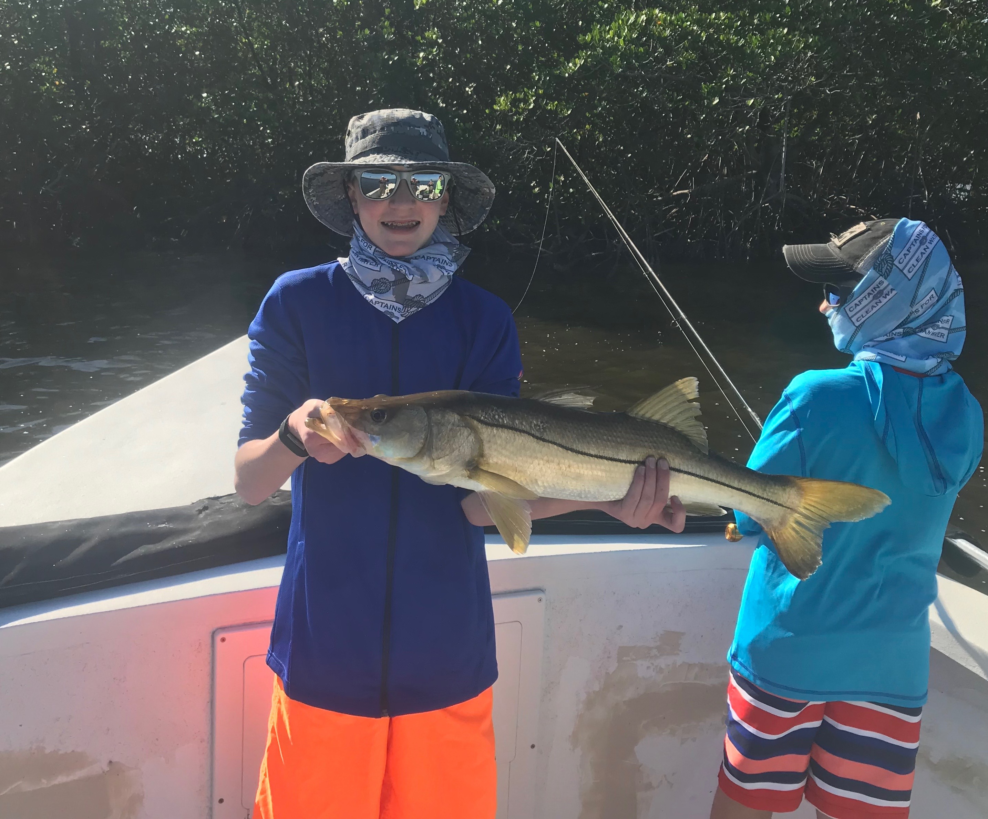
Picture: Trey McGuire with his 30 inch Snook caught while fishing with Capt Matt Mitchell this week.

Great gator trout bite is happening.

Snook and trout where my target species this week with my clients having success on both species. Most of the Snook we have been catching as usual are running on the small side of the 28 inch slot although we did manage a couple of keeper sized fish this week. Catching lots of undersized Snook is always great for anglers of all experience levels and you just never know when you will hook into that much larger fish that will give you a run for your money.

With water temperatures slowly creeping back up the better bite has been in the larger deeper creek mouths of the Ding Darling and even out on oyster bars in the middle sound. Once you locate these Snook this bite can be wide open while casting live shiners. Minus low tides are my favourite time to target Snook in these deeper creek mouths as they can often stack up in crazy numbers. Look for the best action to come in these creek mouths during the last of the outgoing tide and the first part of the incoming tide. During higher tide periods it’s been hard to beat the bite on oyster bars and potholes around them.

Some of the best big trout fishing of the year has been going on for the past few weeks in the southern sound. Usually I do very little trout fishing unless I have clients who request it but for the past few weeks I’ve been on such a non stop big trout bite I’ve been doing it almost every trip when I my clients are looking to take fillets home. Many of the sandholes in the shallow grass flats in the southern end of the sound are loaded up with some of the largest trout I catch all year. This same trout bite has played out in these same area’s for the past several years with lots of trout over 20 inches coming out of sand holes in less than 2 feet of water.

Trey McGuire while visiting his grandfather caught the big Snook of the week on my boat a 30 inch model. After having a pretty slow start to our day Trey caught the memorable Snook while fishing a deep channel during the first part of the incoming tide. Trey has caught lots of snook while fishing with me over the past few years but this was by far his largest yet and was sure to put a big smile on grandma’s face for dinner that night.

Manatee zones in Pine Island sound came to a end November 15th allowing faster access to many of the islands and channels that we have just not been able to fish since April. Many of these shallow grass flats in the southern to middle sound offer some excellent big trout fishing and are awesome places to get out of the wind during the next few months. With our warm water temperatures still there are still lots of Manatee’s around so keep your eyes open while running these shallow area’s.

