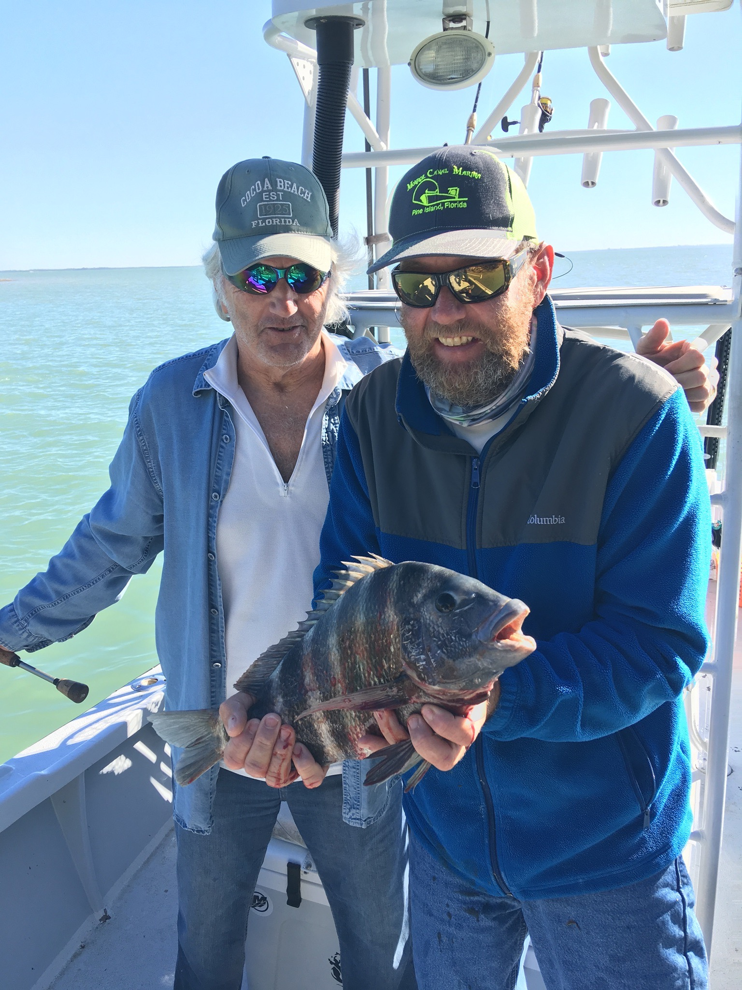
Picture: Ray Salassa with a Sheepshead caught while fishing with Capt Matt Mitchell

Fish don’t have a calendar

With the month of February coming to a end it’s hard to believe the difference we have experienced in weather conditions between January and February. January was one of the coldest we have ever dealt with. Extreme low water temperatures flirted on the edge of us having a cold water fish kill. Then from this extreme cold we went right into only what can be described as a February heat wave with temperatures in the mid 80’s for almost the entire month pushing our water temperatures to the mid 70’s and tricking the fish into a springtime pattern.

After spending most of my life on our local waters fishing I cannot remember a winter that has played out quite like this year has. With our fish not carrying a pocket calendar around with them and only going on what the water temperature does for a time line they have kicked into what I can only describe as a April like pattern. Watching boats set up cut bait fishing for early season tarpon while other anglers target sheepshead is just baffling. So far this year it feels like we have just skipped right over February and March. Although this pattern could quickly change with a few strong March cold fronts it just feels like this warming trend will only continue.

Finding shiners with any kind of consistency has been tough the past few weeks. Warming water has pushed the bait from the deeper water around the bridges and out onto the flats and along the beaches. During calm periods or periods of east wind bait has been caught along the beaches. Chumming out on the grass flats has also been a option for shiners although they have not been easy to come in the huge numbers we like to see this pattern is typical of April and not February. Catching these shiners has been the key to a good day of Snook or trout fishing so its been worth grinding it out to give my clients a chance at a good fish.

Once you have enough shiners to go fishing its been all about catching snook. Mangrove creek mouths with strong moving current have been a good choice. Look for a creek mouth where the wind and tide are moving in the same direction. Deep in these creek systems along with any deeper shoreline in between has also been a good place to search out that Snook. Most years past the March opening of Snook season is really no big deal as water temperatures are just too cold and its generally not a good Snook bite until April. This year its going to be a little different with the unusually warm water temperatures the Snook are hungry and feeding. As temperatures stay warm start looking for Snook to show up in and around the passes too.

The Sheepshead bite continues to be good with bigger fish being caught on docks and pilings around the passes and in the larger bays. During periods of slow to no tide movement these Sheepshead kept the rods bent when no other species would feed. Even has we have had strong mid day winds its been relatively easy to get tucked away and catch these Sheepshead. Having so many fishing options in February is never a bad thing.

