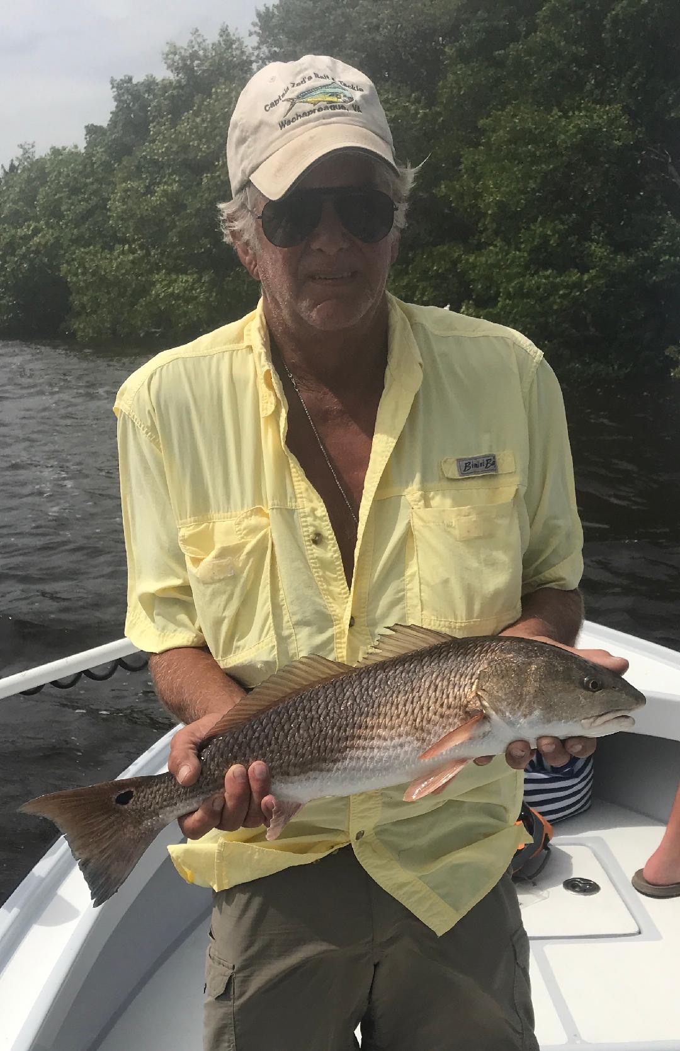

Pic: John from Maryland with a redfish he caught and released this week while fishing with Capt Matt Mitchell.

Zero red tide

Finally, two good news stories about our water this week: For the first time in almost a year FWC reports Lee County is red tide free and the long awaited Water Resources Development Act has been authorized by Congress which is the first step in returning the natural flow of water south to the Everglades.

Finally, some positives after poor water management supercharged a giant 150-mile red tide bloom we dealt with on and off for almost a year. This red tide did major damage to our environment killing many of our marine mammals, turtles, fish and crippled local businesses. This Act passed by Congress is only the first step and a reminder to everyone that we have to stay involved and keep on the right path to fix this water quality issue once and for-all.

As Hurricane Michael luckily skirted by us mid week conditions where windy and rough. Strong winds kept most off the water until at least the end of the week when things finally calmed down. Catch and release snook fishing on either side of this weather event was outstanding on the few days I did manage to make it out. Snook of all sizes are being caught at almost every stop. Along with this crazy fall snook bite we also managed a few redfish and limits of keeper sized mangrove snapper. Jack Crevalle and Ladyfish have been all over the sound and easy to locate by just finding the birds. The above normal high tides brought on by the passing Hurricane proved to be the perfect set up to fish both Mangrove shorelines and Oyster bars.

Both bait fish and feeding birds have returned to the sound in huge numbers. Causeway bridges have just started over the past few weeks to load up with shiners like they do every fall. With so many shiners around its been possible to live chum for the first time since Spring. This live bait chumming quickly lets you know if the fish are hungry as they explode on the surface. Free lined shiners are the goto bait all Fall until the water gets cold which hopefully won’t happen until at least January.
Hopefully this clean bill of health we just received means we can all get back to work after the slowest summer anyone can remember. Not only are the fish out there they have had very little pressure on them. Add in cooler Fall like mornings and its a perfect time to go fishing.

