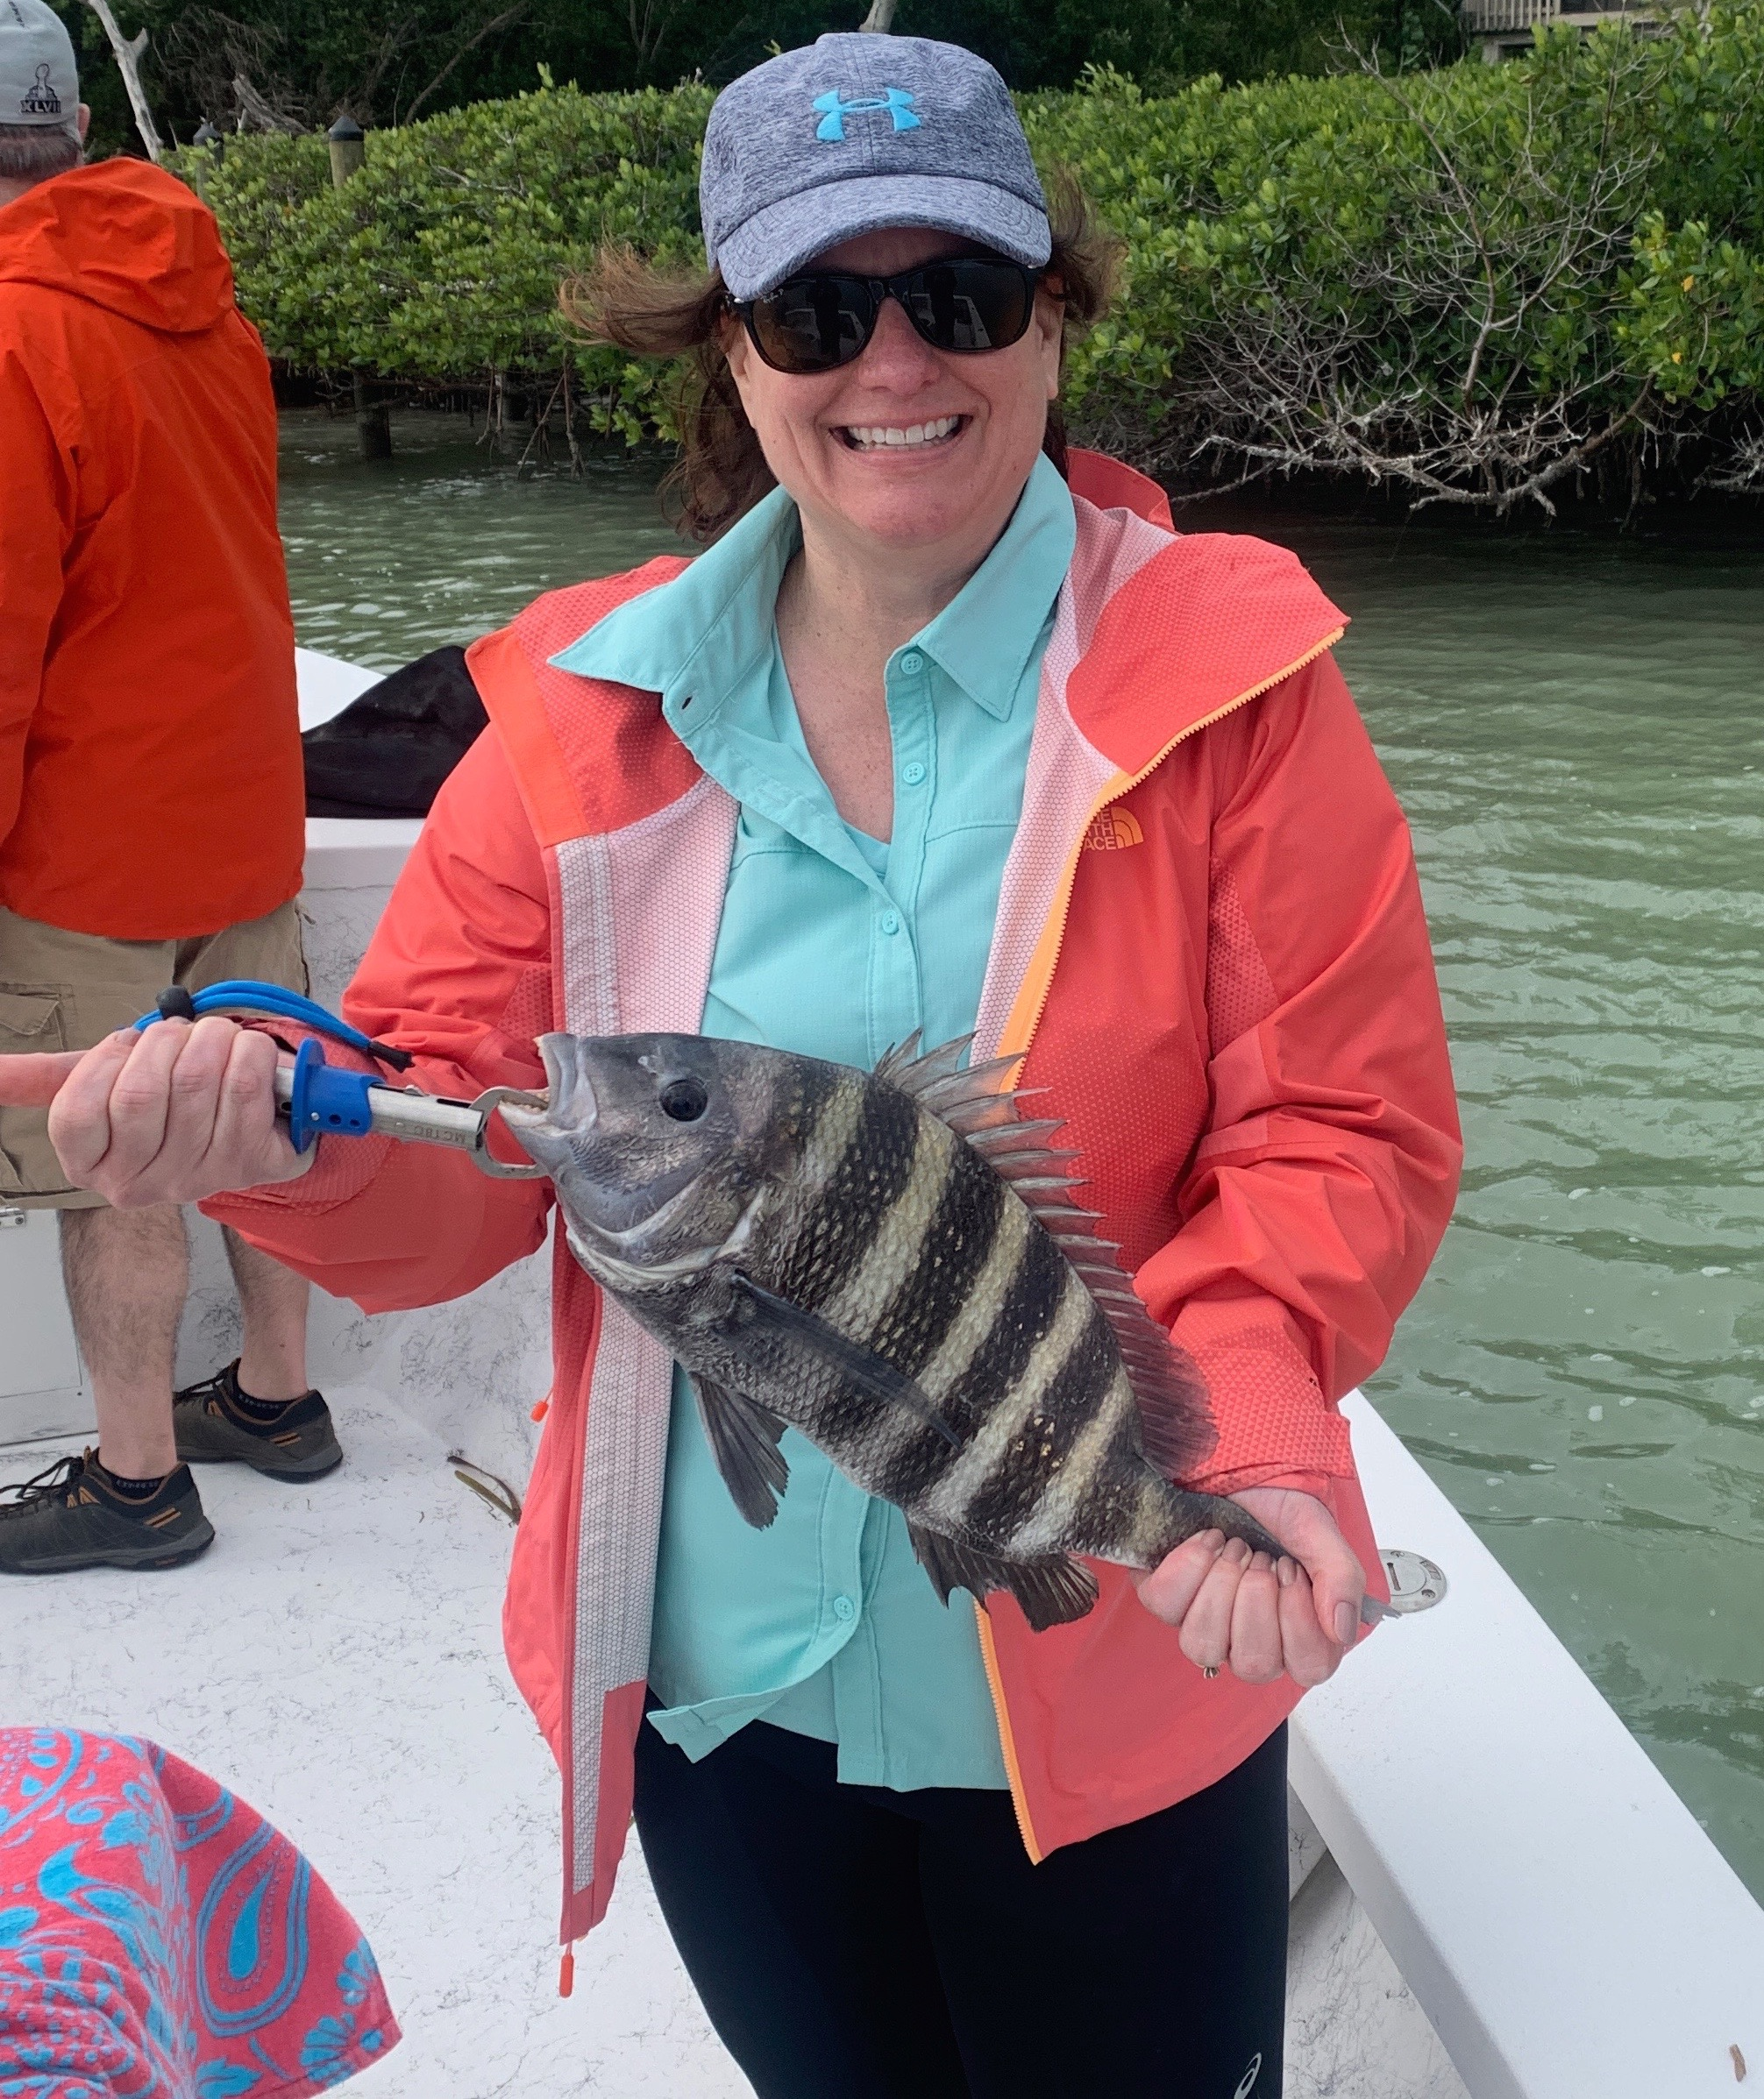

Pic. Laura Basilio from PA with a sheepshead caught while fishing with Capt Matt Mitchell this week

Winter weather swings

What a difference a few days made. Early this week I was catching shiners and enjoying some of the most wide open snook fishing I can remember in recent months. Then only two days later after a major cold front it was all about shrimp fishing and catching sheepshead. Though this is typical of our winter fishing pattern in south Florida this week it just seemed more extreme than usual.

Since our last cold front more than a week ago now the water temperature has slowly crept back into that magical mid 70 range bringing snook fishing back to life. After a major temperature drop water in the bay plummeted to 65 degree’s shutting the snook bite down and giving us a major push of sheepshead. Clients finally got to enjoy some meat fishing for sheepshead with some big spawning models caught in and around the passes.

Shrimp and chunks of shrimp fished on a jig heads around docks and basically any structure close to the passes caught sheepshead up to 19 inches. Along with the sheepshead we also caught lots of redfish anywhere from 16 to 26 inches. Fishing with long time client Nick Basilio twice in just over a week he got to enjoy both great snook fishing and the best sheepshead fishing so far this winter.

Several times over the past week we had an unusual catch of Cubera snapper. These fish which look a lot like a mangrove snapper at first glance have slightly different markings which resemble faint stripes and have many more teeth. I don’t ever remember catching this species before. Other Captains also reported catching a few of these Cubera snappers in the sound this week. After looking at the FWC regulations the minimum size is 12 inches.

This time of year major weather changes can occur almost daily.
Knowing what species to target and where you can do it out of the wind will make all the difference of being successful. Don’t let the weather intimidate you there is always something out there waiting to be caught.

