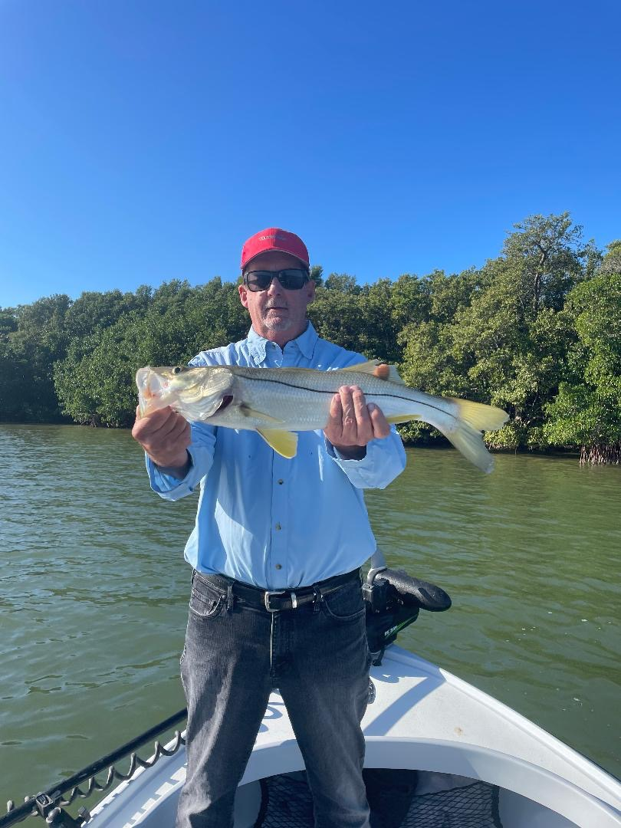

Pic: Nick Little enjoyed some snook action right before the cold front fishing with Capt Matt Mitchell.

Winter arrives

A strong line of thunderstorms associated with a major cold front crashed through over weekend announcing the arrival of winter. After what has been a relatively mild winter so far unfortunately it’s now time to break out the cold weather gear and the shrimp if you plan on being on the water.

Many of our clients this time of year are from much colder places than here and show up to fish in all that can be described as beach attire. It’s always better to have too much clothing than not enough when heading out on the water. It’s a good idea to bring layers of clothing to ensure that you will be comfortable when making runs across the open bay. Once tucked away and out of the wind take it off and enjoy the sun.

This seasonal change of weather will drop water temperatures drastically and will put the fish where they should be this time of year. With such amazing weather until now water temperatures have stayed warm and the fish have been a little scattered. Falling water temperatures will give us a big push of spawning sheepshead moving in from the gulf.

Shrimp are the must have bait during our cold-water periods. They are extremely versatile and can be fished an endless number of ways. Better still, they are easy to get at just about any bait/tackle store. Keeping them alive is as simple as using a bubbler in a bucket. At the end of a day’s trip. I even save my left-over shrimp in a Ziplock bag on ice and use them the following day as chunks.

All varieties of fish eat shrimp. When targeting snook fishing I either free line them or hook them through the head on a jig and slowly bounce them across the bottom. During the coldest periods low and slow against the bottom will be most productive. Use live shrimp under a popping cork both out on the flats for trout or up against the mangroves for redfish. During the coldest temperatures the go to bait for me is a chunk of shrimp threaded onto a 1/4oz jig head.

