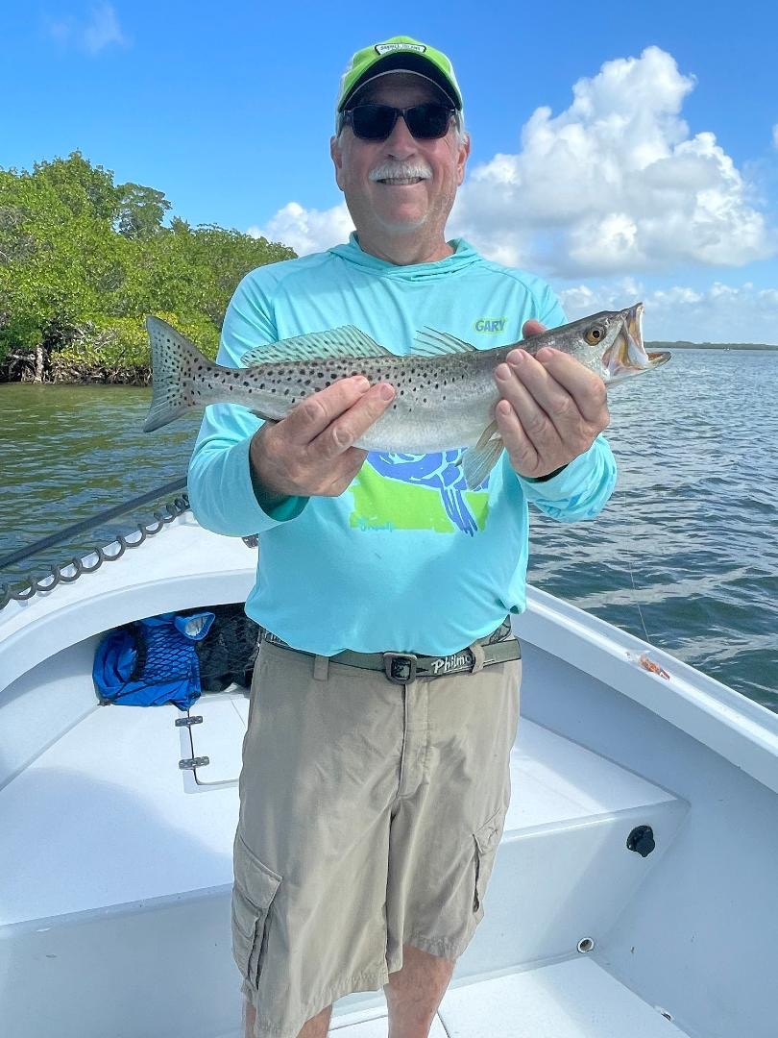

Pic: Gary Biltgen with one of many trout caught while fishing with Capt Matt Mitchell this week

Trout indicate clean healthy water

After what was one last cold front, we experienced all that can be described as a very quick rebound with fishing improving in only a few days. Now that we have officially entered Spring hopefully that’s it for cold until next winter. Spring is always one of the most exciting times to be out on our waters with not only the Tarpon migration kicking off but Snook fishing kicking into high gear as they begin their annual spawn.

After the big blow and a few cold mornings bait returned to the flats and we are right back to shiner fishing again. Over the past few weeks, I have been returning and retargeting places that I have not fished since before our devastating red tide of 2017/2018. It’s amazing that these places that were void of fish for several years are now right back to holding lots of fish. The one true tell-tale sign of the vast improvement in water quality has been the number of trout we are catching almost everywhere we fish. From mangrove creeks to passes and of course the flats trout are all over in big numbers with an average size over the 15-inch minimum.

For as long as I can remember trout where always that fall back species that could be caught almost no matter what when the snook and redfish would not cooperate. Or if you had kids on the boat looking for fast paced easy action, they were the go-to.

After the catastrophic red tide event they were simply gone. We just did not see trout in any kind of numbers for years and Trout and being a very delicate fish, they took the worst hit from the red tide of any species.

Now fast forward basically 4 years and these fish are back in huge numbers. Flats I had given up on are now loaded once again. Healthy trout can be found on every glass flat throughout the sound. Clean clear water and healthy grass flats are the main reason for this vast improvement we have witnessed in this fishery. After so many years of not having these angler friendly fish in the mix it sure feels good they are back.

