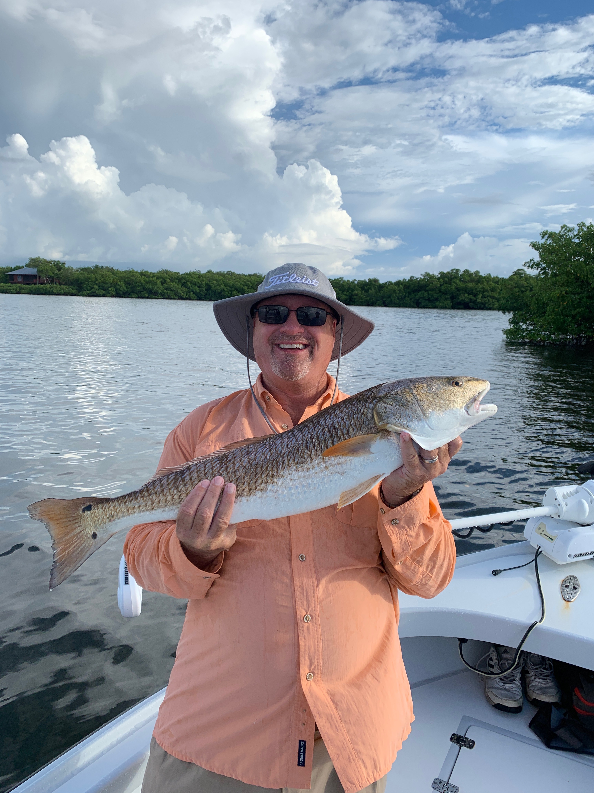

Pic: Paul from Jacksonville caught this 32 inch redfish while out with Capt Matt Mitchell this week

Trout fishing is back

Dodging morning coastal showers most of this week we bounced around between mangrove fishing for snook and reds then getting out on the flats and wearing out the trout. Slow moving rain was often hard to avoid though most days cloudy over cast days where a nice break from the heat of summer. Along with non stop trout action out on the flats we have also been catching mackerel. jacks, ladyfish and mangrove snapper in the mix.

Big early morning high tides have been the perfect set up to fish mangrove islands in the southern sound. Seems the islands in the southern sound to the mouth of the river that have tannin stained water have been the most productive for both snook and redfish. As the tide gets lower the bite has switched over to the many of the mangrove creeks in these same area’s that have super fast water flow.

The amount of life that has returned to the sound since the massive red tide of last summer which was less than a year ago has to be seen to be believed. In what has been just a few weeks we went from catching very few trout to trips of catching 50 plus trout. Many of these trout are well over the 15 inch minimum along with several each trip going over 20 inches. The question we are all asking each other is where are these trout pouring in from after what was a catastrophic event for them. For basically 10 months we just did see them let alone catch them now we are specifically targeting them for great catch and release action.

Catching trout in the sound has been as easy as finding birds feeding on the massive schools of fry bait. Small live shiners free lined and slowly worked back towards the boat caught fish after fish. Anglers are also catching them on a wide variety of artificial lures including soft plastics and top waters. I have been fishing on shallow flats in 2-4ft of water anywhere from the south end of Matlacha pass all the way around St James city up to red light shoal. One possible theory to the reappearance of these trout is that they have followed the huge schools of baitfish into the sound. We can only speculate what has brought all these trout back into our waters but one thing is for sure its amazing to see mother nature come back so strong.

