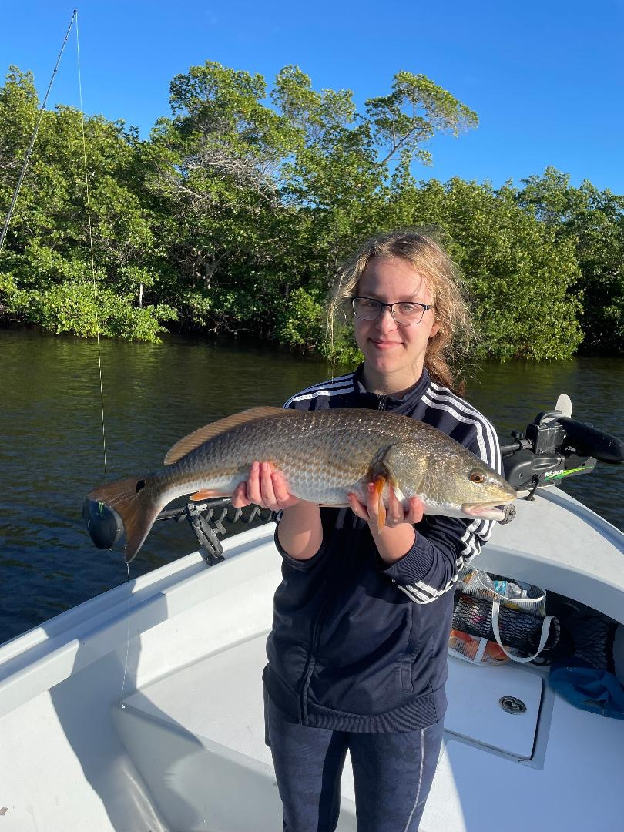

Tropical Christmas

Pic: Izzy from Chicago got in on the Christmas week action with a quality redfish.

Christmas week turned out to be yet another a fabulous week on the water. After what was a brief cool down a few days before temperatures along with great fishing action quickly rebounded. As guides we refer to the week between Christmas and New Years as “ Hell Week” it’s quite possibly the busiest week of the year.

Day time low tides proved the set up to fish deeper mangrove channels for snook. Clients did manage a few bigger snook though most of the action came on fish in the 20–25-inch range. The last few hours of the outgoing tide brought the best bite on the larger fish. With the tide being so low these larger fish often ate right in the middle of narrow channels. One real surprise while snook fishing this week was a 24-inch sea trout we caught. This is the largest trout I have seen caught in a long time.

Dock fishing around the sound and the passes provided clients with a few real quality redfish. This bite was best on pinfish rigged with a split shot to get the bait down by the bottom. Although this proved to be more of a patience bite than my usual snook action some of these redfish were pushing 30 inches. This action was also best during the lower tide periods either outgoing or incoming as long as the water was moving.

Deeper creeks in the Ding Darling did give up a few legal sized sheepshead this week while fishing with shrimp on a jig head. Although this action was fast paced the average size of these sheepshead was smaller than the minimum size. Even with water temperatures falling briefly into the mid 60’s it was still not cold enough to really fire off this fishery. Last year our best spawning sheepshead fishing did not happen until mid-February and was done by mid-March.

Patience was the key word while out fishing during Christmas week. With so many boats on the water it was tough at times to get away from the crowds. Even when you did often there is no courtesy as boats will run right by you while you are fishing. Going into season this is just something you have to deal with and getting angry is a waste of time. Most of the time this behaviour is not malicious it’s just lack of common boating sense. Unfortunately, this will happen more and more as more novice boaters head out on the water. Try to give anyone actively fishing a wide birth.

