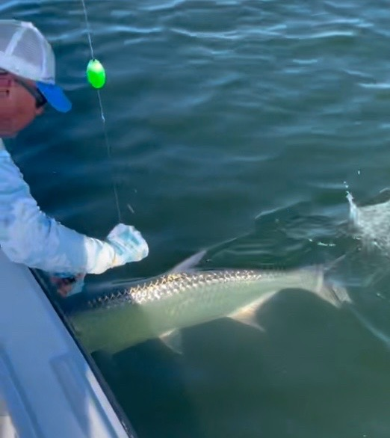

Traveling tarpon

Pic: Connie’s 1st tarpon comes boat side for a leader touch to make it official, congrats!!!!

Finally a week of decent weather gave us some of the best tarpon fishing we have had in weeks. Calm conditions made locating these fish the easy part of the hunt. Sitting in rolling fish in all the usual places in the sound we did manage to close the deal a few times this week. It always amazes me how fast boredom goes to chaos while tarpon fishing.

These tarpon have been visiting our waters in the Spring for millions of years. They use the same places over and over so knowing where to locate them is a big part of the game. Having a route or game plan to find these fish is how the hunt begins. There are not many secret tarpon locations left in the sound as this time of year a pack of boats in open water is usually a good clue.

In the southern sound the deeper finger channels between St James city and Sanibel were a very productive place to soak a cut bait. Catfish tails and mullet heads fished on the bottom seemed to be what these fish wanted to eat. I’ve been giving this area a quick go when starting a trip. Seems if it's going to happen its within a short period of getting the baits out.

Further down the sound the Fosters Point area on North Captiva has had huge amounts of Tarpon moving through. Often these fish seem to be displaying spawning behavior as they daisy chain and simply do not eat. If you put in your time when the switch is turned on these fish will eventually eat. Live pinfish or crabs under a float are hard to beat here.

Moving up the sound the channels that come in from Captiva pass and move north east towards cabbage key also held plenty of tarpon too. This is a huge area and often these tarpon roll right in the intercostal waterway. Although I did not hook a tarpon in here this week I did talk to a few fellow guides who did really well there. Watch for how these tarpon are moving and set up placing a bait in the highway. The best action here came while soaking fresh cut baits on the bottom.

Although tarpon can be easy to locate having common courtesy around the many other boats fishing for them just doesn’t seem that common. Watching boats run right through the pack rather than simply steering around it makes no sense. When fishing around the packs of boats targeting these fish keep your distance and move quietly on a trolling motor or push pole. If you are close enough to recognise people on the other boats you are way to close. Nothing will get you more friends quickly than motoring through a pack of boats tarpon fishing. Better yet move away from the crowd and find some tarpon that are not as pressured and you will probably have more success.

