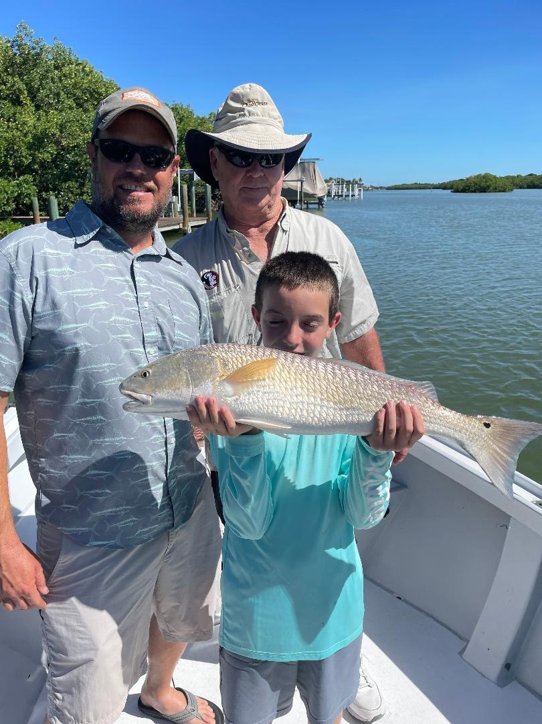

Tips for dealing with our summer heat.

Pic: Luke 9yrs caught this 29-inch redfish to complete his “Slam” while fishing with Capt Matt Mitchell this week.

Summer has arrived and getting out early both to beat the heat and the afternoon thunderstorms is a must. Even at first light our water temperature has been right around 86 while late afternoon it’s been creeping into the low 90’s. Afternoon rains do wonders to cool it off though being out on a boat during these thunderstorms is just not safe.

Like people fish are just more active during the cooler part of the day. During the mid-day heat nothing says summer like an afternoon siesta for both. Keeping hydrated is more important than ever during this heat, for years I drank Gatorade to stay hydrated though recently I’ve started to make the switch to single serving electrolyte drink mixes that you simply add to a bottled water. This really keeps you feeling good even during the most extreme conditions.

Covering yourself up with long sleeves, a mask, sun gloves and hat will help keep the sun at bay and believe it or not make you feel cooler. Fishing clothing technology has come a long way in the past few years. My daily use sun block SPF 100 resembles dry wall paste, I apply a few heavy coats of this to my face and ears before leaving the house. This seems to be the most effective way instead of trying to apply it to a sweaty face with wet hands once you’re out on the water. The only thing worse than getting it in your eyes if forgetting it’s on your hands and reaching into your live well and killing your bait.

Keeping bait alive during this extreme heat also requires a little more effort. First off, I do not pack as many baits in my live well as this hotter water means less oxygen content. Basically, I’m only taking half the bait I usually carry until our water temperature gets back into the low 80’s. A great tool that I use during these conditions is a floating Air head. This is a floating pump that blows straight air into the live well increasing the oxygen level and keeping my baits frisky and happy. The one I use every day is just clipped to one of my batteries and makes all the difference in the world for keeping shiners alive.

