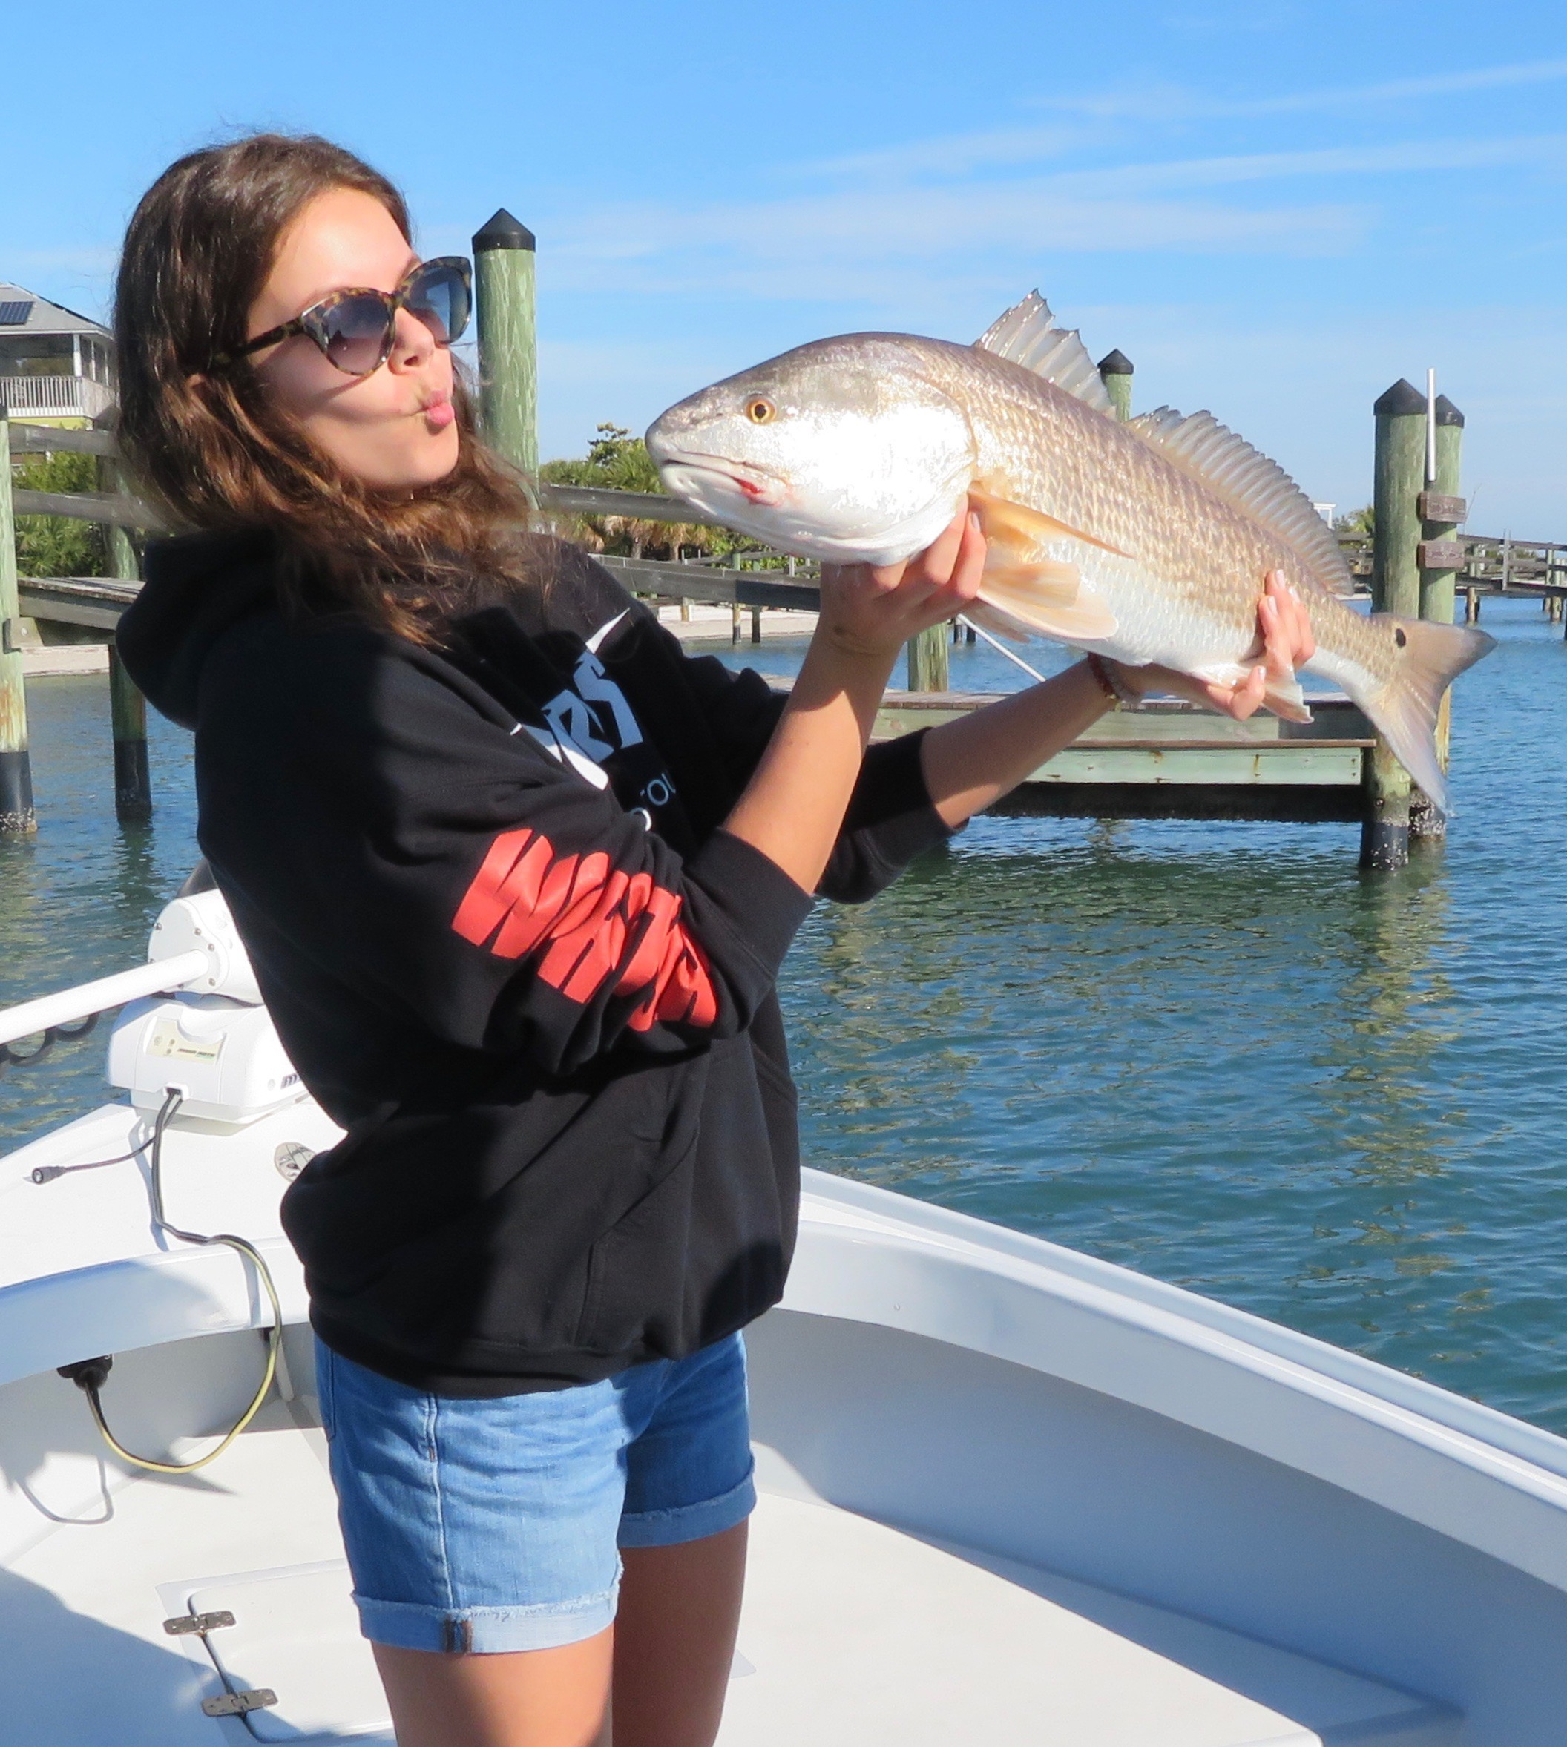

Picture: Long time client Natalie Beerman from Nashville showing her love of big redfish

The process of elimination

It was another great week on the water as not only did we manage to work in all the scheduled trips before yet another strong cold front blew us out for a few days but we also got to spend some quality time out fishing with several groups of favorite long time clients. Although the mornings this week where cold the fishing was fast paced enough to keep everyone warm with lots of sheepshead caught along with some big redfish in the mix too.

On most trips this week we starting fishing relatively close to home as it was just too cold to make any long runs until temperatures began to warm up by mid morning. This strategy proved both comfortable and productive with many of the deeper creeks and shorelines right around St James city having great action on sheepshead and rat redfish. As water temperatures plummeted into the low 60’s this bite only got better. Fast moving tides around the full moon also helped fired up the fish.

By mid morning after the shock of the morning cold started to ware off I would make the run to the north to fish area’s in and around the passes. All our local passes have been great places to get in on the winter sheepshead action. Often to catch these sheepshead Im going from spot to spot until I find that one dock or set of snags that is just loaded up. Once you do find the herd we have been pulling them in out one after another.

Much of the water around the passes has been really stirred up so these sheepshead are not as easy to locate as they can be during clear water conditions. Its been more of a process of elimination to find them. One day its one dock then the next day its another spot that we will catch the majority of our keepers from. From just day to day these fish are moving.
Action on rat redfish was still consistent this week though we did catch some much larger models too. I’m catching these redfish while targeting sheepshead on docks and snags in and around the passes. It seems the redfish are often in a little bit shallower water on the docks than the sheepshead. While fishing some favorite docks up on Cayo Costa this week my clients got a couple of slob redfish on back to back casts. Never really knowing what that next cast will bring is just one of the joys of saltwater fishing.

