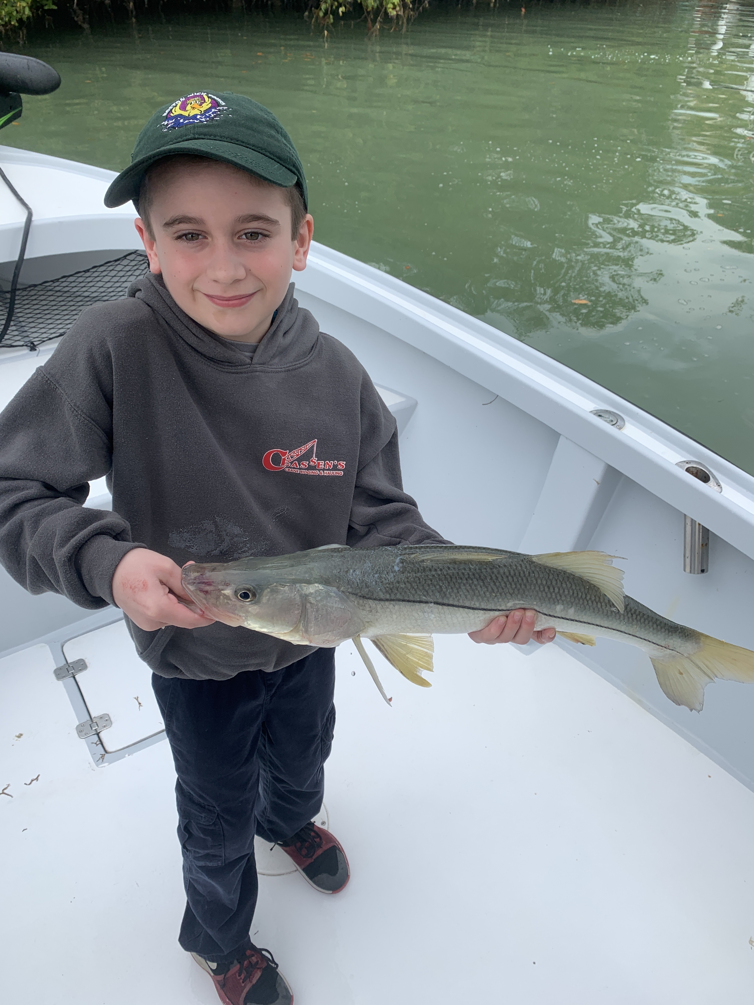

Pic: 8yr old Colin from VT had that banner day of pre front fishing with Capt Matt this week

The good before the bad

The daily ups and downs of our winter fishing are giving fishermen banner days along with almost impossible days. This roller coaster of weather conditions are without a doubt in charge. One day your fishing a spring time pattern pitching shiners and catching Snook, then the next day its too windy to even get out. Once you can get back on the water its back to shrimp fishing for sheepshead.

These fluctuations are all part of our winter fishing. This year just seems more extreme as one day I am in shorts then the next day in mylar ski pants. Watching the weather and getting out at the right time is crucial. Timing a trip to get out in the days as a major cold front approaches can bring the most amazing action. Miss it by a few hours you are stuck sheepshead fishing in a small craft advisory.

Over the past few weeks I have taken on a wait and see approach to all my charters. Often we have been waiting until the morning of the trip to get a better idea precisely when the front will arrive. Neither the client or the Captain wants to get beat up in bad weather, though fishing on the razors edge of eminent weather can lead to a banner trip.

This proved true this week while fishing with Ben and Colin down from Vermont. After catching bait in a rain storm I picked them up at the marina in St James and head straight to where we had caught fish the afternoon before. Getting rained on while heading out of the canal 8 year old Colin was a little scared about his first saltwater fishing trip. I reassured him that the bite would make up for our brief soaking.

Setting up on the shoreline the bite was wide open. We caught big Jacks and Snook on almost every cast. Colin quickly got the hang of doing battle with these strong saltwater fish and managed to land a few Snook right around 30 inches while his proud dad took pictures.

The moral of the story is trust your Captains judgment when it comes to Mother Nature. Our weather fluctuates quickly here in Florida and trying to plan a fishing trip around a ten day forecast is just not possible. Predicting the weather is tough for even us locals who make our living everyday on the water.

