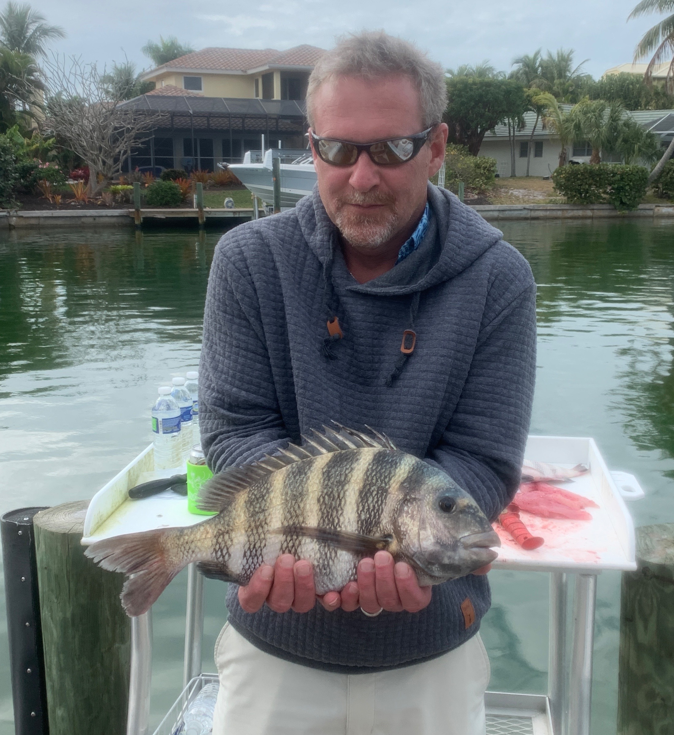

The best Sheepshead fishing of winter

Pic: George from WV with one of many sheepshead caught while fishing with Capt Matt Mitchell this week.

A week of cold dropped our water temperatures in the bay as low as 56 degree’s. Fishing with shrimp clients enjoyed the best sheepshead fishing we have seen so far winter. Along with the sheepshead we also caught redfish, trout, whiting a even a few snook all on rigs intended for sheepshead. Not catching shiners felt strange though the bite on shrimp was amazing.

During the few slow to no tide days we experienced I headed to the passes in search of any water movement. Being able to keep our baits tight to any barnacle covered structure we did very well on both larger sheepshead and redfish of all sizes. My spot lock GPS trolling motor was a invaluable tool to hold the boat close enough to docks, jetties and pilings. Often every well placed cast resulted in catching a fish.

Fishing low and slow with a chunk of shrimp during the coldest periods caught an incredible variety of species. Using the smaller winter set ups of a 2500 series spinning reel on a light rod we had a blast catching sheepshead up to 6 pounds. Pulling a variety of fish out from tight structure takes skill as these fish try to break you off. Every charter this week concluded with a trip to the cleaning table and smiling clients heading home with a ziplock of sheepshead fillets for dinner.

Being able to find so many fish close to home meant very little running in the cold. Clients had to be reminded to dress in layers as most northern visitors simply did not bring enough warm clothes. Sixty degree’s at 30 mph on a open boat is cold not matter where you are from. Once stopped and in the sun day time temperatures where pleasant and the fishing action was hot.

