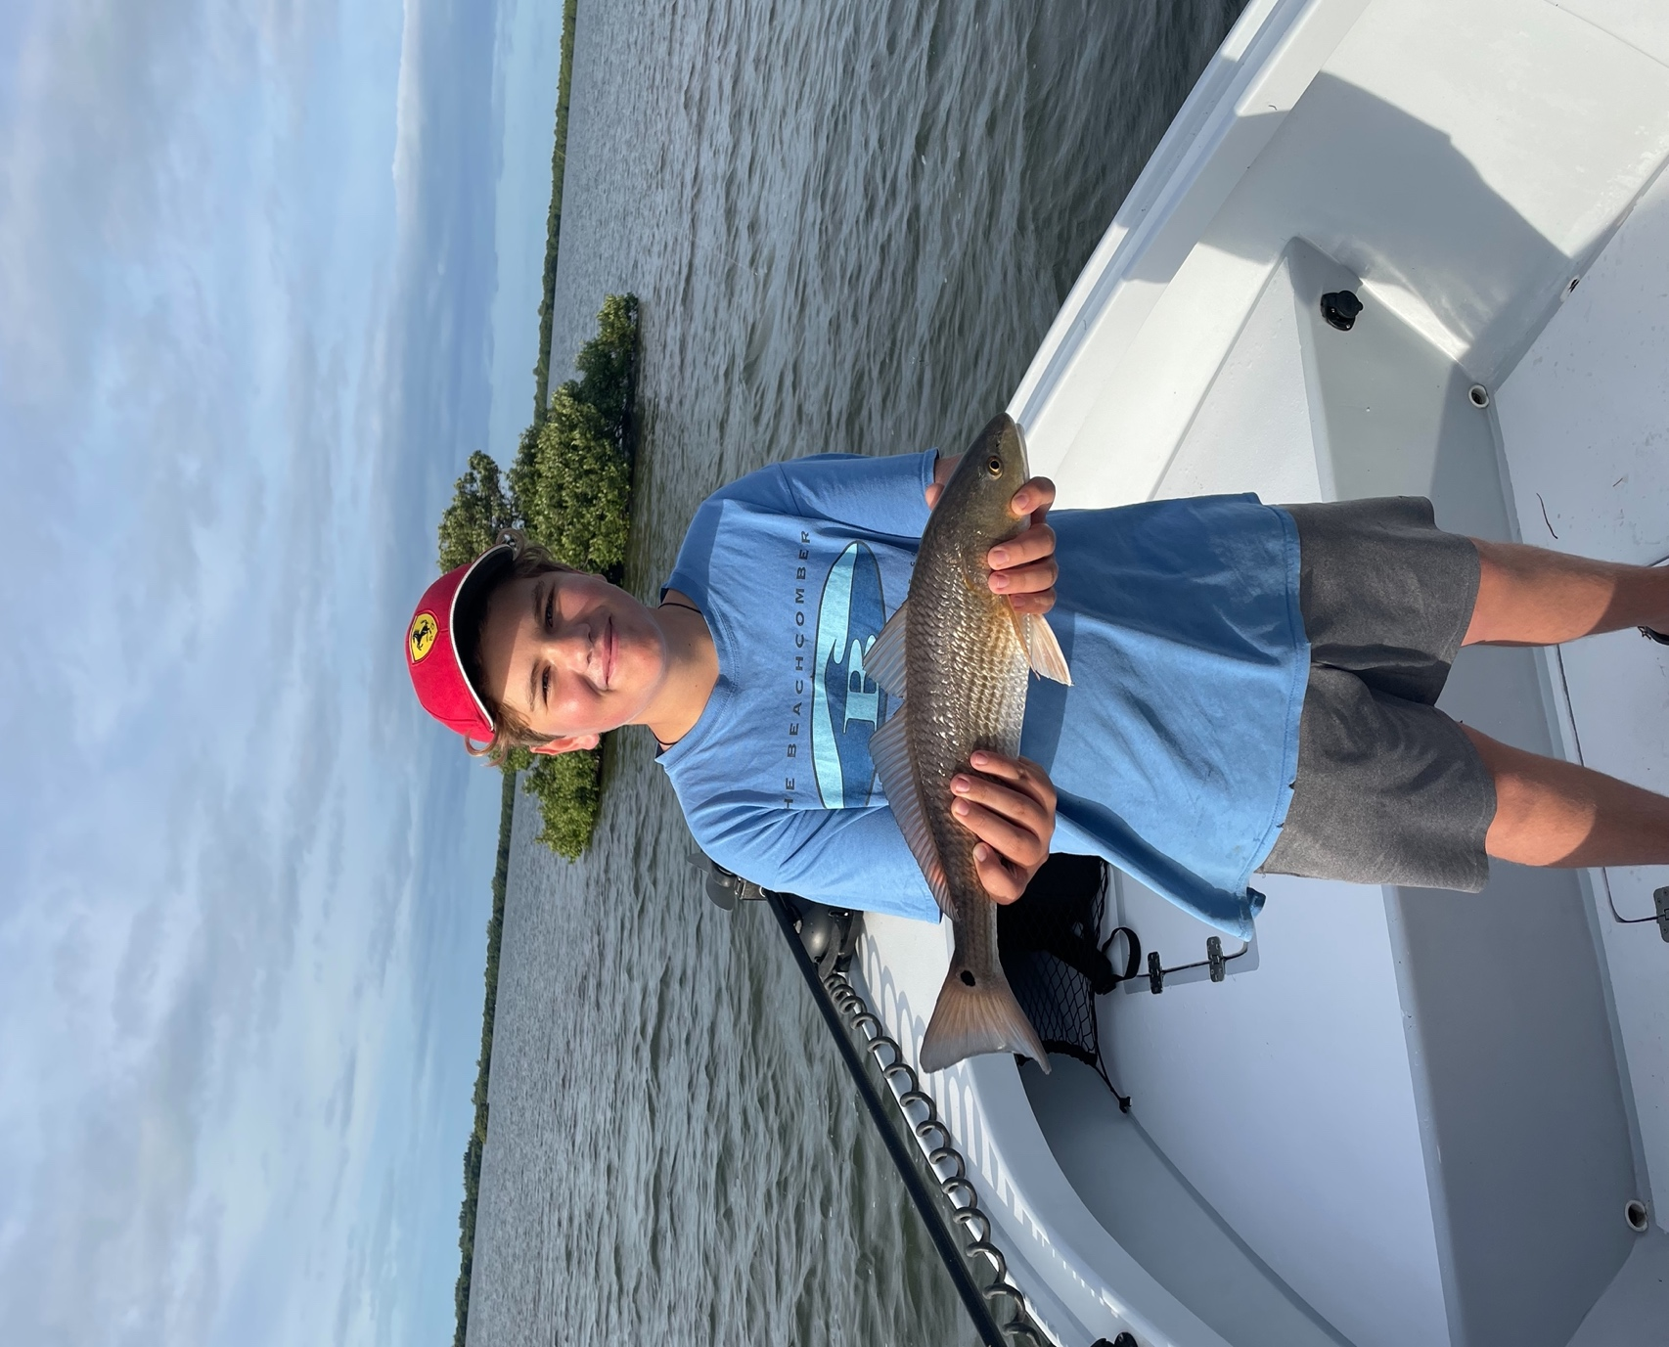

Pic: Mateo from Vermont got in on the redfish and snook action with Capt Matt Mitchell this week

The Fall feed is on.

Chilly mornings and cool afternoons are not our normal for this time of year. This is a much earlier than usual feeling that winter has arrived and is going to stick around than in years past. With our water temperatures already the low 70’s the fish eating to pack on pounds for colder temperatures that are on the way sooner than later.

Over the period of one-week, we went from extreme morning low tides to extreme high tides. A major part of this is wind generated. Wind direction plays a major part in our tides especially during winter months. We see the lowest water during periods of NE winds as it blows all the water out of the sound. These crazy low water times are my favourite time to fish during our winter months as the bunch all the fish up in the deeper channels and creeks.

Look for deeper water to fish during these super low tides. Chino island channel though a very popular place to fish can be on fire during the lowest of low tides. Expect the fish to be out from the mangroves as they have to push out to open water and channel edges when its crazy low. Moving water is always a very important part of the equation, either the end of the outgoing or first part of the incoming. Deeper channels that feed the Ding Darling are also a good choice.

During the higher tides we experienced later in the week the bite switched over back to fishing oyster bars and the many mangrove islands throughout the sound. I pick these places based on the days wind direction. Fishing downwind allows you to sit well out from the target area and make a long downwind cast so the fish don’t even know your there.

The King Mackerel bite out from the beaches is heating up with so much bait out there. Trolling diving plugs is hard to beat along with slow trolling live baits rigged on a stinger rig. Areas with hard bottom and around the well marked public reefs are all good places to get started. Watch for these fish to sky rocket to know you’re in the right place. Hooking these bigger Kings may be the fastest drag screaming run of any fish we catch.

