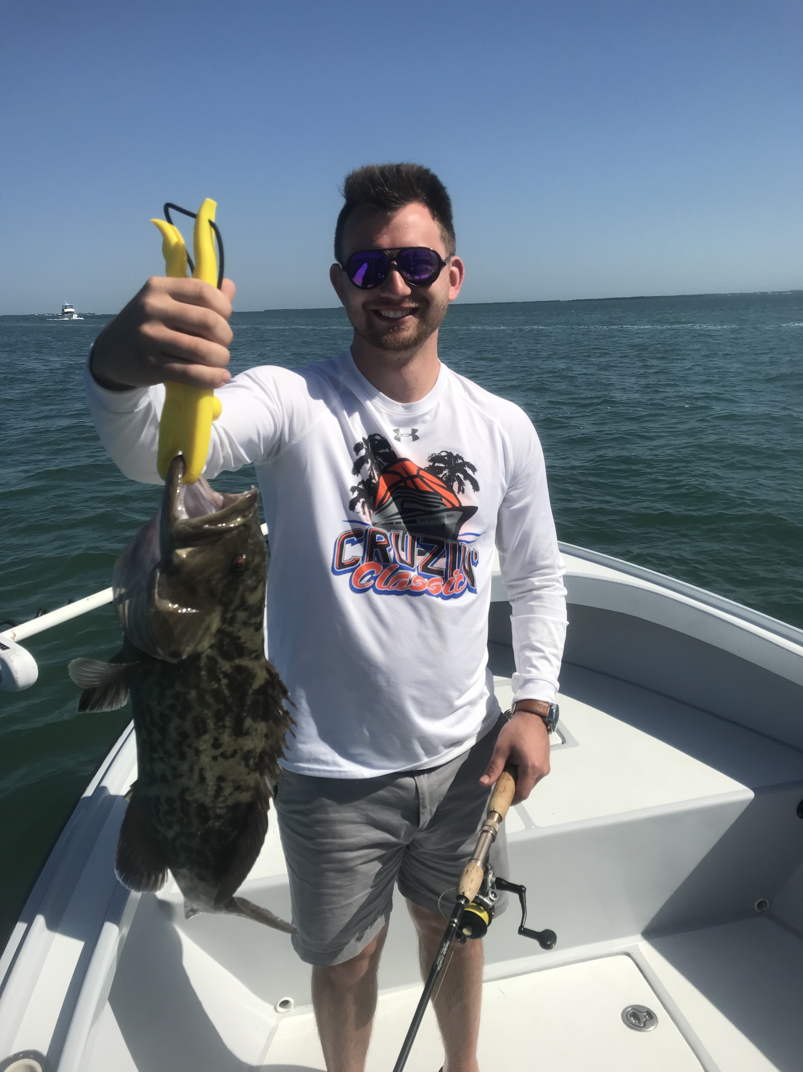

Tarpon have arrived

Picture: A 23inch Gag grouper caught while channel marker fishing this week with Capt Matt Mitchell

Tarpon time has started a little early this year and when conditions are just right with light winds it’s amazing how many fish we are already seeing. During the brief periods of calm we experienced this week I saw lots of rolling tarpon all over in the sound. Reports have already started coming in of tarpon catches along with anglers jumping them while targeting another species mostly on tackle way to light to even have a chance at landing the fish. Catching the first tarpon of the season will happen any day now.

With clean clear water and lots of bait around things are looking good for an awesome tarpon season. We have no cold fronts in sight so these migrating tarpon will continue to flood into our waters and offer anglers more and more opportunities to hook one. Having a few tarpon rods and a few larger baits on-board rigged and ready to go will make all the difference if that chance arises. Personally I don’t schedule any tarpon charters until May as I’ve had just too many past years when we get one last April cold front and the fish have simply disappeared.

Fishing for large trout continued to be the best action for my clients this week. On most trips we caught many trout over the 20-inch max while casting free lined shiners to sand holes in clean clear water. Many deeper sand holes and channels running through the grass flats in the northern sound from hemp key north also held a mixed bag of fish including big Spanish Mackerel, Bluefish and Ladyfish. Chumming sand holes also produced Snook and even a few flounder.

Running up to the north on a few trips this week made a nice change and gave me a chance to fish some of my favourite sunken bottom structure both around channel markers and in open water. Dropping baits on jig heads to the bottom we got on some crazy Gag grouper action and even hooked a few tripletail and Triggerfish. Some of our channel markers in the sound have man made structure either on or around them that creates artificial fish heavens. These can be great spots to fish during periods of little or no tide movement and can produce a mixed bag of species. Being able to catch Gag grouper one after another when there is no tide movement is always a great thing to be able to pull from your back pocket when other action is slow.

