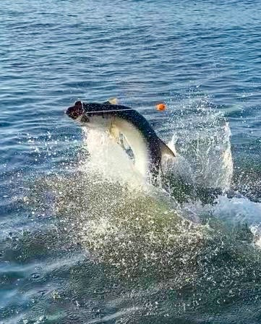

Love em or hate em all in the same day

Pic: Tarpon fishing is in full swing

The month of May is without a doubt the start of prime time tarpon fishing. Over the past few weeks, more and more migratory tarpon are pouring into our waters. Although the fish haven’t been in one place for more than a few days locating them has been relatively easy, getting them to bite as if often can be is a little tougher. Getting set up in these fish most days has included watching a few hook ups in the small pack of boats.

Tarpon stress has kicked into high gear for me as well as the many other guides who are lucky enough to chase these amazing fish daily. After months of planning, clients are arriving with expectations of catching that tarpon that will make the trip. All the gear is rigged and ready to do battle, the fish are here and our schedules have changed to tarpon time. Spending time in and around these tarpon for the next few months is something I simply would not trade no matter the frustration level the good days out weigh the bad ones.

Catching a tarpon is simply put a massive adrenaline rush, probably the biggest in all fishing. Unfortunately fishing for tarpon can be mind numbing some days. This fishing can go from hours of all that can be described boredom to wide open in just a few seconds. When it is time you need to be focused and prepared, as you don’t get many shots at it. Watching tarpon roll as they glide by your baits will make you want to pull your hair out. Then once that bite happens all that waiting is quickly forgotten as chaos breaks out, rods are quickly cleared as the fish goes absolutely nuts for the first few minutes. Once hooked up there is simply nothing else in fishing like doing battle with one of these amazing fish. Every tarpon battle is different. Some stay down and slug it out while only making a few jumps, while others jump endlessly.

Being successful landing tarpon is about technique and not brute strength, knowing when to just let the fish run then knowing when to apply lots of pressure only comes with experience and coaching. Keeping the fish hooked up while it jumps wildly requires bowing the rod to create enough slack that the free falling fish doesn't break off or pull the hook. Constant pressure pulling against the fish will wear these fish down much faster than simply holding the rod up high.

Most days’ successful tarpon fishing starts by locating these fish. Free jumping tarpon can be spotted from a good distance away while slow low rolling tarpon take a little bit more spotting depending on the days conditions. The first few hours after sunrise are generally the magic hour as it can be the calmest water all day. Once located, I try to get a read on the movement of the fish and intercept them with baits. The more tarpon you can have go by your baits the better your odds of a hook up. Play in the tarpon highway long enough and you will get hit.

During tarpon season I run 4 bait traps that allow me to pick up my clients much earlier than if I had to throw a cast net to catch bait. I bait these traps daily as I pull them so I always have pinfish and crabs. On board I carry a sabiki rig on a spinning rod to catch threadfin herring as the trip goes along. Along with the live baits I also have fresh silver mullet in a cooler on ice. My preference is a 12-14 inch mullet to use as cut bait.

Weather especially wind speed and direction plays a major part in the days tarpon tactic’s. Even during periods of less than favourable breezy conditions its possible to still locate these fish in leeward areas. West winds require fishing the inside of the barrier islands while East winds give opportunities both on the beaches and eastern side of the sound.

Tarpon are not like any other species we target in this area, it’s not like snook fishing where you can expect 20-30 fish a trip. I tarpon fish almost exclusively for the next few months and at best have around a 50% success rate. Most trips I find these fish and set up with a full spread of baits and all I can say after that, is that getting a bite is out of my hands. No matter how long I guide for these fish getting that bite no matter how many fish you are in can be frustrating. Some days it’s easy and we have multiple hook ups while other days you just cannot buy a bite. Tarpon are not for the weak of heart as they require patience and with great patience comes great rewards.

