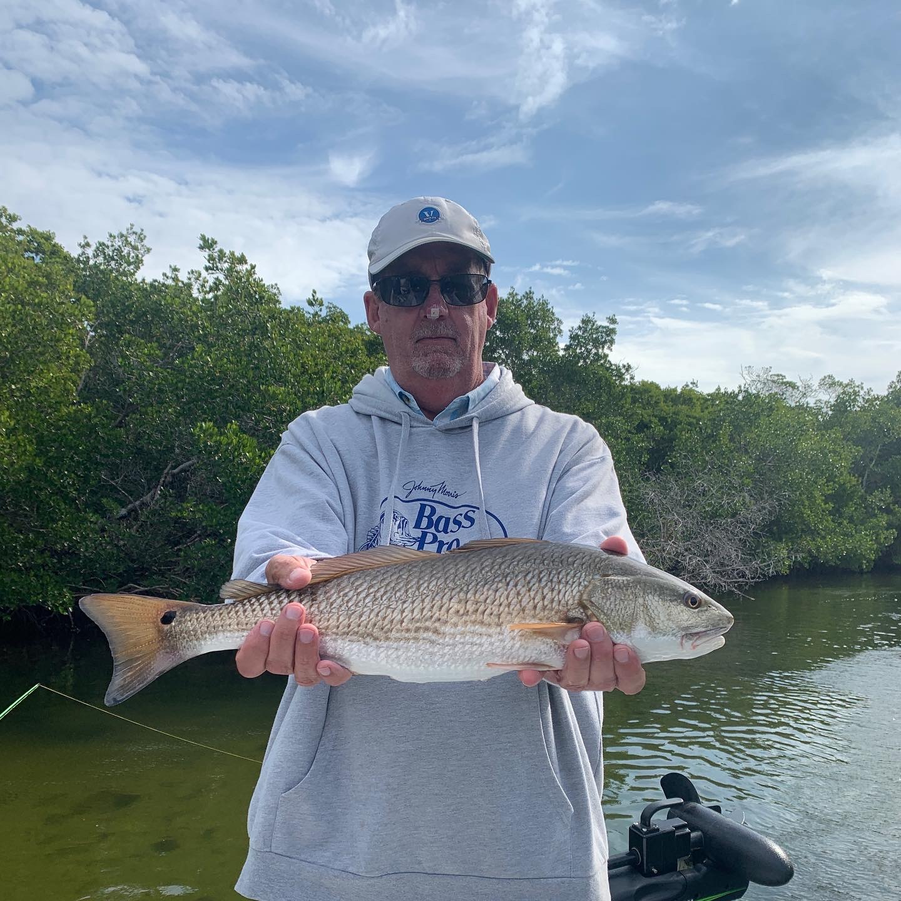

Switching it up

Pic: Nick Little with one of many Ding Darling redfish caught this week with Capt Matt Mitchell.

Many trips this week where about being able to find some place out of the wind to increase not only the comfort level of everyone on board but also catch a few fish. Several days over the past week we had little to no tide movement and finding any kind of action often took patience and persistence.

Bouncing between several Ding Darling creeks we not only managed to find a little tide movement on the tougher days but also some amazing redfish action at times. The deeper water in the bends of these crystal clear creeks would hold lots of redfish between 16-24 inches. Catching redfish after redfish between a few stops of not even a bite was just what was needed. Like any fishing trip some days it took just one hot spot to make the whole day successful.

During slightly calmer days we had a few charters that we found good action out on the flats including St James hump, Red light shoal and Picnic Island. Shrimp under a popping cork caught a wide variety of fish from trout and ladyfish to Spanish Mackerel and even a few pompano. Finding diving pelicans often gave up the location of these feeding fish.

The roller coaster of water temperature we call winter in Florida means being able to switch up the target species. Once our water rose back into the low 70’s finding sheepshead got tough and redfish filled in the void. After the weekend cold front water temperature dropped and it was back to sheepshead fishing. Some of the largest redfish all week came while targeting sheepshead post cold front in the passes.

With a week of warmer temperatures on the way I can’t wait to switch it up and start catching shiners again to target snook. As our water creeps back into the low 70’s this snook bite will fire off. This will be a much awaited change after what has been over two weeks of shrimp fishing.

