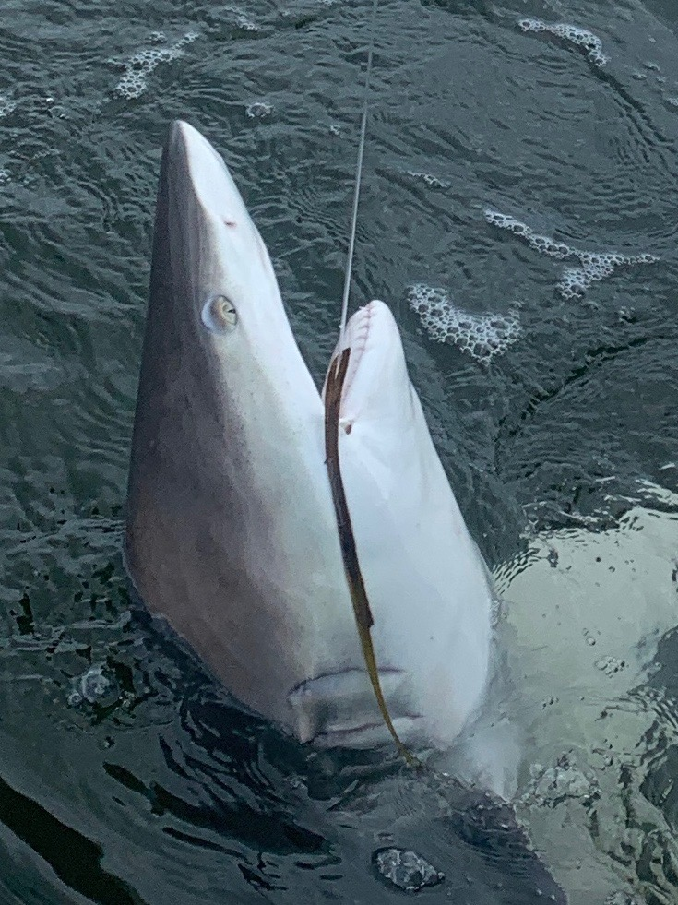

Pic: Summertime catch and release shark fishing is in full swing

Summer time fishing just keeps getting better

Most of this week I spent my time in and around the passes catching Snook along with some redfish and even trout. To see our passes come alive over the past few weeks is awesome. Every pass is holding lots of summer time snook its just a matter of what the tide is doing to decide which pass will be most productive. What all these passes have in common is the huge volume of water that travels through them on the tide which make a perfect set up for hungry fish to feed.

Captiva pass offers lots of options with snags and deep fast moving water both on the Cayo Costa side and along the docks on the south side. Along with snook this pass will produce some really big bull redfish on the lower stages of the tide all summer long. The snags on the north side load up with snook along with the inside deeper trench on Cayo. Working out this bite only comes with time served though once you do figure it out it is very consistent.

Redfish pass is one of our more famous snook fishing passes and offers a seawall with rocks on the south side that turn into sand beach. This side of the pass is all about drift fishing a live bait close to the bottom. Rock jetties on either side of the pass can be fished while anchored and at times can be holding hundreds of snook. The north side of Redfish pass has docks on the inside which are also a good place to anchor up and snook fish.

Blind pass is far from a secret and has some of the fastest moving current anywhere. Dialing in what tide these fish want to feed on is forever changing though when you do hit it right the bite is often non stop. Its not unusual to catch redfish in here too though this week the big surprise was the amount of large trout we caught while snook fishing. Some days this week you could see the snook laid up under the mangroves almost right on the surface. Sight casting these fish is a blast.
What all these passes do share beside the fact they hold lots of fish is that the only way to work out how to fish them successfully is to put your time in. There is not one specific place that will always hold fish as its constantly changing depending on the wind and tide. Look for reverse eddies and tide rips which often change depending on how fast the current is moving to be the ambush places these fish will be. Any piling or downed tree limb can also work as a snook honey hole. In the deeper water snook get down flush to the bottom behind rocks or even just bumps and lumps in the bottom so they don’t have to use up any energy fighting the tide. Once a snook has a comfortable place to set in the tide its a never ending baitfish buffet for them as they just dart out and grab a easy meal.

