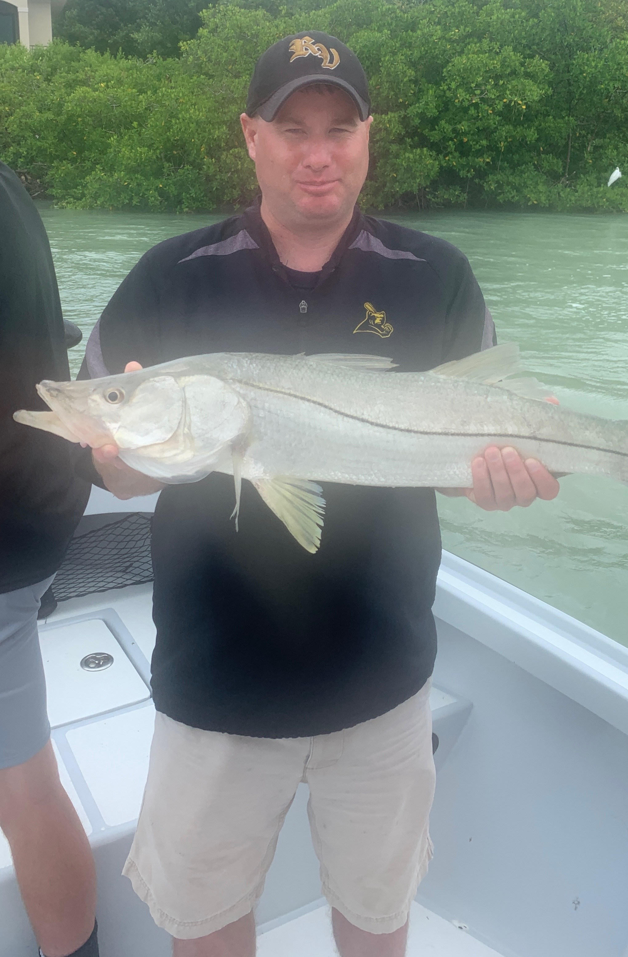

Summer rains
Pic: Steve from Ohio got a big Snook to finish up his charter while fishing with Capt Matt Mitchell this week.

Our summer rainy pattern really ramped up into high gear this week. Getting out early and being back at the dock by lunch time was the only way to avoid the mid day heavy rain and fast moving storms. The only thing close to as consistent as the rains was the fishing with both a great flats bite going on and then a wide open pass bite.

Seems for over a week now I’ve been fishing the same pattern almost everyday. First stop is the open flats with popping corks and small shiners. This has been great for non stop action on a variety of species along with some trout over 20 inches.

As we push further into summer the Mangrove snapper bite on the flats keeps getting better and better too. Starting a charter off with this flats bite gets all my clients a fish on the board and is all you could ask for as a guide. The variety of fish on the flats has been outstanding, a few of the stranger fish we caught this week included a 3ft greater hammerhead shark and a even a few bluefish. Add in a few ladyfish to the mix so I’m able to rebait my pinfish traps for the next day and life is good.

By mid morning I’ve been making the move and heading to the passes to drift live pinfish and grunts. Some days it took a few drifts on either side of the passes to work out exactly where these fish are staged up. Once located it was often double hook ups on Snook almost every drift.

Stirred up water in the passes from both our daily rains and winds make for the perfect set up. Snook don’t like it too clear as they get spooky, they prefer to feed by feel from that pronounced lateral line. Add a few big redfish into this mix and we have had some outstanding fishing charters .

Having rods rigged for both types of fishing I’m doing day to day makes life much easier when the bite is on. I carry rods rigged both with popping corks for the flats bite and rods rigged free line for drifting the passes. Being able to simply grab another set up when the bite is on keeps our lines in the water and catches more fish.

