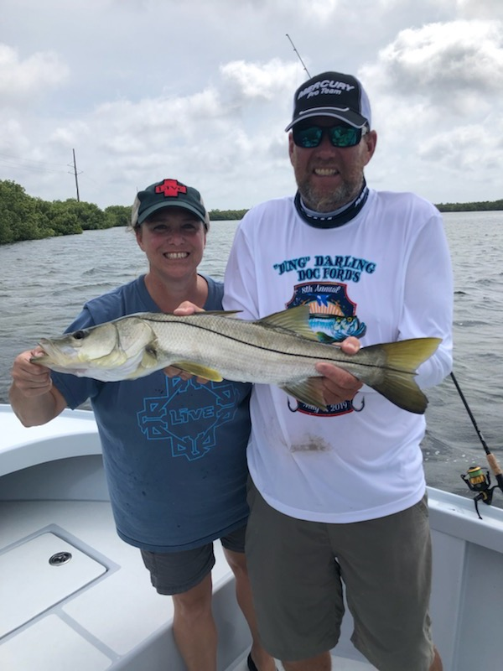

Pic: Pam Murray with one of two big fish bonus Snook she caught while fishing with Capt Matt Mitchell last week.

Spring time fishing options.

Though tarpon will remain the main target for lots of anglers for at least the next few weeks we have plenty of other fishing options. For a few days this week I had fishing trips where bending the rods and just having fun was more the theme than chasing a bucket list fish. For these trips we went shiner fishing and caught Mangrove Snapper for dinner along with good numbers of Snook and even a few redfish

Even with slow incoming day time tides all week the catch and release Snook bite was great. Though most of these Snook are not large on every trip we either landed a few bigger models or hooked into a few that one the battle. Many of the places I targeted Snook this week we caught other species including a few redfish, keeper size mangrove snapper and some really huge jacks.

The better mangrove fishing for me continues to be on the eastern side of the sound. During lower tides I’m targeting deeper mangrove channels and creek mouths then as the tide comes up oyster bars and mangrove island shorelines. The southern end of the sound along with southern end of Matlacha pass have been some daily choices. Matlacha pass is a real hidden gem and although it takes some time to get around and to work out this fishery gets very little angler pressure while holding lots of quality fish.

During the better weather days this week locating tarpon was generally easy both in the sound and on the beaches. As usual some days they would eat then other days they would torment you by swimming right through your bait spread and even rolling over your baits while flipping you off. Watching these fish all around the boat is all part of the game. All you can do is try different baits and hope they will eat one of your offerings.
The FWC ruling to keep Snook, Redfish and now Trout closed for harvest in our area until at least May 2020 is great news. This response to the prolonged 2018 red tide is the right choice and will only help our fishery rebound. Anglers can still target these species though now they are all catch and release only.

