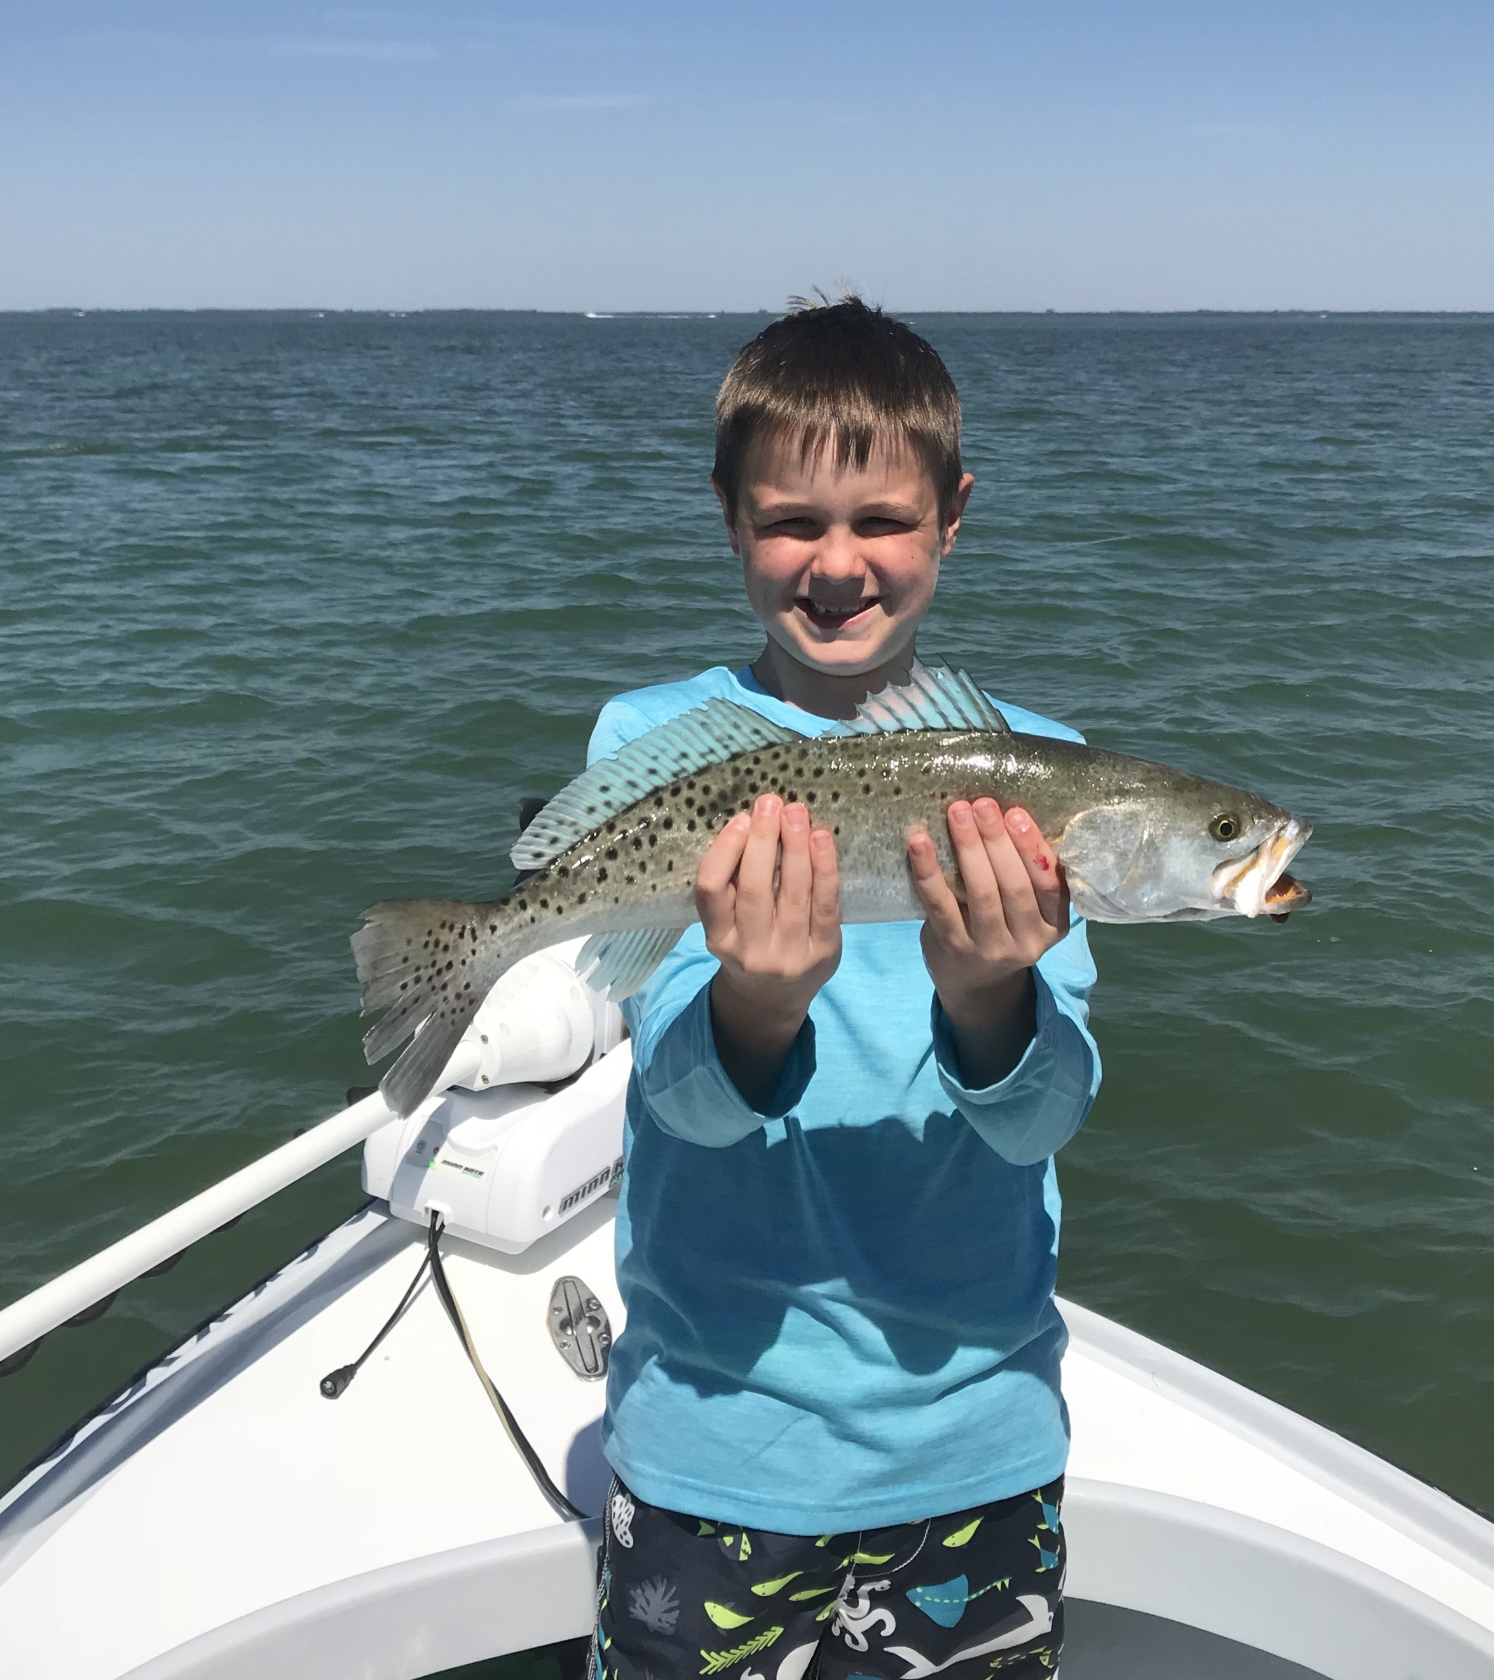

Spring fishing close at hand.

Yet another March cold front put the breaks on Snook fishing again for a few days with our morning lows dipping into the low 50’s. This latest cold blast was as cold as anything we dealt with almost all winter long. After having had such mild weather the whole month of February this late season cold front was another real shocker to the fish.

If the cold did not keep you off the water for a few days then the strong winds certainly did. Weather conditions caused lots of cancelled fishing trips as conditions where just un fishable for a few days. Once the wind speed did finally relax a little we bundled up and ventured back out to enjoy some outstanding Sheepshead fishing. Then gradually as temperatures slowly crept back up Snook and trout fishing began to get back to normal.

When ever we get such a drastic 10 degree plus drop in water temperature fishing just totally changes for a few days. One of the few species that feeds better in during these cold temperatures is the Sheepshead and for several days we targeted and caught lots of keeper Sheepshead up to 5 pounds. Just about any dock close to the passes was loaded up with fat roe filled Sheepshead which are at the end of the annual spawn. This was probably our last chance at some really good Sheepshead action until next winter.

For a few days after the cold front past we struggled to catch shiners and even when we did get them with water temperatures hanging in the mid 60’s nothing would eat them. Cooler temperatures and rough conditions push these favourite baits out to the deeper warmer water from the grass flats. The aggressive Snook and Trout bite we are use to got a whole lot slower although it is improving everyday as temperatures gradually warm back up. In many of sheltered shallow dark bottomed bays I found lots of Snook just laid up soaking in the heat from the sun as they tried to warm up.

When going fishing after yet another extreme cool down like we just experienced being able to switch it up and go target Sheepshead is often the only choice when you need to catch fish. Luckily this week I had anglers who were just happy to be out on the water and catching any kind of fish. Changing it up to the ultra light spinning gear we made the best of this bad weather situation and still managed to keep the rods bent. Now that we finally have a week of 80 degree temperatures in the forecast fishing will really light up. Once our water temperature starts getting into the middle 70’s its like someone flips the on switch.

