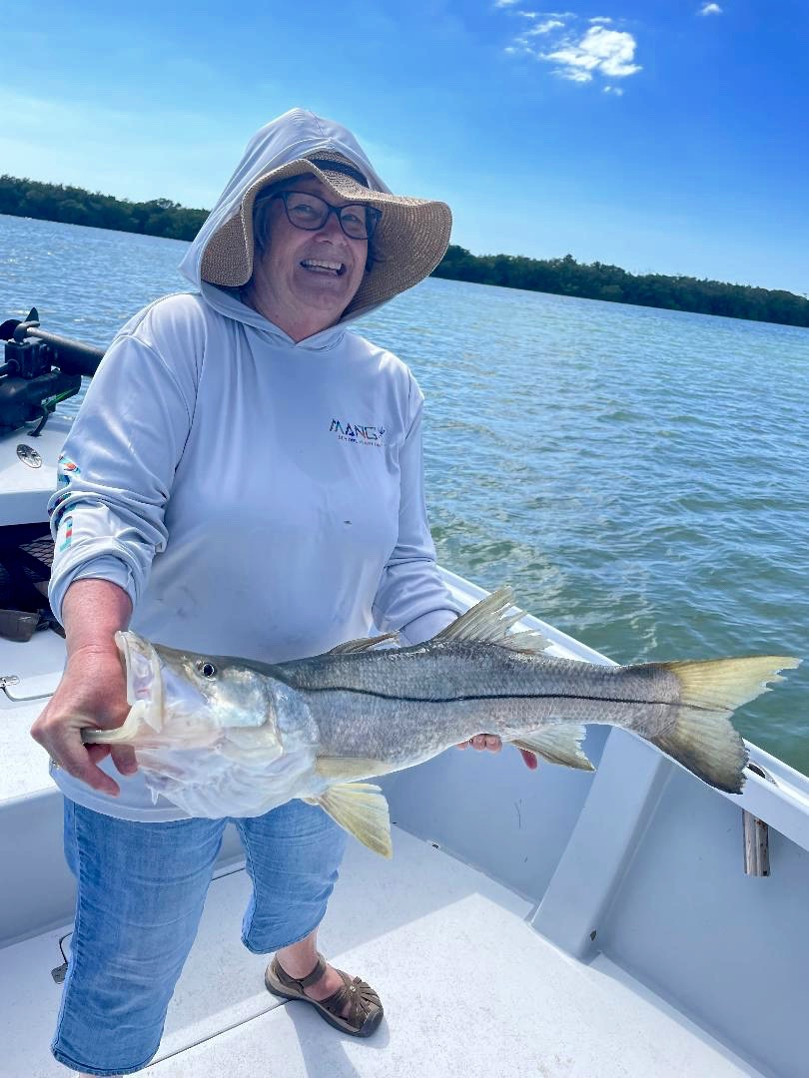

Spring Snook

Pic: Pat from WS with the trip maker 41-inch Snook caught while fishing with Capt Matt Mitchell this week

Warm water along with lots of bait around has our snook fired up. During a cold January and most of February these fish where in all that can be described as a hibernation mode. Now that temperatures have bounced back snook are on a wide open feed.

The key to snook fishing as ever are live shiners and the more the more the better. Stuffing your live well full of these Snook candy’s almost guarantees action. Any flat from picnic Island to the middle sound is holding shiners. Chumming is the best way to catch these baits and getting out early makes for less work to get all you need.

During high tide periods oyster bars have been the place to be. A few live chummers quickly tells you if the fish are there. While fishing these oyster bars one afternoon this week we had over 30 snook ranging in size from 20 to 41 inches. This bite was insane with every bar we picked being a successful stop. Unfortunately, we have only had an hour window while the tide is high enough to target these fish.

Oyster bars are not random, they are always in places that have lots of tide flow as oysters need to filter lots of water to flourish. Snook use these bars as transition area’s as they cross the sound. With so much food around the bars they hold lots of bait. Many of these oyster bars are totally covered during higher tide periods and take some homework to be able to locate. When you see mullet jumping and working the bars the gamefish generally seem to be there. Cast free lined live baits to the white sand holes and highways right up against the shells.

Mangrove creeks have also been a good choice during the lower tide periods. Many of the miles of creeks systems we have been gin clear and made for lots of sight fishing opportunities for these snook. The better creek bite for me has come during the first few hours of a low incoming tide. Live chummers in these creeks do wonders for locating these fish too. During the outgoing tides I’ve been spending time in the passes catching snook. Look for blow downs and structure as these fish tuck in tight ready to ambush a passing bait.

Snook are all through our area and ready to eat. Being in the right place for that stage of the tide is what will keep the rods bent. Moving tide is the most major factor as these fish just don’t feed well on slack water.

