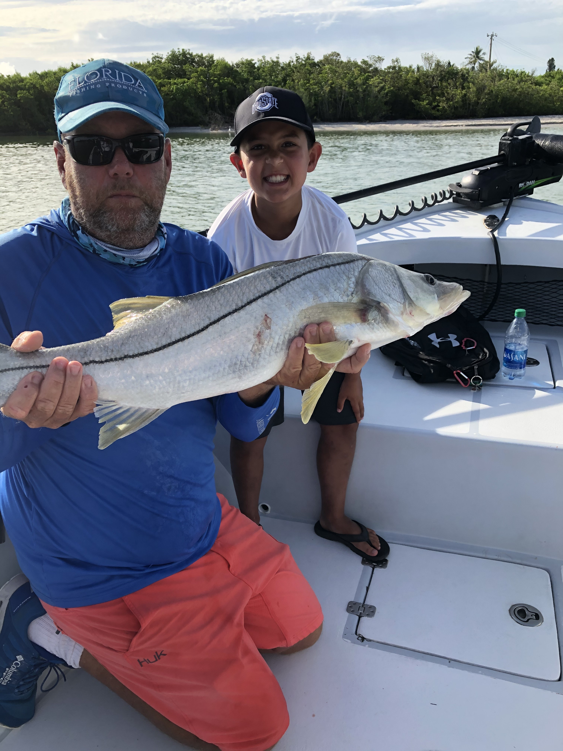

Picture: 9 year old Nico Zoha with his first Snook a 36 incher caught while fishing with Capt Matt Mitchell this week.

Small baits big fish

Everywhere you look in and around the passes we are seeing huge schools of small fry bait. Most of this bait although too small to cast with is what the fish are dialed in on. Having a live well full of smaller shiners has been the key to getting in on great action on a crazy variety of fish.

Catching this bait has been as easy as finding diving pelicans over shallow grass flats. Using a 1/4 inch mesh cast net after a few minutes of chumming these baits rise up and flicker by the hundreds and its basically one and done. What this bait lacks in size in makes up for in numbers. Its mostly shiners and does have threadfins mixed in. I like to use most of the really small stuff to live chum with. After a few hours the threadfins die off and sink to the bottom. There is so much of this small bait around its easy to catch all day long.

My favorite way to fish these small baits is to down size the gear to 10# test on 2500 series spinning reels. I rig up with a 20# leader and a #1 hook making it possible to throw these little baits. Another option is fishing under a popping cork which gives you enough weight to cast these tiny baits a little bit further.

Mangrove shorelines within sight of the passes with fast moving tide are great places to get started. Chumming some of this bait will quickly tell you how many fish are there. Snook, redfish, jacks and big mangrove snapper have been exploding on this little fry bait.

Grunts and pinfish have remained effective in the passes though during the heat of the day it seems the fish are not willing to work for a big meal and just prefer to snack on this small bait. Our big snook of the week did come first thing in the morning while drifting larger grunts through the passes. Fishing with the Zoha family mid-week on our very first drift 9 year old Nico caught his very first Snook a 36 inch bruiser.

