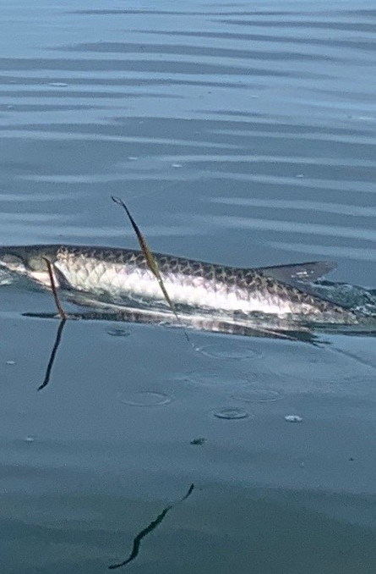

Slick mornings and a day off

Pic: Good morning tarpon

I’m often asked by clients if I still just go fishing for fun? The answer is yes. My favorite thing to do is sight fishing tarpon from my small flats skiff. Having a couple days off this past week along with perfect oil slick calm mornings I got to spend some time doing what I love: chasing tarpon. Luckily my girlfriend Mary may be even more obsessed with tarpon fishing than even me. Although she won’t ever ask me to take her fishing on my day off all I have to do is mention it and she is in.

On a perfect day off I wake about 5am and am heading to the marina by 5:30am with my skiff in tow I will have a few dozen perfect tarpon baits tied at my dock in a holding pen. After heading out the canal we make a few mile run in the dark down the sound to where I hope the tarpon will be. I’m dropping the trolling motor and starting to search just as its getting light. This week was easy and just a matter of returning to the same area again and again to visit these happy tarpon.

There is very little angler pressure on these tarpon this time of year. Most days we have had them almost all to ourselves. Being there early to enjoy that first few magic hours after sunrise is just prime time. This next few months is my favorite time of the year to enjoy our tarpon fishery. All the spring time hype is over and these fish will get in a pattern until we get a big weather event.

Getting on these late summer tarpon has been about locating the big schools of fry bait that have feeding Mackerel, ladyfish and trout on them. Watching this fry bait spray as predators gorge on it usually means the tarpon are close by. Groups of tarpon move around this feeding frenzy sometimes even breeching as they come through these huge bait schools. Watching these fish go airborne is just about as exciting as hooking up. Some days we cast into the frenzy while other days we pitch at rolling fish. Either way this tarpon fishing is as good as it gets. Though we do not the numbers of tarpon we see in May when they are mating, these fish are eating and much more cooperative than in the spring.

The small flats boat with a high power trolling motor makes us fast, quiet and agile. Spotting rolling or laid up fish is the first step then being able to quickly get within casting distance is next. When we are able to get a pinfish or crab to these fish its not taken long to get bit. The 3 mornings we fished this week we jumped 10 tarpon and sadly only managed to land one. These tarpon have mad moves picking up the bait and jumping as they came right at the boat before we could get tight on them. Several times we had them almost come in over the bow right before they got loose as we stared them down eye to eye less than 10ft away.

Most days by 10am the bait schools and feeding fish have usually disappeared. and its time to call it a day. We beat the heat and head in to the AC. As business slows down in September and October if conditions are right I will be out any morning I get a chance to do this, it just never gets old. I can’t think of a more quality way to start any day off then by spending time with these amazing fish.

