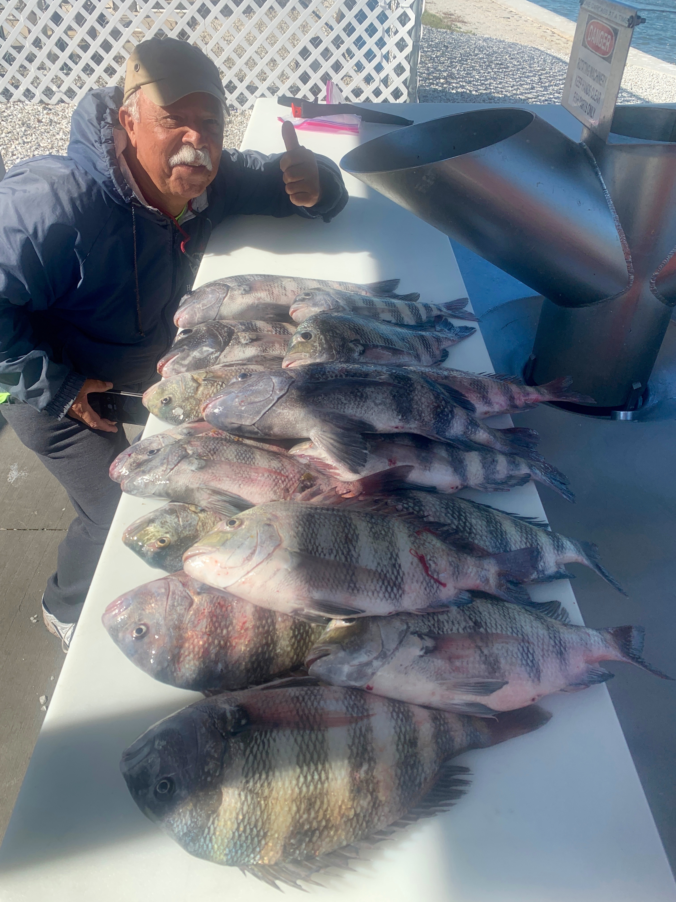

Picture: Alex and Doug got there limit of big sheepshead with Capt Matt Mitchell this week.

Sheepshead smackdown

Clients this week enjoyed the most consistent sheepshead fishing we have seen so far this winter. With water temperatures staying in the mid to low 60’s these fish fired up and are chewing. Many days we had our 8 fish per angler limits as we headed to the fillet table. The average size on these fish also increased with most going over 14 inches along with several as large as 20 inches caught.

Now that these Sheepshead have finally arrived in huge numbers they are very accessible to all anglers with or without a boat. Some extremely productive sheepshead spots for shore bound anglers include the Blind Pass bridge and the Sanibel pier. To catch these fish its as simple as dropping a chunk of shrimp on a jig head down a barnacle encrusted piling.

I recently purchased some jigs designed specifically for sheepshead fishing. While searching the web for the usual jig heads I buy I stumbled upon a new style of Sheepshead jig. This jig is a painted egg shaped lead with a flat bottom making it sit flush on the bottom. It has two rings molded into the lead. One side is tied into the leader and the other side holds a split ring and hook. The jig comes in a variety of weights and can be rigged with any size hook. A 1/0 needle point hook seems to be the perfect set up. This jig has increased not only our hook up percentage but the majority of the fish we are catching are hooked in the corner of the mouth. This makes for both a solid hook set and easier hook removal. What makes this jig work so well is the chunk of shrimp sits above the lead making the fish turn on their side to eat it.

If your looking to go home with a fresh fish dinner it does not get much easier than now. With many of our other food fish species still closed to harvest, Sheepshead are not only plentiful but delicious. Our winter Sheepshead fishing will be on fire through the whole month of February.

