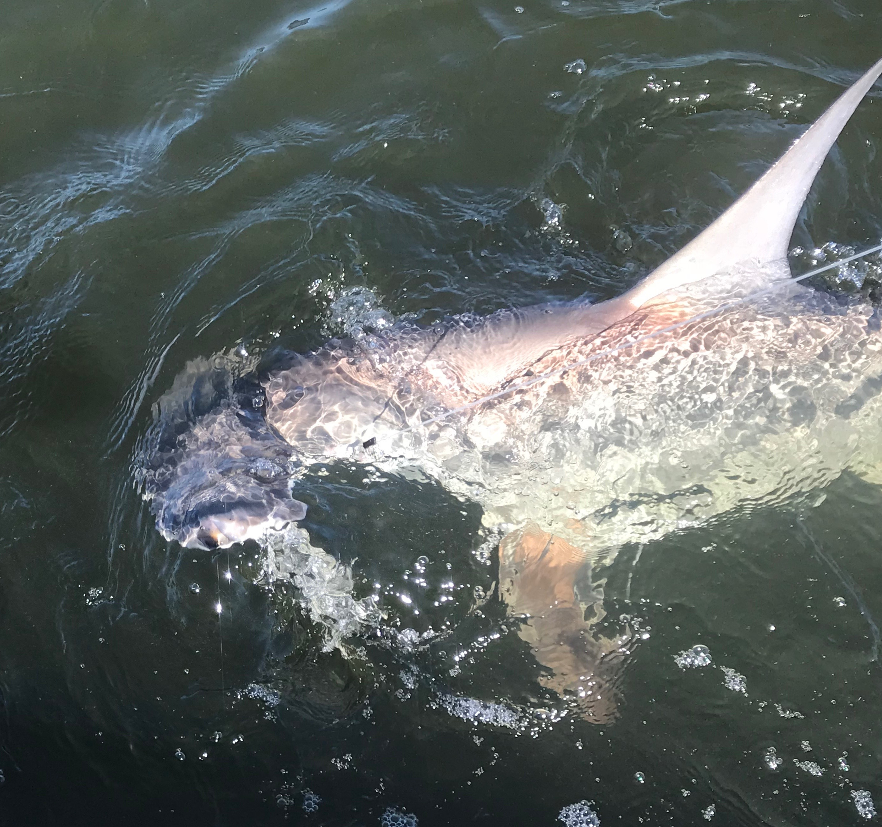

Picture: A 5ft hammerhead caught and released while fishing with Capt Matt Mitchell this week.

Shark variety pack.

Wide variety was the best and easiest way to describe this weeks fishing action. Early in the days trip we have been stopping and catching ladyfish, mackerel and jacks under the hundreds of feeding birds around the powerlines and southern sound. This is great action and fast paced on jigs and spoons then then a second later just as you reach down to unhook another ladyfish a tarpon would come out of nowhere and grab it. This exact thing played out a few times this week with clients basically having very little chance of doing anything when hooking a 100 pound plus tarpon on light trout gear . Its still very cool to experience and get that rush of excitement that only a jumping tarpon can bring.

Many of my anglers this time of year are repeat customers and are always looking for something a little different to target. With our water temperature rebounding quickly from the last cold fronts I’ve been seeing lots of sharks around on the open grass flats so I offered a few groups the option of shark fishing this week. Setting up in the northern sound with cut mullet for 3 days in a row this was some of the most fast paced shark action I can remember.

The last few hours of a low outgoing tide is my favorite set up to shark fish in the natural deeper channels in the northern sound. The sharks that patrol these large grassflats have to drop off into these deeper channels as the tide gets really low. Although Its not unusual for me to catch a good variety of sharks up here this week was better than most as we not only had the usual blacktips, spinners and nurse sharks we also caught a big Lemon shark and had 2 hammerheads to the boat before releasing them. Many of the blacktips where in the 30-50# range and are just fun to catch as the fight really hard. This is relatively easy fishing done with heavy spinning gear and cut chunks of fresh mullet on a large circle hook.

Catch and release Snook action was also good this week with great action also coming on the outgoing tide. Live shiners for this fishing came from the causeway bridges although these shiners seemed to be moving from one bridge to the next from day to day. Redfish seemed a little harder to locate this week on the low morning water pattern although sea trout of all sizes showed up in many of the same places to fill that redfish void.

