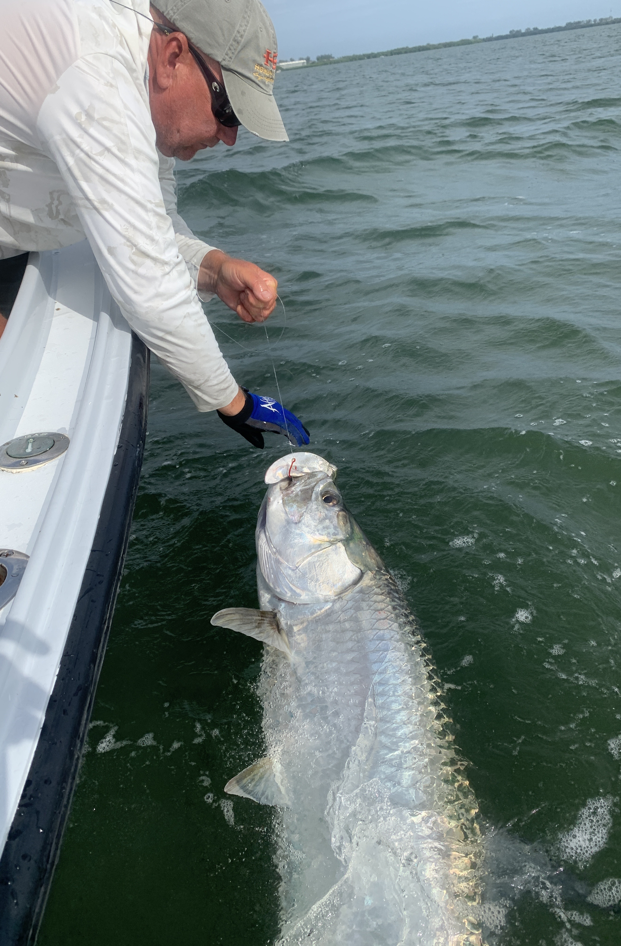

September Silver
Pic: Tarpon fishing in September can be amazing

September has always been one of my favourite months to fish our waters. Now that the busy Labor day holiday weekend is over things get nice and quiet on the water. From tarpon to Snook and Redfish September is prime time to get out and enjoy the best of what our fishery has to offer.

During days off when we have light winds my favourite thing to do is get out early and chase tarpon. All though there are generally not the huge numbers of fish we see in the Spring you will often have them all to yourself. The further through the month we get the more these fish get keyed in on the baits schools out on the beach. When conditions are right some of the most wide open tarpon fishing of the year happens over this next few months.

In the sound our redfish have just started to school up. During low tides its a great time to locate them on the shallow flats on the inside of the passes. Often you will first see feeding birds then as you get closer you can see the bait jumping to get out of their way. Flats inside of both redfish and Captiva passes are great places to start your search. Long casting weedless spoons work really well for these shallow water fish along with a trusty chunk of cut bait cast out in front of the school.

Snook have just begun to make the transition this month as they start coming in from the beaches and pass hang outs of summer. Oyster bars and points with good tide movement in the middle sound can hold amazing numbers of snook. After what has been some of the best summer snook pass fishing we have had in years. Thanks to the closure this Fall snook fishing is gonna be epic. Seeing the amazing recovery of our beloved snook all we can hope for is the FWC keeps this fishery closed for another year.
As water temperatures slowly begin to drop by October the annual south bound bait migration will kick into high gear. Although we don’t notice the change of season yet our days have begun getting shorter already September has always been the month that us fishing guides and locals get to enjoy some of the best fishing of the year.

