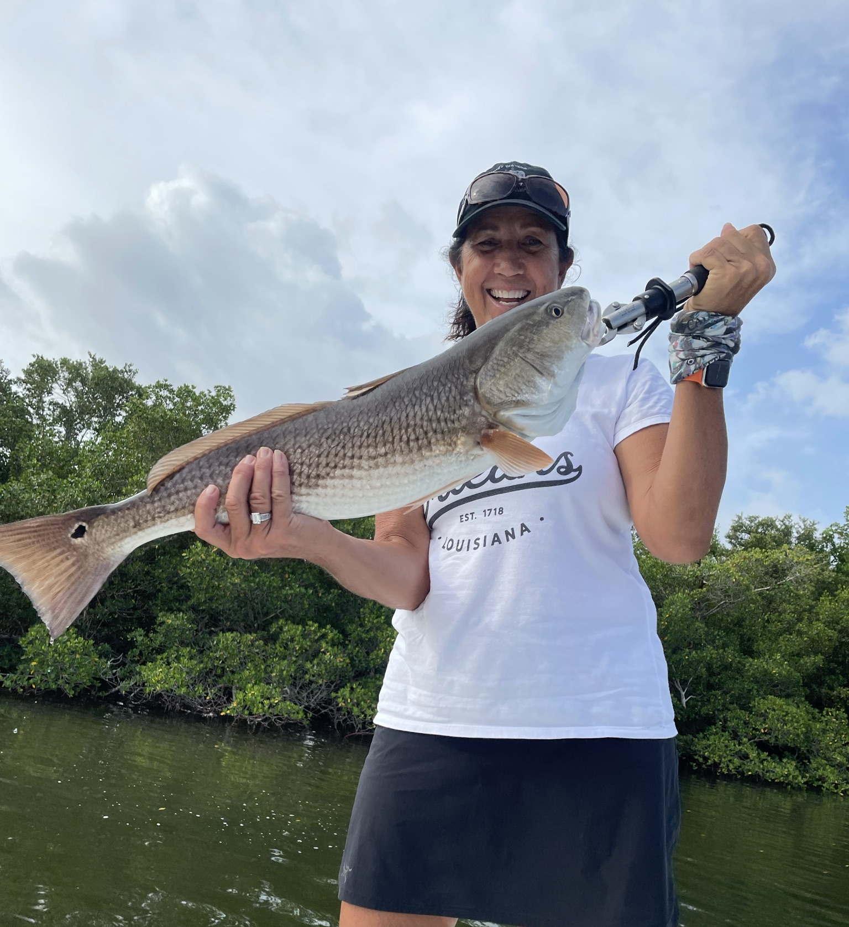

Schooling Redfish time

Pic: Renee Miller from St James City got in on the redfish action while fishing with Capt Matt Mitchell this week

September and October are the prime months to target schooling redfish in our waters. This fall fishery will bring the best redfish action of the year. Once located hungry schools of rampaging fish will eat every and any bait you can get to them. These are larger spawning size fish averaging from 25 inches to well over 30 inches.

To find these fish start your hunt both in the passes along with on the flats inside the passes. What makes finding these fish in the shallows so cool it’s such a visual bite. Once you locate a school get close enough to cast out in front of them. The competition between these fish to eat means multiple fish will charge your bait.

My go to when sight fishing these redfish on the flats a chunk of fresh cut ladyfish or mullet. On a few other rods I have them rigged with 1/2oz
weedless gold spoons. What both of these set ups have in common is
they can be cast accurately a great distance when the opportunity arises. Often these schools of redfish will be in not much more than a foot of water with long grass on the bottom. Any kind of live bait or non weedless artificial will hang up in the grass.

When looking for a weedless spoon to target these big redfish look for one that the hook is both screwed and wielded to the spoon. Cheaper spoons just don’t hold up and result in parting ways with these bigger fish as they have incredible crushing power. When rigging up a weedless spoon I like to attach a high quality clip on ball bearing swivel to the split ring to eliminate line twist. Deeper water in the passes can also offer amazing redfish action both while anchored or drift fishing. All our local passes will have big breeder stock redfish traveling in and out. From the Sanibel pier all the way up to Boca Grande anglers will have the opportunity to hook into some of the biggest redfish of the year.

When in the passes a live pinfish on either a knocker rig with a 1/2oz sinker or a jig head is hard to beat. Pinning your bait down close to or on the bottom is where these redfish eat. With our redfish being closed to harvest now for roughly four years this fishery just keeps improving.

