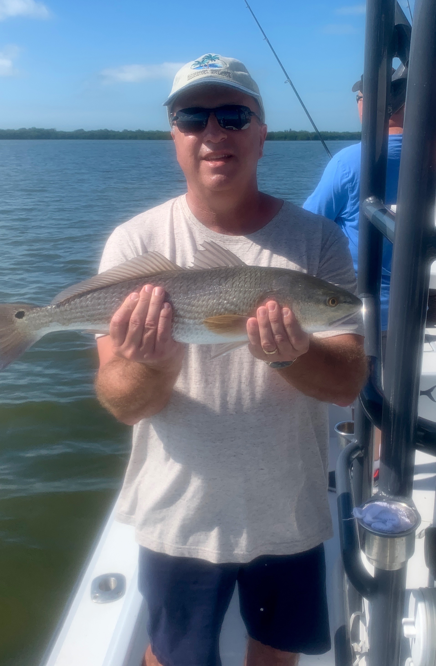

Pic: Doug from IN with a redfish caught while fishing with Capt Matt Mitchell this week
Roller coaster weather

It felt good to be back on water after being blown out by hurricane Eta for basically 5 days. Going fishing with clients after such a long break felt strange, both the bait and fish had not moved a whole lot. Though the water was stirred up for a few days after the storm all it took was a few tide cycles for things to clear up and get right back to normal.

The minus low water incoming tides in the mornings proved to be the perfect set up for the deeper creek mouths that feed the Ding Darling. After not doing much in these places for the past few years I was surprised at how many fish we caught. These channels have had some incredible snook action in years past though had just not recovered from the red tide of 3yrs ago. After catching lots of Snook at our first stop I continued to fish this creek mouth pattern and was thrilled to see that the fish have finally returned. This is great news and put a big smile on my face.

Docks and shorelines in and around Captiva, Redfish and Blind passes all produced snook and redfish during the slower tide periods. All the passes have still been a great choice during the lower water periods. Taking a closer look at some of these docks I’ve started to see a few sheepshead slowly showing up. The cold front forecast for this week should give us another push of these fish.

Even with all the water releases from Lake O the amount of life in the mouth of the river has to be experienced to be believed. Bait fish are the tell tale and both Picnic Island and St James hump have been loaded with shiners. During the higher tides the small mangrove islands around St James city have all been producing Snook and redfish.

Every week for more than a month now we have had weather issues keeping us off the water for several days at a time. I simply don’t remember the last week when we managed to get all our scheduled trips completed. Moving into late November our weather is usually very consistent though it seems all bets were off for this year proving our hurricane season does not end till December 1st.

