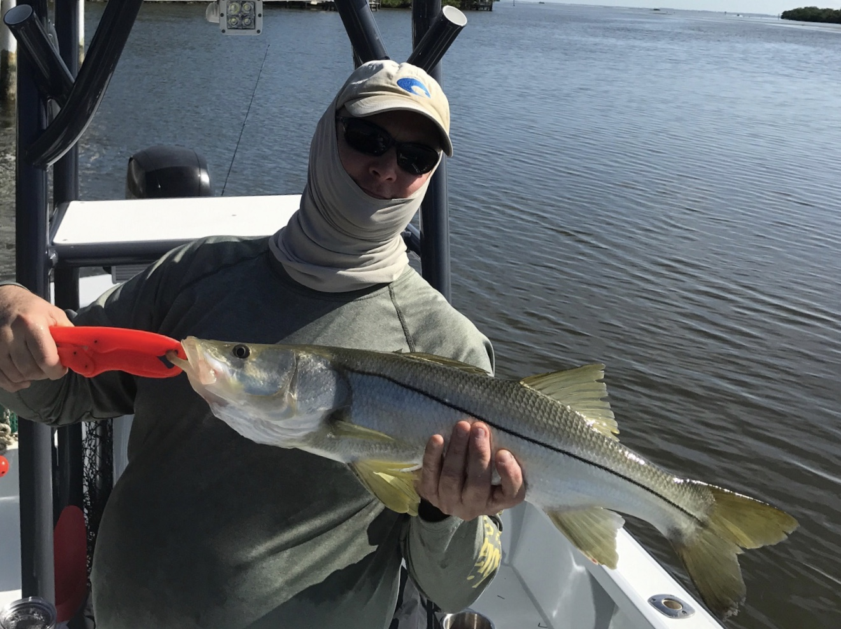

Picture: The masked Steve Day with a 30 inch snook caught while out with Capt Matt Mitchell.

Resiliency

Pine Island sound waters have greatly improved over the last week from this never ending red tide. It’s certainly still not back to normal yet but the improvement in conditions is fabulous to see. As long as we stay on a easterly wind pattern the red tide should continue to blow out of the bay. Lower red tide levels and cleaner water around the local passes meant catch and release Snook action is strong.

The toughest part of fishing has been keeping bait alive. Grass flats I’m throwing the cast net on are holding both shiners and pinfish Once you start putting these baits in the live well they have been hard to keep alive.. On several outings this week I ended up catching bait multiple times as it one only take running through one area of red tide and you would lose the majority of your bait.

If you could get these baits to the passes alive the bite has been outstanding with Snook, Trout, Snapper and Jacks keeping the rods bent. Our big Snook of the week measured 30 inches through several times bigger Snook where hooked and won the battle. After not fishing with shiners for over a week due to the red tide having these great baits really upped the action and the quality of the fish caught. To catch Snook again really felt good after several trips of only targeting Mangrove snapper on live shrimp.

Making national news has had a major ripple effect on tourism with this being the slowest August anyone can ever remember. This situation is making things very lean for anyone who makes there living in the hospitality business and especially those who do so on the water. Marina’s, Bait shops, and Captains are all experiencing the slowest month bearable.

After such a major reoccurring and what feels like a never ending red tide nightmare that’s still happening all over the Florida Gulf coast, I’m seeing a glimmer of hope. With tons of dead fish, dead turtles, dolphins and Manatee’s being removed from our local waters, marine life is gradually returning. This really says a lot about the resiliency of Pine Island sound. I’m slowly feeling a little relief as things are slowly getting back to almost normal.

