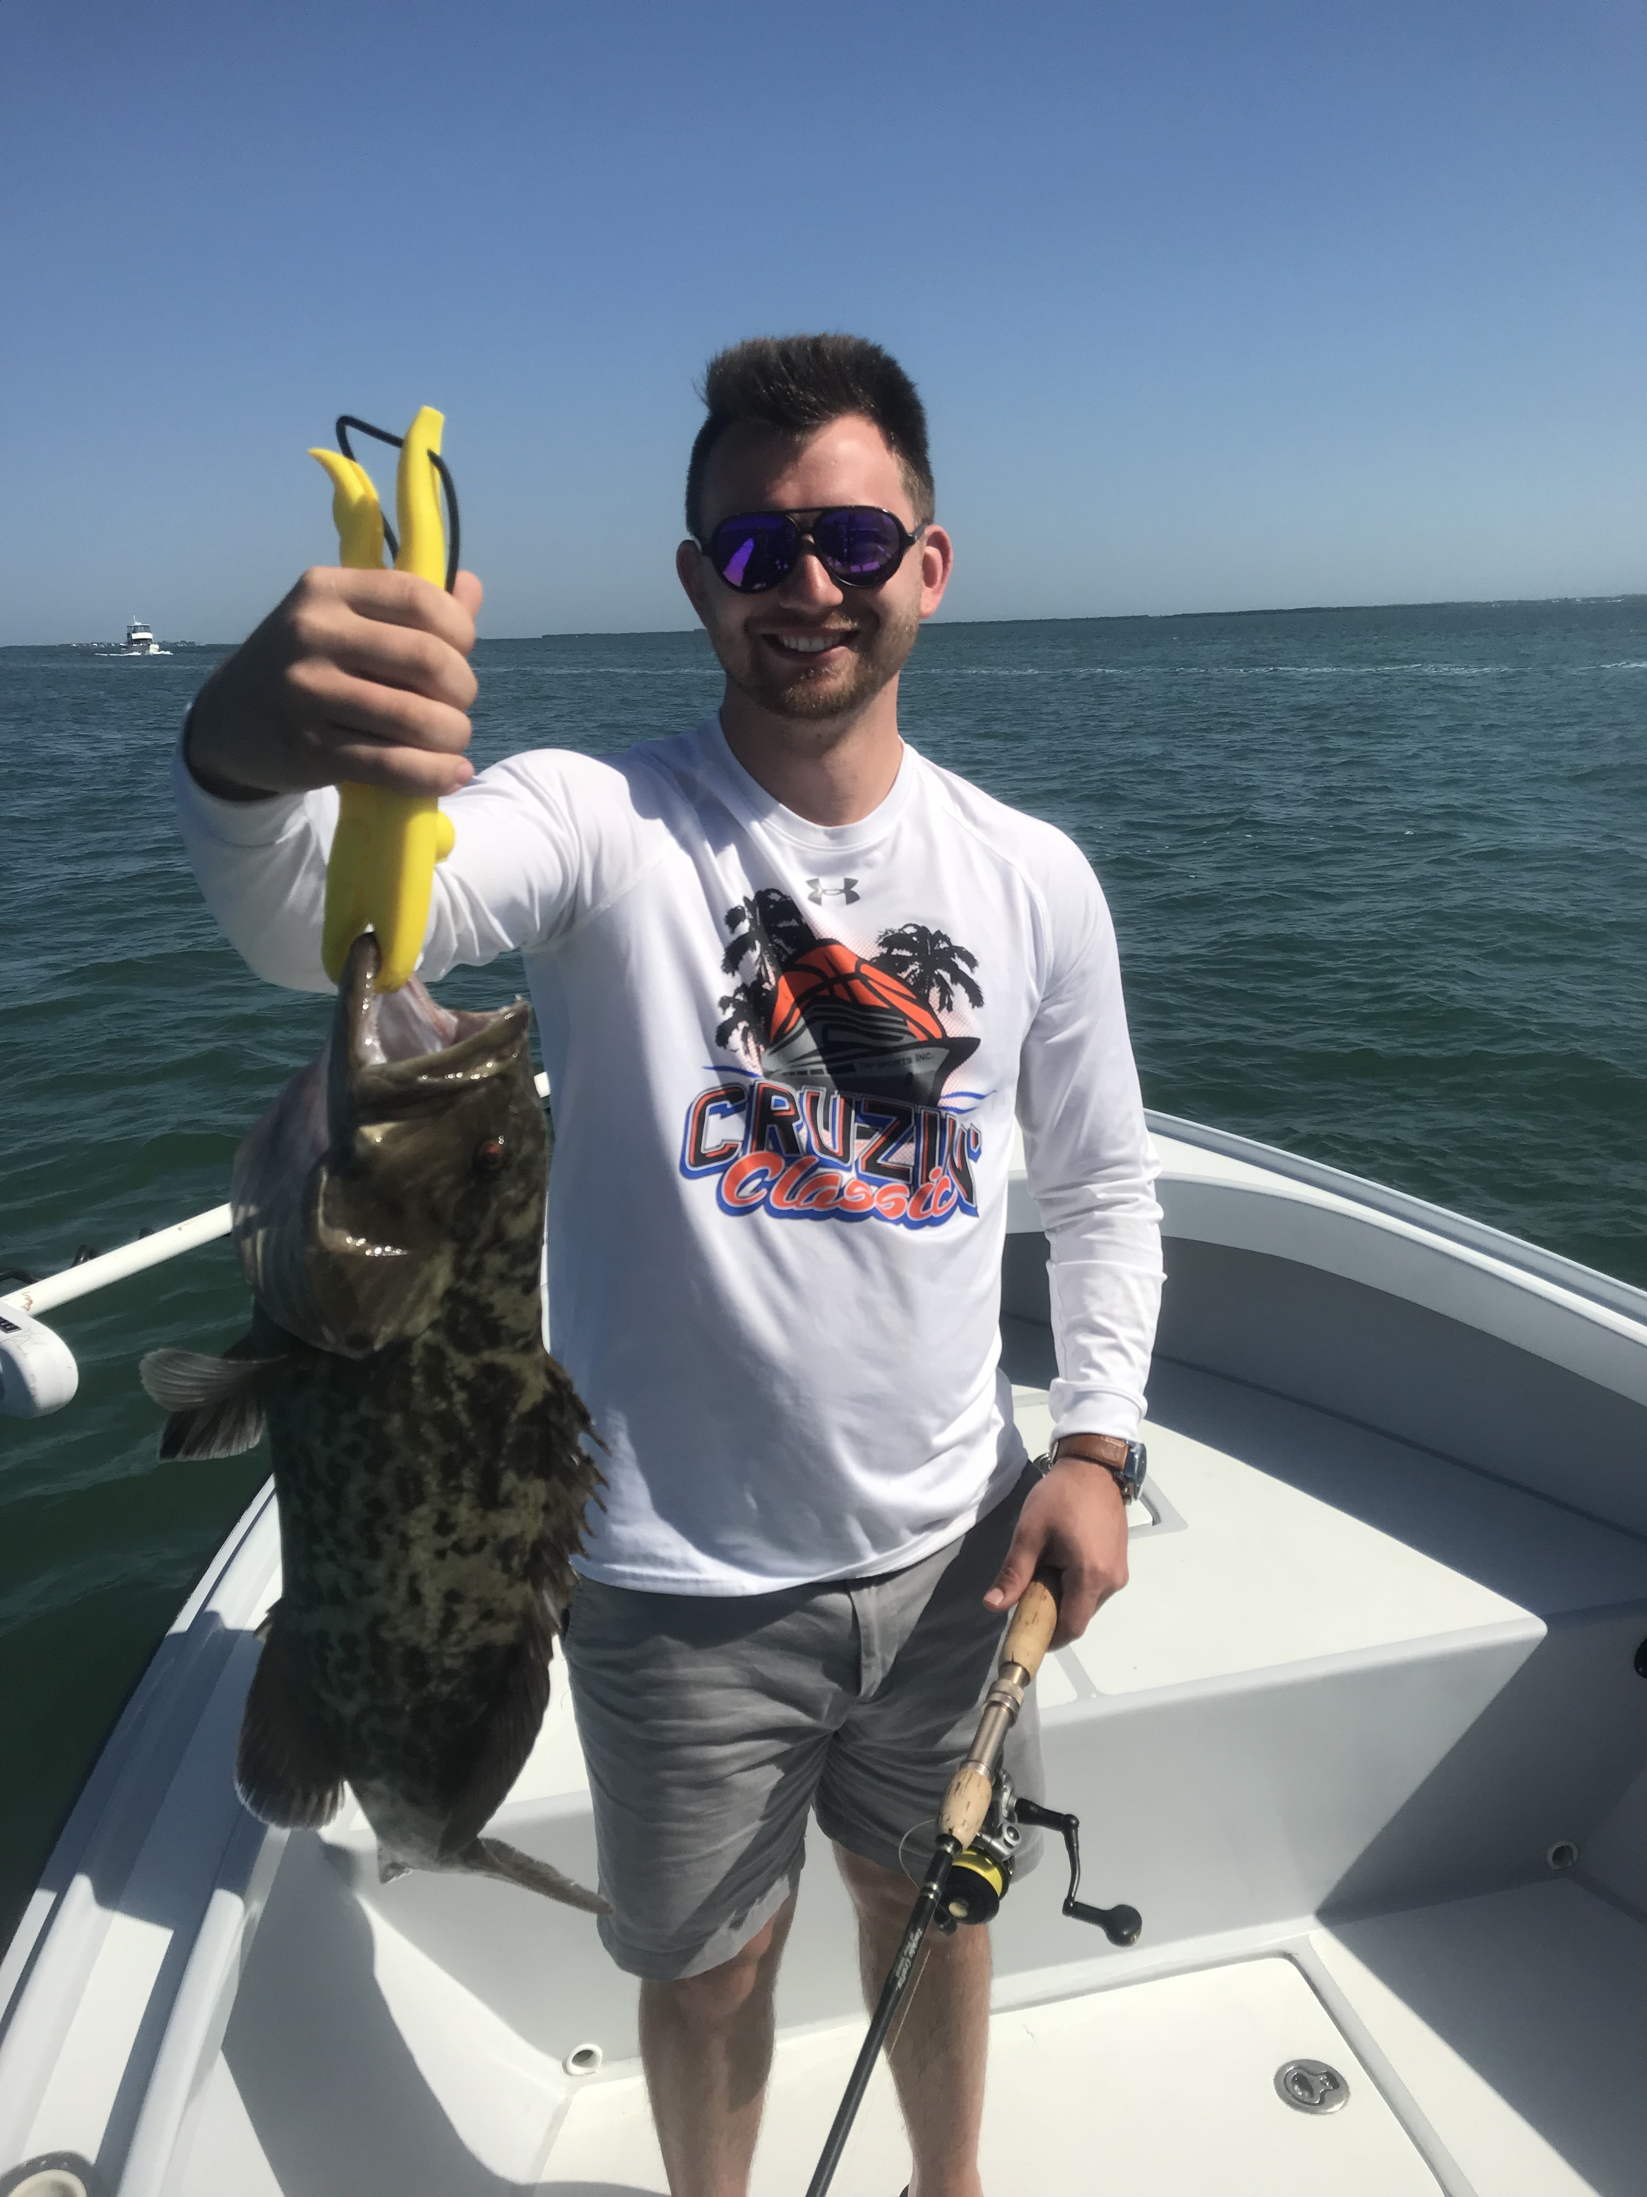

Red tide is gradually pushing out.

Pic: Gag grouper caught while fishing with Capt Matt Mitchell this week

What a difference a week has made for Pine Island sound and our surrounding waters. Prevailing southeast winds helped push the stench and floating dead fish out into the Gulf. Although there are still areas of small dead fish floating on tide lines in the sound generally the water has cleaned up. Fishing is far from back to normal and will take at least a few weeks to hopefully fully recover.

Out on the water for only three charters this week it was strange to see almost zero other boats out. Running north at the beginning of the week we had no problem finding some nonstop mangrove snapper action while targeting deeper structure in the sound. Along with the mangrove snapper we have also been catching some small Gag grouper in these same locations. Water in the northern sound is really clear in places with the bottom being visible in many of locations in up to 7 to even 8ft of water.

Unfortunately I have still been unable to locate any shiners so all of my fishing has been with live shrimp, which is something totally new for me during this time of year. Luckily for some reason the live shrimp over the past week have been larger than our usual summer time bait shrimp. Light gear and terminal tackle has been key to catching

As the week progressed I gradually started working my way back to the south and trying places I had success prior to this red tide. Certain places were really good then other areas were simply void of any life. Southern Matlacha pass proved a great area to catch fish while other locations in the southern end of pine island sound remained a dead zone.

Running the whole Gulf side of Sanibel and coming back in through Blind pass one day mid week there where very few floating fish out along the beaches though also no bird or bait activity. Once inside Blind pass as I moved back into the sound I did spot several large rafts of threadfin herring, which is a great sign that our water quality in this area is getting a whole lot better. It should only be a matter of time before we are back to the daily shiner fishing we are used to.

Despite the far from normal conditions we have been dealing with it just feels good to get out and catch some fish with all of the death we have been dealing with. Even though the fishing is not what it should be my clients have all been happy catching limits of quality mangrove snapper specially when they have had such low expectations after watching the news.

