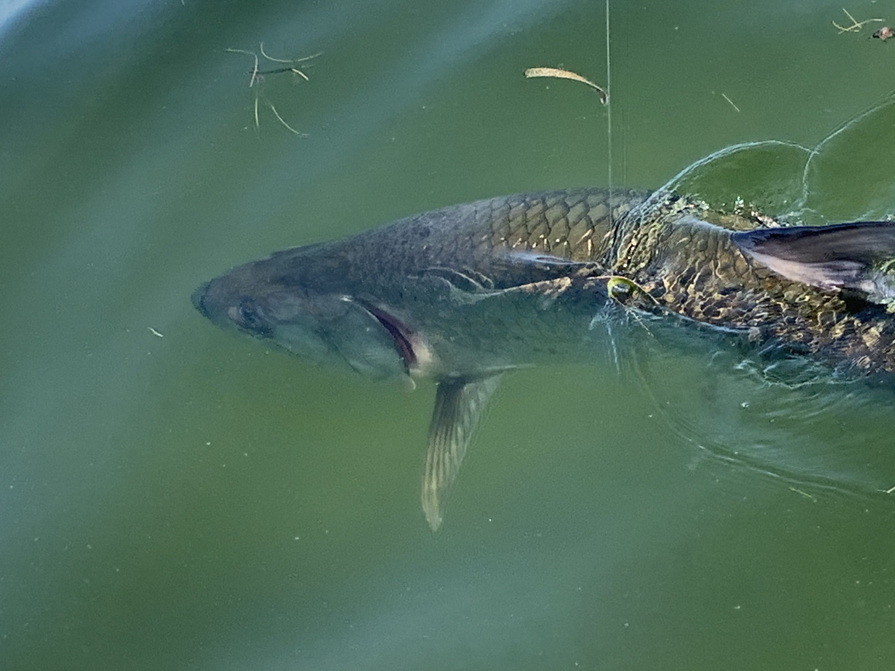

Prime time tarpon fishing

Pic: A leadered tarpon comes boat side before release.

Hunting for tarpon some days required lots of running and looking. Once located it was possible to return to them for a few days until the wind and weather changed and they moved. One day this week after scouting the outside of the barrier islands from the lighthouse to Cayo Costa without much success we came in through the pass. Our very first stop in the sound we found what we were looking for: rolling tarpon.

Finding tarpon is just the first part of the equation to catch one. These fish can be crazy finicky and require patience like no other fish we target. Some days they feed with abandon while other days they roll over your baits while flipping you off. Having an assortment of baits is the only way to find what they want to eat.

May is prime time for tarpon though our weather has been all over the place which has added to the difficulty level. All it takes is a day of strong winds to stir up the water or a sudden temperature drop and these fish will vanish moving back offshore. As conditions stabilize they reappear in the same places they have used for millions of years.

In a perfect tarpon world we would run to rolling laid up fish and be able to sight cast to them. This set up doesn't usually happen. More times than not you have to plan your days tarpon fishing based on the conditions and choose the area’s that are going to give you the best chance. West winds can make the beaches rough and un fishable while giving you calmer waters on the eastern side of the barrier islands. East winds give you the beaches and the eastern side of the sound. The calmer the water the more likely you are to sight these fish up by the surface.

This year’s Tarpon season was off to a much earlier start than normal due to warm water by mid-March. So far it has been amazing when the conditions are right there are as many fish here as I can remember in the last 10 years. One silver lining of COVID-19 is the noticeable lack of angler pressure during week days. If you want to mark tarpon off your bucket list or just catch another one this is the time.

