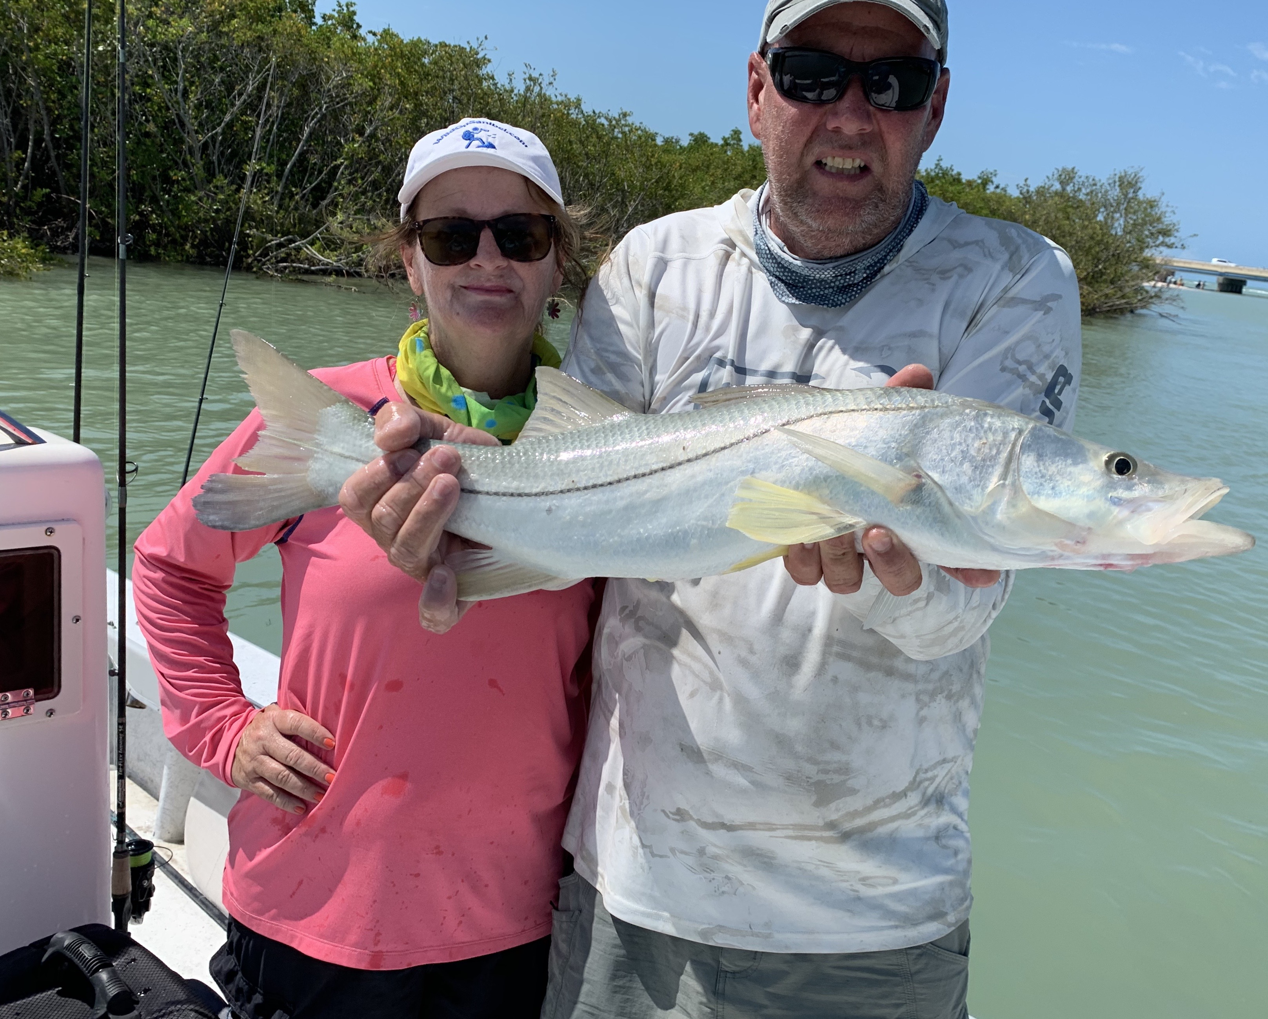

Pick a pass

Pic: Lisa Bonnett with a snook caught while drifting the passes with Capt Matt Mitchell this week.

With our water temperatures hanging out at a bath like 86 degrees the best action for me this week came in and around the passes. All our passes not only have faster moving current but are also deeper than the open flats. This deeper moving water stays cooler and hold lots of snook and redfish. The best time to mangrove fish in the shallower water has been either in the early morning or after a afternoon thunderstorm cools the water down.

Heading to the passes after one such mid afternoon thunderstorm this week had passed we opted to use soft plastic jigs. After the rain we had the pass all to ourselves. Working the same area’s I had caught fish while drifting live baits earlier in the week we caught more than a dozen snook in roughly a hour all on artificial. We used a 3/8oz jig head to make contact with the bottom and just let the jigs drift with an occasional hop.

Pinfish and grunts where the live baits of choice in these same passes. Rig with just enough weight to keep the bait down close to the bottom. Drifting was more productive method though this can change depending on the speed of the current. Catching lots of spawning snook along with redfish over the slot has been the normal. Usually dolphins chase us out though this week the Bull sharks where the issue as they cut fish right in two while reeling them in.

Tarpon fishing improved this week with lots of fish showing up in the northern part of our region. Conditions have improved immensely since the tropical storm last weekend stirred everything up. It seems all the tarpon are now from Captiva pass north. Both the beach and bay side of Cayo Costa are holding lots of fish. After sitting in these rolling and daisy chaining fish for over two hours one morning we just could not get a bite. Picking up and moving less than 50 yards it took only one cast to hook up and then land a tarpon. Crabs and cut baits have been the baits of choice.

Fast moving afternoon thunderstorms made for challenging conditions most days this week. Being out on the water anytime from mid afternoon on requires keeping your eyes on both the sky and radar. These storms often just erupt and close out escape route. Heavy rains, strong winds and lightening are no joke. If it looks bad don’t take any chances and tie up at a waterfront restaurant or marina taking shelter until the weather passes.

