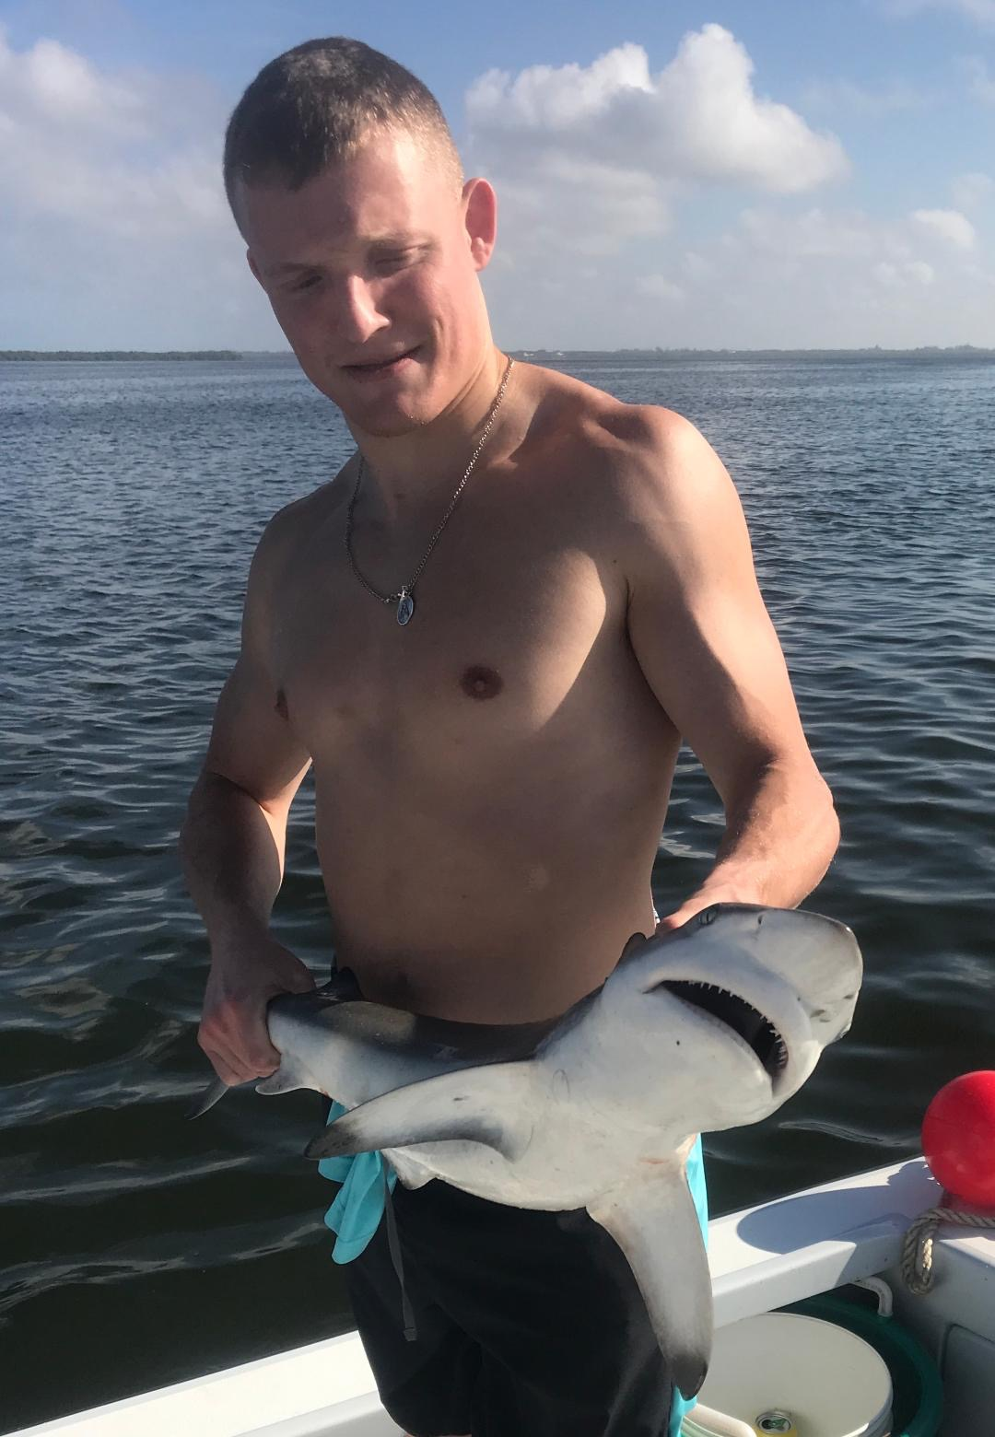

Pic: Jed with a blacktip shark caught this week in rocky channel while fishing with Capt Matt Mitchell

Our waters are healing.

As each week passes our local waters continue to rebound and gradually return to back normal. Clean clear water is getting easier to find and all types of sea life can be spotted. Turtles, Dolphins and Manatee’s are returning to our waters which is great to see. The resilience our waters have is amazing with bait and feeding birds scattered almost the complete length of the sound once again.

We do still have area’s from lighthouse point to the north end of Ft Myers Beach and Boca Grande that are experiencing effects of red tide. Generally though the levels have red tide in our region continue to drop. Running offshore 25 miles due west of redfish pass this week we saw lots of baitfish schools starting out in 30ft and did not see a single floating dead fish. This past week the improvement to our waters is easy to see and is just remarkable.

Rocky Channel in the middle sound can be one of my favorite places to shark fish. During lower phases of the tide all the flats around it get really shallow and these sharks drop of into the channel by the hundreds. Most varieties of shark species can be caught while fishing here in this area that is basically a big fish highway. I like to set up on the anchor in the deeper fast moving water in this natural channel and soak large pieces of fresh cut mullet on a large cut bait circle hook. Pulling on these hard fighting sharks is easy fishing that anyone can do.

When live bait fishing its been a good idea to stay away from the passes specially Blind and Boca Grande during the incoming tide as it only take one small area of red tide to push in and all your bait is dead. These places have still been experiencing fish kills during the big high incoming tide.
Most of my live bait fishing this week was on the eastern side of the sound.

Our go to species continues to be large healthy mangrove snapper. These snapper can be found just about anywhere but finding some submerged structure can really pay of with larger fish. This past week while fishing a favorite concrete rubble pile in the northern sound I found another pile of sunken toilets in 7ft of clear water that I must have past over hundreds of times and never knew it was there. This toilet reef held snapper up to 16 inches and lots of fun to catch Gag grouper up to 20 inches. Casting free lined shiners this place went off with fish exploding on the surface.

Catch and release snook fishing has remained very consistent although I have not found any really large groups of fish. Pulling into a favorite mangrove shoreline or oyster bar you seem to catch a handful of fish then the bite just stops. Keep your eyes open for schools of redfish while working these same area’s. I have heard a few reports of schooling redfish around the tip of Bokeelia and around Captiva Rocks although I’m yet to find them myself yet.

FWC has decided to keep both Snook and Redfish closed for harvest until at least May 10th in response to the fish kills caused by red tide. The effected area thats closed runs south from Tampa to Naples. This closure is a good thing for our fishery and ruling on the side of caution after such a massive red tide event can only help. You anglers looking for food fish there are plenty of other species in the sound to eat other than the snook and redfish which are two of our premier species and need some protection.

