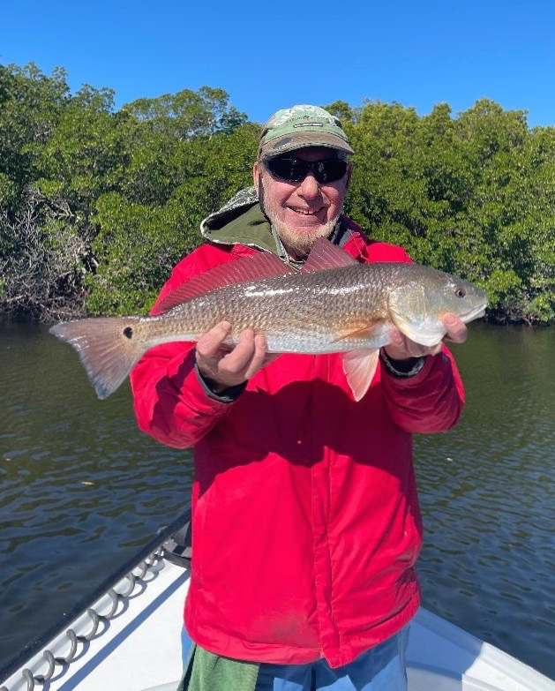

Pic: Jim Robertson with a low tide redfish caught while fishing with Capt Matt Mitchell this week

Negative lows a plus

All winter long we experience some of the lowest tides of the year. These negative tides which can be a foot or more lower than a regular low tide are my favourite. During these super extreme lows, the lack of water causes all of the fish to get much more concentrated. Imagine half as much water in the bay and just as many fish.

Deeper channels both natural and man made are the places to be during these lows. Some of the best action will come both on the last hour of the outgoing tide and then again during the first hour of the incoming. Moving water as always is still the critical factor.

Many of the mangrove channels I fish all winter long offer the fish a place to hide up under the trees during regular tides. Reaching these fish with a bait can be tough if not impossible once the tide is high as the water can go back as far as 20ft into the mangroves. During these negative low tides these same fish have no choice but to fall out from the tree’s and sit on the channel edge.

A few of my favourite mangrove creeks require a shallow draft boat to access as there are very skinny areas in the entrances. Once across these area’s and into the creeks the channels are deep enough to manoeuvre. Look for the fish to be set up in the deeper pools in the bends and even in the middle of these narrow channels. The most perfect set up is when you get trapped by the tide way back in one of these mangrove creek systems. Some days it gets low enough another boat cannot enter until the tide comes back up a few inches and you have it all to yourself.

Negative low tides are also a great time to learn the lay of the land. Seeing how the natural channels weave through both the mangroves and even the open sound is priceless knowledge. When exploring on these minus low tides I suggest going out during the first few hours of the incoming tide so if you do get stuck the tide is coming up and you won’t get trapped or grounded for too long. There is no other time of the year when having a shallow draft boat is so important as the next few months.

