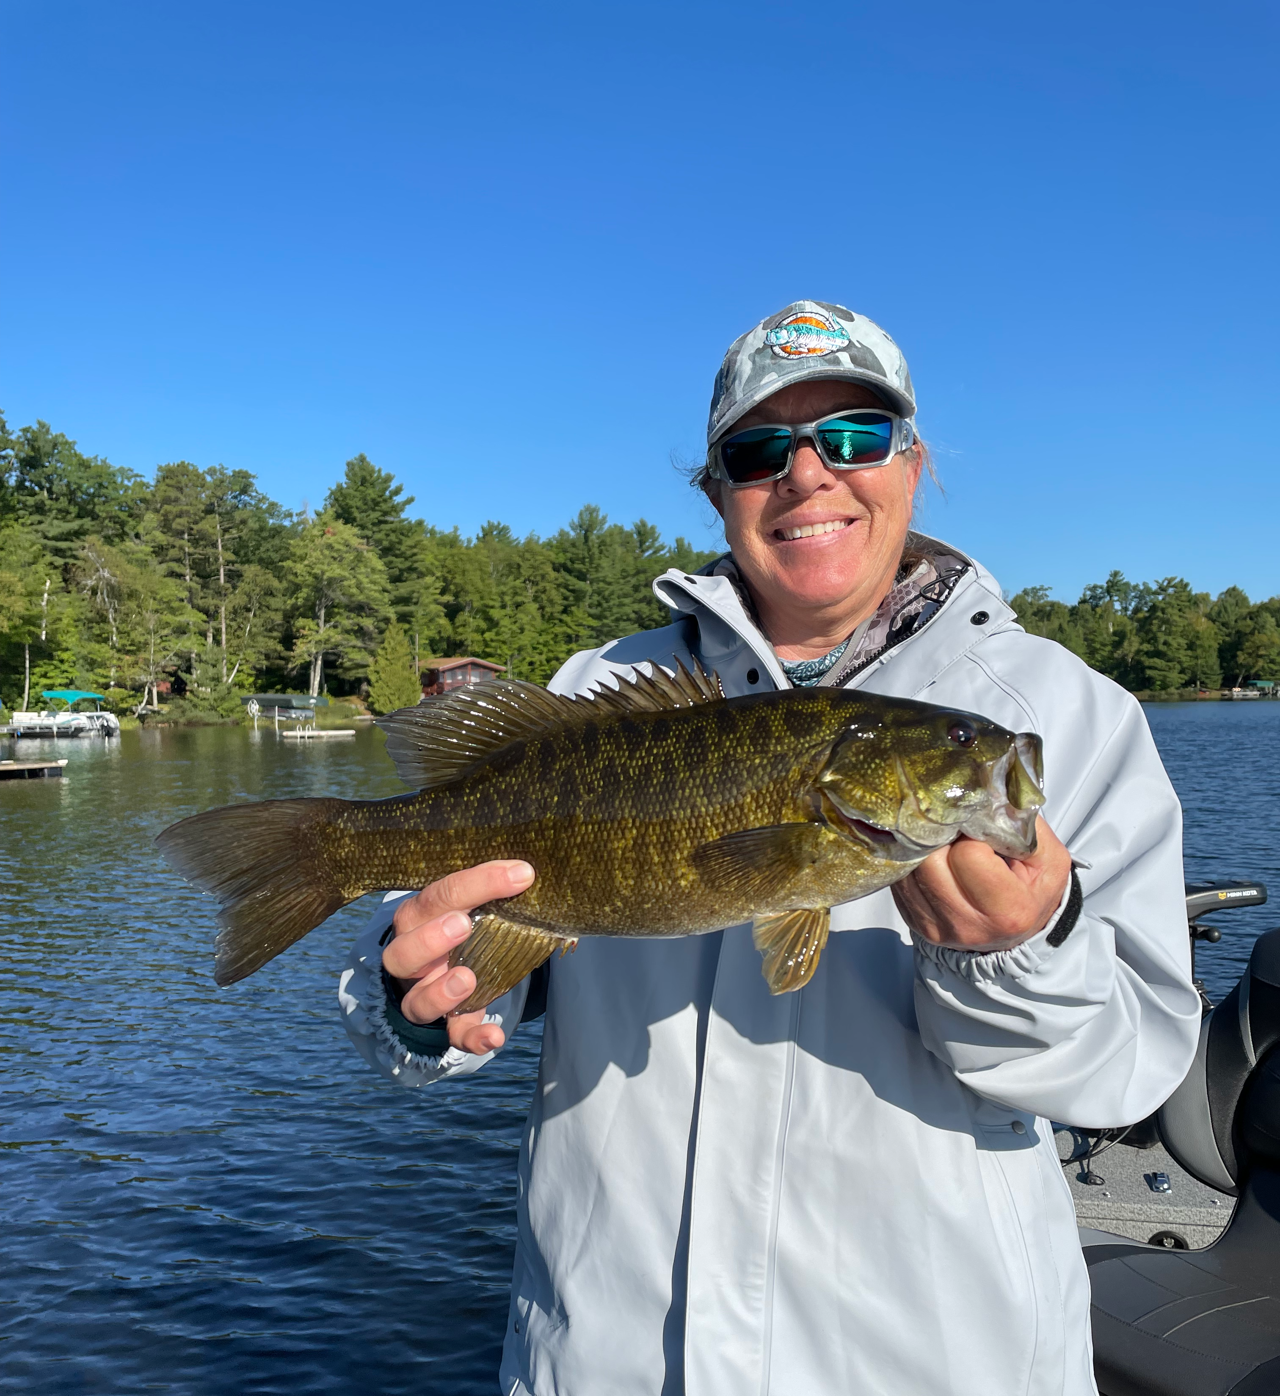

Pic: Mary Laser with a north woods small mouth bass.

Muskie fishing in Wisconsin

After a long hot Florida summer I’ve been planning to get away both from the heat and to take some time off. The plan was to drive to Boulder Junction in the very northern part of Wisconsin the beginning of September. This place is the Muskie capital of the world. Once there I had 3 days of fishing booked with my long time client Tom who guides and manages Wittig’s resort. Tom has lived year round in Boulder junction guiding/running a fishing camp that’s been in his wife’s family for 3 generations.

This is a part of the country I had just never seen. After some research I booked a private cabin on 5 acres on the Cisco chain of lakes. Taking our time Mary and I would make the roughly 1400 mile drive up over 4 days then make a large loop coming back through the UP of Michigan.
On our first day of fishing Tom planned on marking off some of the easier fish off my bucket list. Small mouth bass, walleye, and Lake perch made for some great action as he explained the water temperature being in the high 60’s was going to make our next few trips targeting Muskie tough. Heading back to the cabin that afternoon we had plenty of walleye and panfish for a fish fry that night which was outstanding.
The next few trips we fished different lakes casting both custom made big spinner baits and plastic baits made to resemble a sucker fish. Day one I had one Muskie follow the bait all the way to the boat. I failed to make the classic figure eight moves once the fish was next to us. Day two on a even prettier lake I had another Muskie follow the spinner all the way to the boat again and just not eat. Then about a hour later I had one hit the huge plastic sucker out from the boat and after a hook set and a few cranks it just came unhooked.

I had done some research on these “fish of a thousand casts” and knew our odds of getting one where pretty low. As a fisherman I understand the hunt and was thrilled to even seeing a few of these elusive prehistoric giants. Getting to spend time on the water in this remote beautiful place was amazing. It was the perfect spot to wind down and cool off as we lit a fire nightly.

One day we rented a ATV side by side and rode trails for miles into northern Michigan. This whole area is full of hundreds of miles of snow mobile/ATV trails. What an amazing untouched place the North woods are. After seeing these Muskie and the thousands of lakes to fish I’m more fired up than ever to mark this species of my bucket list…..

