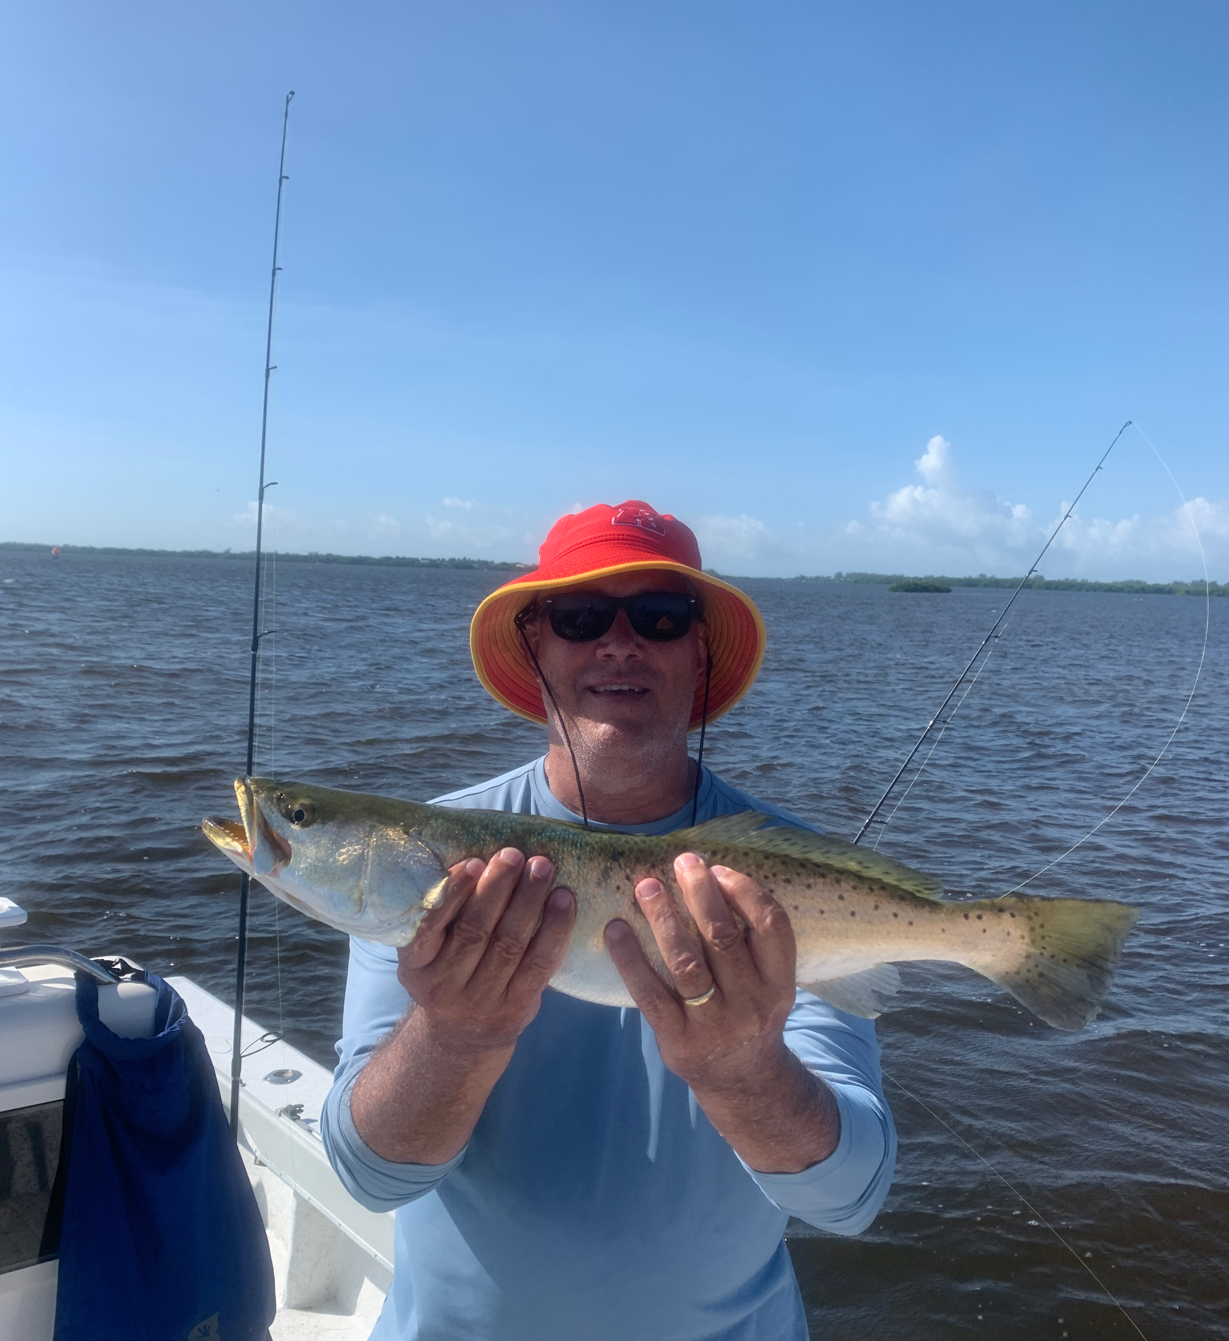

Match the hatch

Pic: Big trout out on the flats have been around the fry bait too.

Over the past several months as always in the heat of the summer our shiners disappear then slowly reappear as small hatch bait. At first these millions of fry baits are even too small to catch without Christmas treeing a 1/4 inch mesh cast net. Over the past few weeks they have now reached a large enough size that they are finally fishable again. What this bait has lacked in size it has made up for in sheer numbers with rafts of it found all through the bay. Filling your live well with this bait comes easy with a little chumming and a few casts of a small cast net.

Once baited up its simply a matter of live chumming all your favorite places to catch fish. From the mangroves to the flats and even the passes this fry bait gets everything fired up. With our water temperature hanging right at 87 degree’s it seems the fish are just looking for a small bait and not that big stuff. Watching fish fire off on these baits when chummed its as easy as throwing a hooked shiner to the pops to catch a amazing variety of fish.

Out on the flats around all the shoals I’ve had great success chumming up trout, mackerel, small sharks and lots of keeper sized mangrove snapper. Chumming a half dozen or so baits every five minutes has the fish exploding on the surface. Down sizing my gear to 2500 series reels spooled with 10# braid has made not only casting these small baits possible but also gives the clients some great battles on a mixed bag of fish. Down size the leader too to 20# test and tie on a 1/0 light wire hook and your in business.

Several spots out on the flats this week while cleaning the dead baits out the live well we had wolf packs of big mangrove snapper swarming the free lunch. To catch these fish we would open the spool of the reel and feed the baits back at the same speed as the chum was moving. When the line started to peel of the spool close the bail and wind tight to hook up. Limits of these tasty fish have come without much effort.

Mangrove fishing for snook has also been a great option on these smaller baits. The same process of live chumming a shoreline has quickly let you know if you have feeding fish there. Look for shorelines with moving tide and when you see the fish blow up move to that area. These same shorelines have also had jacks, a few redfish and more mangrove snapper.

As we often hear when it comes to fishing “match the hatch” or basically fish with what is naturally there. This is proving to be the case when nothing else will get it done in the hot water these small baits do. With so much smaller bait just about everywhere its proving to be what all the fish are dialled in on right now.

