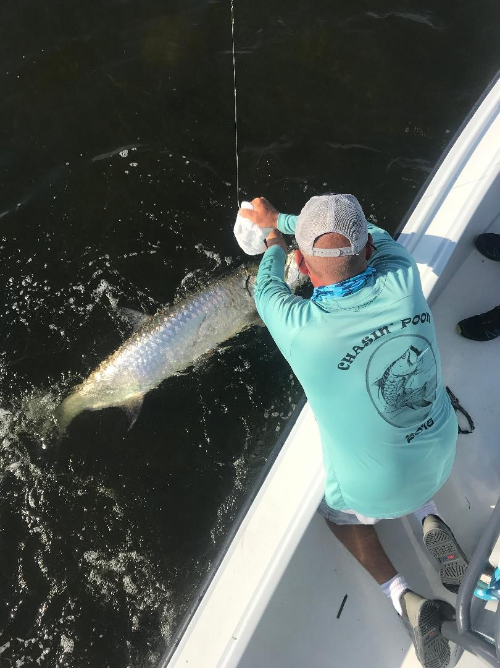

Life rebounds in the sound.

Pic: Gary Naylor’s bucket list tarpon comes boat side caught while fishing with Capt Matt Mitchell this week

This week proved to be one of the more memorable weeks fishing on the sound than I have had in months. Bait birds and feeding fish have returned and for now things are looking so much better. In the middle sound just past redlight shoal schools of feeding ladyfish and diving birds were a very welcome sight of normality.

Fishing with long time clients the Naylor family from England we went and gave shark fishing a go. Heading up to Rocky channel on the low incoming tide it did not take long to catch our first shark of the day. We caught Blacktip sharks in the 3-4ft range basically one after another as we watched quite a few tarpon rolling around the boat. About a hour into the trip Gary was lucky enough to hook one of these tarpon which made a crazy long run and had us thinking it was another shark until it leaped sky high. Chasing this fish around Gary did a great job and managed to mark tarpon off his bucket list.

With all the schools of ladyfish and bait in the sound the fall run of tarpon we get to enjoy should only get better and better. Once you locate these fish you can generally return to them day after day or as long as the conditions remain the same. Fall tarpon fishing is my favorite fishing of the whole year as not only do these fish have very little angler pressure but they seem to feed better as they are packing on fat before the water temperature drops and they migrate south.

Taking a stay-cation this weekend and heading up to Little Palm Island for a few days I had a chance to see not only the condition of Pine Island sound but also Charlotte harbor and Lemon Bay. From Sanibel lighthouse all the way north to Boca Grande was dead fish and odor free. Once past Boca Grande things where not so great then at the northern most point of our trip Lemon Bay it was full of dead fish and the strong smell of red tide. Riding outside down the beach of Gasparilla and Little Palm Island the red tide was really bad with cloudy water and no life.

Although southwest Florida is far from done with this nasty red tide for now the sound seems like it has rebounded although there are area’s to our north that are not so lucky. Don’t lose hope get back out on the water and enjoy some of our fabulous fall fishing.

