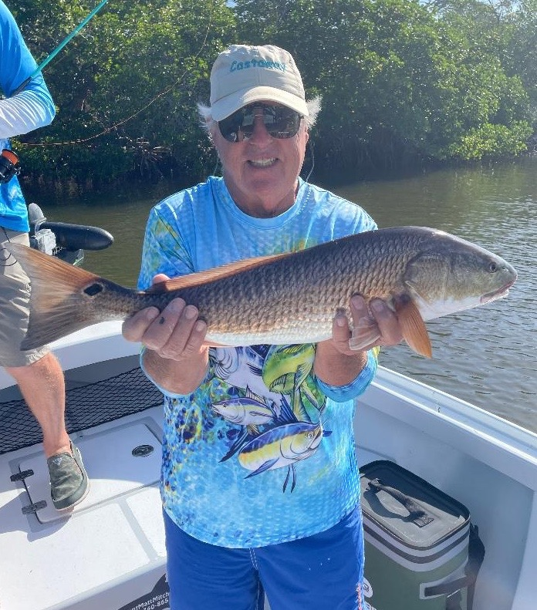

Let them live to fight another day

Pic: Jim from St James city with a nice slot size redfish he released while fishing with Capt Matt Mitchell

Big news for our fishery this past week was both the opening of Redfish to harvest and the last minute FWC change of policy to keep our snook closed. With both of these fisheries on the rebound since our catastrophic red tide 4yrs ago I’m thrilled to see that the FWC listened to both guides and anglers and will keep snook closed till at least next year. I don’t think opening redfish to harvest is the best idea though these are a much faster growing fish than a snook and with a lowered new bag limit of 2 per boat maximum this will certainly help.

I totally understand that many anglers want to take home fish to eat. Luckily, we have many other species of fish to harvest than just snook and redfish. Many guides and fishermen will continue to practice catch and release only on redfish even though its legal to take one. It’s hard to find a better eating fish than a mangrove snapper which have been found throughout our region and have a 5 per person bag limit.

With no sign of our temperatures cooling off the annual big schools of redfish have already started to appear in the northern sound. Flats between Useppa and Bokeelia have had large schools in shallow water. One of the most effective ways to catch these fish is to sight fish them on a long casting weedless spoon. When rigging a spoon to target these mostly over slot redfish buy a quality spoon either 3/8th or a 1/2oz, my go to is an Aqua Dream though a Johnson spoon will get it done. I like to attach a high quality ball bearing snap swivel to the spoon before tying it to 40# leader. Redfish have a extremely strong mouth and will break the wield that attaches the hook to the spoon on cheaper models.

More and more redfish have been showing up all through the sound. If not in the massive schools like in the northern sound most mangrove shorelines on the high tides and the passes on the lower tides have been a good bet to catch a redfish. Cut pinfish or cut ladyfish have been my baits of choice though I have been catching a few on live shiners while targeting snook.

Tarpon fishing is gradually improving both out along the beaches and in the middle sound. As the days get shorter and our water starts to cool this fishery will really fire up before the first major cold front brings it to an end. Fishing over the Labour Day holiday weekend we found a few groups of rolling fish just south of Bird key. After finding a few feeding terns working bait you would see a few Tarpon roll. After sight casting and hooking a roughly 50 pounder this fish went absolutely nuts jumping close to the boat over and over before jumping into my powerpole and motor then breaking us off. For a brief second it looked like it was coming inside the boat with us. About a hour later we did manage to sight cast a roughly 100 pounder that we got boat side for a leader touch. In a perfect world I’d spend a few hours every morning chasing these amazing fish.

