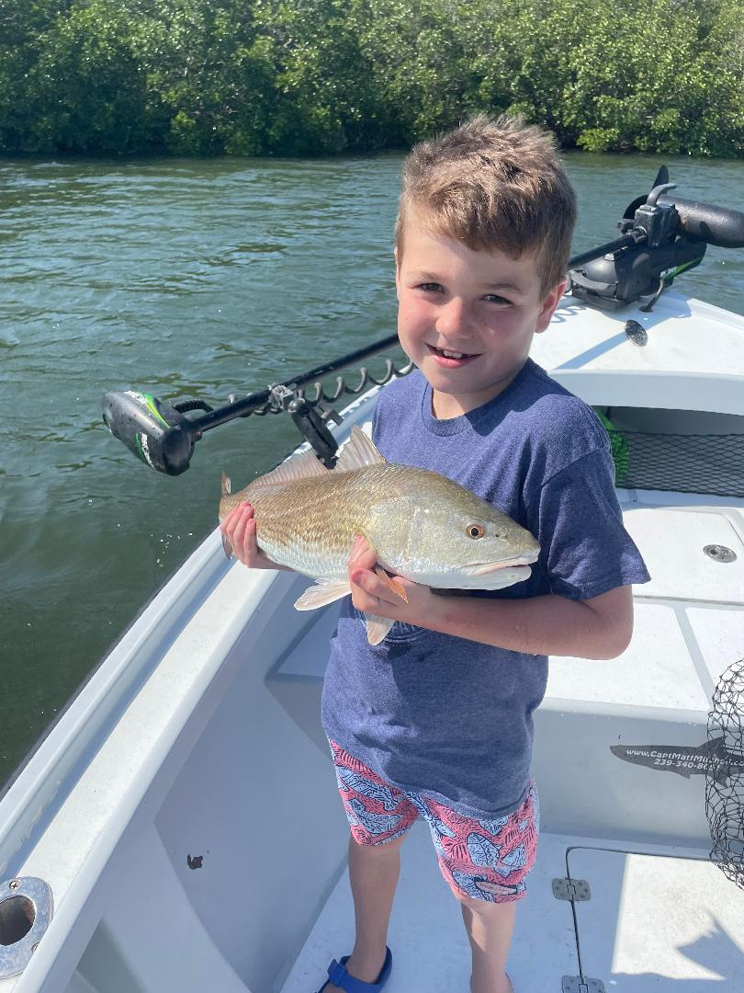

Kids on summer break

Pic: The fish don’t have to be big to make a huge smile

The majority of my charters this time of year tend to be family’s taking advantage of summer vacation. There is always something special about taking out kids for their first ever saltwater adventure. I say adventure because often these trips evolve into much more than just fishing.

The main thing I’ve found when Introducing kids to fishing and boating is keeping them interested and busy. Plan on targeting species that will be high activity, Depending on the age and experience level of the kids, they may want to fish the entire trip or they may want to take a break to check out Dolphins, Manatee’s or even go for a quick swim.

The diversity of life we have in our local waters is hard to match anywhere on the planet. The simple things we take for granted like blowfish and pelicans are a whole new experience for many kids. Being able to touch a live fish is something that can be very scary at first. It takes time to warm up to the idea yet by the end of a charter children often want to touch every fish they catch.

If you plan on taking kids out for a day on the water, I’ve found that catering to there needs first will make everybody onboard happy. If the kids have a great time and want to go again its a successful trip. Flats fishing is hard to beat for non-stop action and depending on the skill level a popping cork with a live bait will catch fish after fish. The variety of species along with consistently bent rods makes this type of fishing hard to beat.

Many of these trips introduce kids to seeing where their food comes from. Taking home a fresh fish dinner is often a requirement and when the kids have caught the fish they are much more apt to want to eat something new. I like to get them involved in the measuring of the fish and explain the conservation aspect of why we catch and release the smaller fish.

Seeing what our waters offer through the eyes of a child has to be experienced to be appreciated. So often we take for granted the little things we see every day and showing it to someone for the first time is refreshing. Being able to share what I love with young anglers is one of the many pluses of my job.

