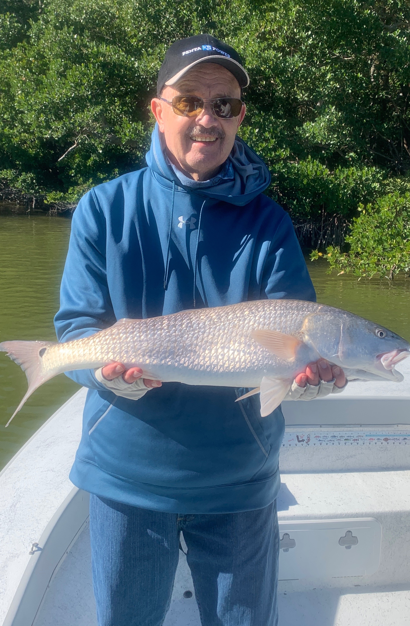

Pic: Bob McGuire got in on the redfish action with Capt Matt Mitchell this week.
Keep on shiner fishing

Never ending cold fronts over the past few weeks have kept our water temperatures hanging in the mid to upper 60’s. Usually when we have had long periods of cooler weather our shiners disappear and we make that winter switch to shrimp fishing. This has not been the case so far with snook and redfish action on shiners still being the best bite in town. Shiners have remained easy to catch in the deeper water around the causeway bridges..

Clients who got to go fishing this week took part in some of the most wide open catch and release action on Snook and Redfish I can remember in January. With so many fish packed together in and around the passes 50 plus fish 1/2 day trips where normal. Lower tide periods along with fast moving water made for a non stop bite. Live shiners where the bait of choice although bouncing a live shrimp along the bottom on a jig also caught them.

With this cold weather forecast to stick around for at least the next 10 days I’m hopeful our Sheepshead bite will kick into high gear. Docks, bridges and jetties are some of the most productive area’s to catch these winter time fish. Bait up with pieces of shrimp and fish close to the structure. Fiddler crabs and sand fleas are also a good choice. Sheepshead love to gnaw on the barnacles that grow on this structure.

The rebound we have seen in our Snook, Redfish and Trout fishing over the past few years after a emergency closure implemented in 2017 has to be experienced to be believed. Redfish fishing is currently as good as I have ever seen it. Last year at this time we caught tons of them all on the smaller side. This year the numbers are still increasing with the average size being much larger. Unfortunately this closure is scheduled to end after May 31st. Its fabulous our fishery has improved but imagine how much better yet it could get with a continued closure.

