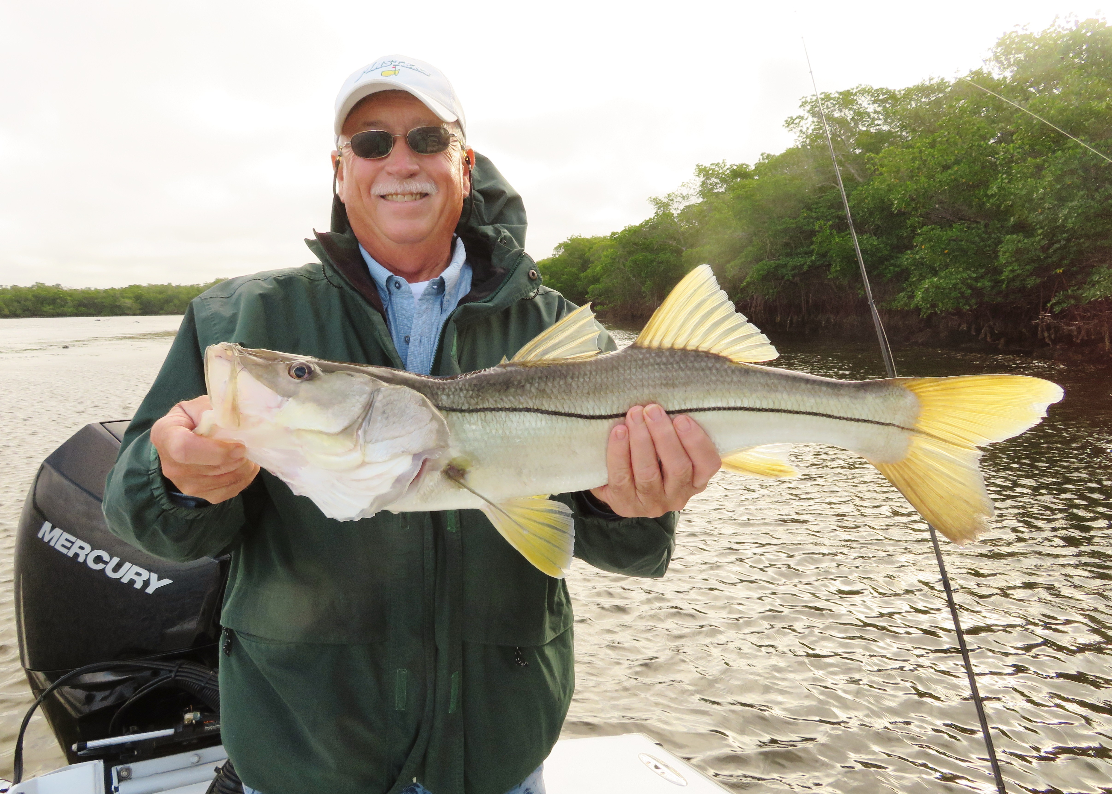

Pic: Gary Biltgen with a snook caught on the negative low tides with Capt Matt Mitchell this week.

How low can it go

We had the pleasure of fishing winter negative low tides this week that can bring amazing action. This crazy low water played out as expected with my clients experiencing some of the best snook action while mangrove fishing we have seen in months. Thirty inch snook and a non stop bite had everyone smiling.

While fishing a favorite channel we arrived on the last of the falling tide and could see the entire exposed grass flat littered with high and dry crab pots. Once the tide switched and flooded in the grass flat was totally covered in less than a few hours. Picking the deepest spots on the shoreline the bite started immediately with almost every shiner flipped up close to the bank getting hit. Fast moving tide in these narrow channels creates rips and eddies on every piece of structure and makes for a perfect ambush spot for hungry snook to sit.

We get to experience these negative low tides all winter long. The lower the water gets the tighter it bunches up the fish in very small area’s. Learning to access and locate these deeper areas only comes with time served though looking at google earth and charts is a great way to get started. The narrower and deeper the channel the faster the tide with usually move.

Winter tides are when having a shallow draft boat can really pay off as many of these deeper channels are only accessible by crossing shallow bays and flats. Another option is getting into these areas while the tide is still up and going out. Once the tide bottoms out you will be trapped until the water comes up high enough to leave. Watching wading birds work the acres of exposed grass flats all around you is an amazing sight.

Along with the snook in these deeper channels we also did well on redfish. Bouncing a live shrimp on a jig head in the fast moving tide caught lots of redfish ranging from 16 to 24 inches. Larger mangrove snapper have also been a welcome surprise in these same area’s. Two days in a row we also caught what at first glance I thought where mangrove snapper but on closer inspection turned out to be a cubera snapper measuring roughly 15 inches. Fishing these deeper water creeks is not only great action the variety can be limitless.

I often hear people complain about how hard sheepshead are to clean. With a sharp knife and a little practice, they are well worth the effort. Not cutting through the rib cage when cleaning them along with not cutting the fillet completely off the carcass before skinning are a few pointers that help. Cutting through the rib bones doesn't give you a better yield and quickly dulls your knife. I see more and more people cleaning them with electric fillet knives even though I’m not a fan. I feel I get a better yield and end up with a better looking fillet with a sharp quality fillet knife.

Don’t let the colder weather keep you off the water, get out and fish.

