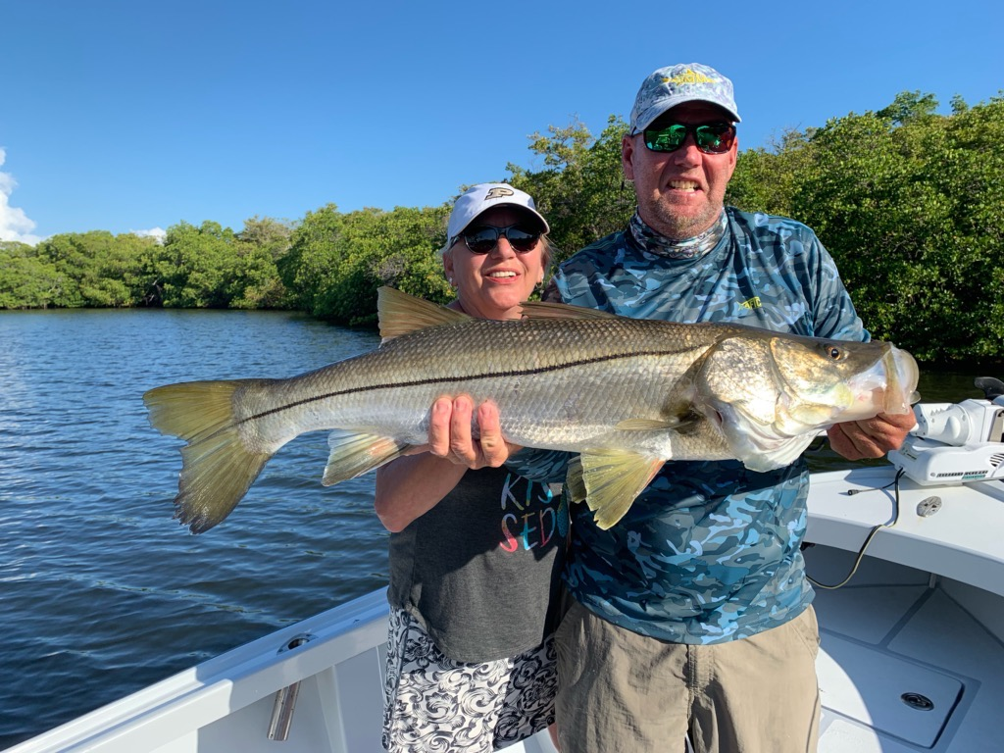

Holiday weekend fishing

Pic: Jan from Indiana with her 41 inch Snook caught and released while fishing with Capt Matt Mitchell this week.

As usual the Memorial Day weekend was a extremely busy time to be out on the water. After what has been a relatively quiet few weeks it took some getting used to having boats buzzing around all over. My go to during these busy holiday weekend is Matlacha Pass which see’s very little angler pressure. Getting tucked away in a creek or against a wind blown shoreline things where quiet and Snook fishing was good most days.

Anglers trying to tarpon fish over the holiday weekend had it a little tougher as no matter where you seemed to set up boats would run right by often spooking the tarpon. There must be some subconscious thing that makes pleasure boaters have to run right through a pack of boats fishing when its just as easy to go around them. I don’t think this move is something that is done maliciously its more because they just don’t know any better. This move used to drive me crazy any more I just laugh over the lack of common courtesy. A good rule of thumb is if you can recognize a person on a boat you are too close. Luckily things will get back to normal after this weekend.

Tarpon continue to be found all through the bay and up and down the beaches in some of the best numbers i have seen in ten years. Fishing out on the beaches look for muds or area’s of stirred up water and you will find tarpon. Almost anywhere out on the beaches you can run into these fish right now though from Blind Pass to west rocks has been one of the most predictable places to start your search. In the sound good numbers of tarpon have been found from Cabbage Key back south down to Red fish pass. The key in the sound is finding clean water which can change from day to day depending on the wind and tides.

While tarpon fishing at Fosters point this week we sat and watched rolling fish for most of the morning while only seeing a few hook ups. At first we where throwing a wide variety of live baits including crabs, threadfin herring and pinfish without any luck. Mixing it up and throwing a cut fresh mullet out of the stern we hooked up within 10 minutes. Though you don’t need a lot of bait to go tarpon fishing having a variety is important. Depending on where and when you are fishing you never know what it will take to get that tarpon to bite.

Fishing with long time clients Jan and Brian from Indiana this week we had the wind and full moon fighting us so we opted to target Snook instead. Fishing mangroves around St James city we caught Snook and mangrove snapper at our first few stops. Heading back into a favorite creek I anchored up and threw a scoop of live shiners out to see if we had any feeding fish.

After a few minutes I heard a pop that was as loud as a dolphin slapping its tail. Several minutes later I saw another huge pop on the mangrove shoreline which we quickly cast to. A few seconds later Jan had a monster Snook on that immediately ran back up under the mangroves and into the roots. Jan never panicked and was able to finesse this giant 41 incher out from under the mangroves and successfully battle it to the boat for a few pictures before watching it swim off unharmed.

